AGREEN
CROSS-BORDER ALLIANCE FOR CLIMATE-SMART AND GREEN AGRICULTURE IN THE BLACK SEA BASIN
Subsidy Contract No. BSB 1135

GUIDEBOOK
Entrepreneurship for Climate-smart Agriculture
in the Black Sea Basin

AGREEN
CROSS-BORDER ALLIANCE FOR CLIMATE-SMART AND GREEN AGRICULTURE IN THE BLACK SEA BASIN
Subsidy Contract No. BSB 1135

GUIDEBOOK

Training course
“Entrepreneurship for Climate-smart Agriculture in the Black Sea Basin”

2022

The project Cross-Border Alliance for Climate-Smart and Green Agriculture in The Black Sea Basin (AGREEN), Ref. No. BSB 1135 is funded by the Joint Operational Program for Cross-Border Cooperation under the European Neighbourhood Instrument "Black Sea Basin 2014-2020", under Priority 1.2 "Increasing cross-border opportunities for trade and modernization of agriculture and related sectors".

Table of Contents:
Foreword 5
Module 1: CSA concept and approach / CSA in the BSB 7
1.1 Weather, climate and climate change 7
1.2 Impact of climate change on agricultural production in BSB 8
1.3 Climate change, food security and challenges 9
1.4 Definition of Climate Smart Agriculture (CSA) 9
1.5 Sustainable production under CSA 10
1.6 Adaptation strategies to climate change impacts 11
1.7 Approaches to increase competitiveness in agricultural sector, ensure sustainability and mitigate climate change under CSA 16
1.8 Institutional aspect of climate smart agriculture implementation 17
Bibliography: 18
Module 2: Climate-resilient agro-food value chains 20
2.1 The essence of the concept of Value chain and its key parameters. 20
2.2 Principles of building a Value Chain structures (stages/partners) 20
2.3 Types of value chains and their composition 22
2.4 Principles of evaluating effectiveness of the Value Chains (stages, volumes and profitability, SWOT analysis) 24
2.5 Measuring results and fine-tuning. 25
2.6 Case study 26
Bibliography: 32
Module 3: Managing sustainable farms 33
3.1 Enhancing biodiversity as a practical component of SFM 33
3.2 Benefits of nature resource protection in SFM 36
3.3 Sustainability of family-controlled farms, economic viability and human wellbeing 38
3.4 Integration of Sustainable Farm Management /SFM/ practices into agribusiness 40
3.5 Checklist of sustainability 42
3.6 Case study of a sustainable farm 43
Bibliography: 45
Module 4: Financing CSA activities 48
4.1 The financing of SCA as a contribution to their development and implementation in practice. 48
4.2 Legislation in the area of SCA financing 49
4.3 Sources of funding 51
4.4 Business Plans and Business Budgeting 58
4.5 Costs and effects of financing 63
Bibliography and additional reading sources 65
Module 5: Marketing for sustainable agricultural produce 66
5.1 The definition of Marketing and its purpose 66
5.2 Marketing and the Agricultural Sector 70
5.3 Marketing Strategies for Sustainable Agricultural Products 73
5.4 The Agricultural Marketing Plan 74
5.5 Measuring Results and Fine-tuning 78
5.6 Case Studies 78
Bibliography 79
Module 6: International trade and cooperation 80
6.1 The importance of agricultural trade 80
6.2 Modern Trade models 81
6.3 Food price and price fluctuations 83
6.4 Institutional regulatory and legal framework 84
6.5 Tariffs and exchange rates 89
6.6 International transportation of the goods 95
6.7 Relevant international regulations for transportation 96
Bibliography 96

GUIDEBOOK

Foreword
This Guidebook is designed to serve as a training material for the learners in the AGREEN training course “Entrepreneurship for Climate-smart Agriculture in the Black Sea Basin”.
The course is developed within the project Cross-Border Alliance for Climate-Smart and Green Agriculture in The Black Sea Basin (AGREEN), Ref. No. BSB 1135, funded by the Joint Operational Program for Cross-Border Cooperation under the European Neighbourhood Instrument "Black Sea Basin 2014-2020", Priority 1.2 "Increasing cross-border opportunities for trade and modernization of agriculture and related sectors" and is intended for young farmers, professionals and students in agriculture and climate studies, following formal education at secondary or tertiary level.
The general objective of the training course is to support, up-skill and stimulate young entrepreneurs to engage in sustainable agriculture and organic farming and to improve the capacity of the young entrepreneurs and framers while on the job.
The present course is designed as a training suitable for blended mobility training and could be delivered in distance or blended-learning format. The structure of the course is composed of 6 training units (modules), presented in the following chapters.
The online version of the training course (including this Handbook and training contents) is available in English and all partners’ languages (Bulgarian, Romanian, Georgian, Armenian, Turkish and Greek) in the e-learning section of the project internet platform: https://agreen-platform.com.

List of abbreviations used:

AGREEN | Project “Cross-Border Alliance for Climate-Smart and Green Agriculture in the Black Sea Basin Project”
BSB | Black Sea Basin
CSA | Climate-Smart Agriculture
EAEU | Eurasian Economic Union
EEC | European Economic Community
EFET | Greek Food Safety Authority
FAO | Food and Agriculture Organization of the United Nations
GAP | Good Agricultural Practices
GHG | Greenhouse Gases
GI | Geographical Indications
GPS | Global Positioning System
HEI | Higher Education Institutions
IoT | Internet of Things
IPCC | Intergovernmental Panel on Climate Change
IPM | Integrated Pest Management
JOP | Join Operational Programme
NGO | Non-Governmental Organization
OF | Organic Farming
RTA | Regional trade agreements
RTAs | Regional Trade Agreements
SFM | Sustainable Farm Management
SME | Small and Medium Enterprises
SPS Agreement | Sanitary and Phytosanitary Measures Agreement
TBT Agreement | Technical Barriers to Trade Agreement
UNCTAD | United Nations Conference on Trade and Development
UNEP | United Nations Environment Programme
UNFCCC | United Nations Framework Convention on Climate Change
USDA - APHIS | U.S. Department of Agriculture - Animal and Plant Health Inspection Service
VSS | Voluntary Sustainability Standards
WHO | World Health Organization
WTO | World Trade Organization

Module 1: CSA concept and approach / CSA in the BSB

1.1 Weather, climate and climate change
Weather refers to atmospheric conditions that occur locally over short periods of time—from minutes to hours or days. Familiar examples include rain, snow, clouds, winds, floods or thunderstorms. Climate, on the other hand, refers to the long-term regional or even global average of temperature, humidity and rainfall patterns over seasons, years or decades.
Climate change is a long-term change in the average weather patterns that have come to define Earth’s local, regional and global climates. These changes have a broad range of observed effects that are synonymous with the term.
Greenhouse gases (GHGs) control the Earth’s climate system by making the atmosphere warmer. Without greenhouse gases, the earth would be in an eternal ice age, about 30°C lower than the present average temperature of the world. These GHGs form a blanket over the Earth, they retain heat that comes from the Earth’s surface. This heat originally comes from the sun in the form of visible light and is re-radiated from the Earth’s surface in the form of infrared radiation. Otherwise, this heat would pass through the atmosphere and be lost to space. GHGs, ordered from most impactful to least impactful, are carbon dioxide (CO₂), methane (CH₄), ozone (O₃), water vapor.
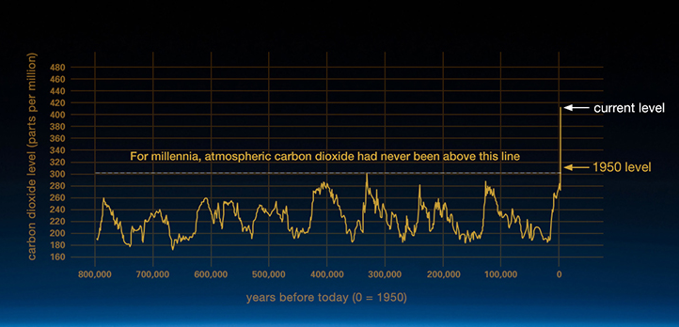
Figure 1: The relentless rise of carbon dioxide during the past few decades (Source: https://climate.nasa.gov)

Changes observed in Earth’s climate since the early 20th century are primarily driven by human activities, particularly fossil fuel burning, which increases heat-trapping greenhouse gas levels in Earth’s atmosphere, raising Earth’s average surface temperature. These human-produced temperature increases are commonly referred to as global warming. Natural processes can also contribute to climate change, including internal variability (e.g., cyclical ocean patterns like El Niño, La Niña and the Pacific Decadal Oscillation) and external forcing (e.g., volcanic activity, changes in the Sun’s energy output, variations in Earth’s orbit) (Source: https://climate.nasa.gov).
Since the pre-industrial period, human activities are estimated to have increased Earth’s global average temperature by about 1 degree Celsius, a number that is currently increasing by 0.2 degrees Celsius per decade. It is unequivocal that human influence has warmed the atmosphere, ocean, and land (Source: https://climate.nasa.gov).
Scientists use observations from the ground, air and space, along with theoretical models, to monitor and study past, present and future climate change. Climate data records provide evidence of climate change key indicators, such as global land and ocean temperature increases; rising sea levels; ice loss at Earth’s poles and in mountain glaciers; frequency and severity changes in extreme weather such as hurricanes, heatwaves, wildfires, droughts, floods and precipitation; and cloud and vegetation cover changes, to name but a few.
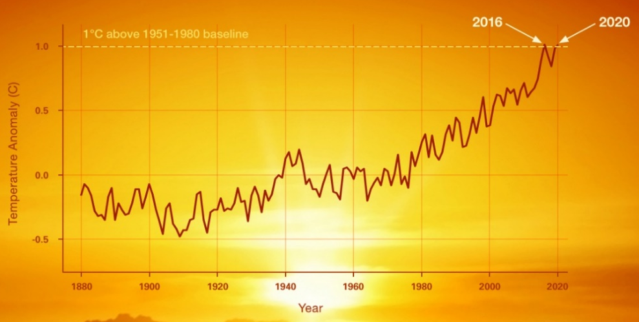
Figure 2: The change in global surface temperature relative to 1951-1980 average temperatures, with the year 2020 tying with 2016 for warmest on record (Source: NASA's Goddard Institute for Space Studies, https://climate.nasa.gov )

1.2 Impact of climate change on agricultural production in BSB
Decrease in suitability for agricultural production. In BSB, excluding the Black Sea cost line, decreases in spring and summer precipitation coupling with the increase in temperature and evapotranspiration will lead to decreases in yield/cultivated area of summer crops like sunflower, corn, rice, bean, chickpea, lentil, sugar beet, cotton, vegetables and fruits beside alfalfa and pastures. In Turkey, for instance, it is predicted that climate change will cause decreases in the yield of some strategically important crops for Turkey, by 8.18% in wheat, 2.24% in barley, 9.11% in corn, 4.53% in in cotton and 12.89% in sunflower by the year 2050. Shortage of forage crops, oilseed crops and legumes will increase with climate change and become more problematic in the medium and long term (Kadıoglu et al. 2017; Dellal et al. 2011).
Water resources will decrease, irrigation water demand and water stress will increase: Due to the climate change the amount of irrigation water needed could be doubled compared to today. Even with irrigation, it is expected that there will be a decrease in the yield of summer plants, as the plants will be exposed to higher and extreme temperatures during the flowering and grain filling period. Beside increases in temperature and decreases in precipitation, prolongation of the crop growing season, decreases in the number of frozen days, soil water deficit in the crop growing season, increases in the frequency and severity of the flood events particularly in the Black Sea coastline will adversely affect the crop production and biodiversity (Kadıoğlu et al. 2017; Konukcu 2019).
Damages due to seasonal shifts: If the temperatures are higher than expected at the beginning of winter or in early spring, it will cause early flowering of plants, especially fruits, and a loss of yield and quality with the frost event to be experienced afterwards. If the cold winters can no longer control them, some diseases and pests can survive or even multiply more and more every year, causing epidemics. As temperatures and humidity conditions change, new diseases and pests can cause damage in areas previously unseen. Even in today's somewhat severe weather conditions (hale, heatwave, heavy rainfall, frost), it is seen that the yield and quality of agricultural production decrease, prices rise excessively and exports decrease. With the changing climate, weed populations that are more competitive than cultivated plants will increase, there will be an obligation to use more chemical pesticides as a result of morphological changes in the plants, which negatively affects the product quality. This will affect human and environmental health negatively (Amare, 2016).
Increased risk as a result of extreme climatic events: prolonged droughts will prolong the fire season and increase the risk of fire. Unexpected heavy rains and increased humidity will cause product quality to decline, sometimes even to a complete loss, grain stagnation and soil erosion. While extreme temperatures will cause a decrease in product quality and yield, hail may lead to a big economic lost.

1.3 Climate change, food security and challenges
To feed an expanding population, the annual world food production will need to increase by 60 percent over the next three decades (Bruinsma 2009). However, the impacts of climate change, which include increasing temperatures, shifting precipitation patterns, more severe and frequent extreme weather events and the loss of ecosystem services and biodiversity, will undermine agricultural production systems and food systems, especially in agricultural communities in developing countries where poverty, hunger and malnutrition are the most prevalent (FAO 2013). The agricultural sectors, which include crop and livestock production, forestry, fisheries and aquaculture, are also a major contributor to global greenhouse gas emissions. According to FAO estimates, in 2010, emissions from the agriculture, forestry and other land use (AFOLU) sector directly accounted for 22 percent of total global emission (FAO 2013). Therefore, agriculture and food systems must improve and ensure food security, and to do so they need to adapt to climate change and natural resource pressures, and contribute to mitigating climate change. These challenges, being interconnected, have to be addressed simultaneously
Therefore, the agriculture sectors need to overcome three intertwined challenges (FAO 2010):
- sustainably increase agricultural productivity to meet global demand;
- adapt to the impacts of climate change; and
- contribute to reducing the accumulation of greenhouse gases in the atmosphere.
To meet these challenges, FAO has developed and promoted the concept of Climate-Smart Agriculture (CSA).

1.4 Definition of Climate Smart Agriculture (CSA)
Climate-smart agriculture (CSA), as defined and presented by FAO at the Hague Conference on Agriculture, Food Security and Climate Change in 2010, contributes to the achievement of sustainable development goals. It integrates the three dimensions of sustainable development (economic, social an environmental) by jointly addressing food security and climate challenges. CSA is based on 3 objectives or pillars (FAO, 2010):
- Productivity/sustainability/food security: CSA aims to sustainably increase agricultural productivity and incomes from crops, livestock and fish, without having a negative impact on the environment. This, in turn, will raise food and nutritional security. A key concept related to raising productivity is sustainable intensification.
- Adaptation: CSA aims to reduce the exposure of farmers to short-term risks, while also strengthening their resilience by building their capacity to adapt and prosper in the face of shocks and longer-term stresses. Particular attention is given to protecting the ecosystem services which ecosystems provide to farmers and others. These services are essential for maintaining productivity and our ability to adapt to climate changes.
- Mitigation: Wherever and whenever possible, CSA should help to reduce and/or remove greenhouse gas (GHG) emissions. This implies that we reduce emissions for each calorie or kilo of food, fiber and fuel that we produce. That we avoid deforestation from agriculture. And that we manage soils and trees in ways that maximizes their potential to acts as carbon sinks and absorb CO₂ from the atmosphere.
Climate-smart agriculture is an approach for transforming and reorienting agricultural production systems and food value chains so that they support sustainable development and can ensure food security under climate change. This does not imply that every practice applied in every location should produce 'triple wins' that deliver positive results for each of these three objectives. Rather the climate-smart agriculture approach seeks to reduce trade-offs and promote synergies by taking these objectives into consideration when agricultural producers, policy makers and researchers make decisions at the local, subnational, national and global levels about short- and long-term strategies to address climate change.
CSA builds on sustainable agriculture approaches, using principles of ecosystem and sustainable land and water management and landscape analysis, and assessments of the use of resources and energy in agricultural production systems and food systems. This is particularly important in developing countries, where agricultural growth is generally a top priority.

1.5 Sustainable production under CSA
For each crop system, there are countless climate change adaptation and mitigation options that can sustainably improve yields and minimize the harmful environmental impacts of production. They will differ for each farming household, depending on its coping and adaptive mechanisms. Management practices and technologies for climate change adaptation and mitigation include practices with an explicit focus on adaptation and practices with a broader scope on reducing production risks and reducing emissions. Specific climate-smart approaches to crop production include:
- increasing diversity and complexity within the agricultural ecosystem, which can be done in many ways (e.g. expanding the diversity of crops or crop varieties), at many spatial scales (e.g. landscape level, within farms, and/or within the same crop) and over different timeframes;
- improving sustainable soil and land management (e.g. carefully channelling the expansion of crop and grazing land to mitigate the loss of carbon storage that results from land-use change);
- increasing energy use efficiency; promoting sustainable mechanization (e.g. increasing the availability of suitable machinery in combination with proper agronomic management to reduce greenhouse gas emissions from various farm and processing operations); and
- developing simple and robust scientific tools to guide the decision-making of farmers on a seasonal and long-term basis.
The detailed information on the subject of sustainable production under CSA is given in Module 3: Managing sustainable farms.

1.6 Adaptation strategies to climate change impacts
Adaptation to climate change requires taking the right measures to reduce the negative effects of climate change (or take advantage of the positive ones) by making appropriate adjustments and changes. The Intergovernmental Panel on Climate Change (IPCC 2007) defines adaptation as adjustments to natural or human systems in response to actual or anticipated climatic stimuli or effects that reduce harm or take advantage of beneficial opportunities. It also refers to the actions taken by people, countries and societies to adapt to the occurring climate change. Adaptation has three possible goals: to reduce exposure to the risk of harm; develop the capacity to cope with inevitable harm; and to take advantage of new opportunities (Akinnagbe and Irohibe 2014).
The measures that can be taken for adaptation to climate change impact in BSB can be listed as follows.
- Plant variety/species selection or breeding
- Crop diversification
- Change in cropping pattern
- Change in calendar of planting
- Mixed cropping
- Improvement in water and irrigation management
- Adapting soil, soil water and energy conservation measures
Plant variety/species selection or breeding:
The easiest way is to select crop varieties of any species resistant to unfavourable climatic condition (heat wave, drought), to diseases and pests. In BSB, lodging as a result of excessive precipitation, rust under humid condition and heat stress under heat wave are common problem decreasing wheat yield and quality as a result of climate change. Among the existing cereal varieties, varieties with shorter stems (against lodging) and resistant to heat wave and diseases can be selected. However, the selected resistant new varieties may not always guarantee the high yields as the previous ones. As for the sunflower, another strategic crop for BSB, selection of drought and high heat resistant or early varieties may be considered.
Another alternative is to prefer plant species that are resistant to drought. For example, wheat requires significantly less (irrigation) water compared to dry season rice or corn. Against the shortage in summer precipitation and increasing heat waves, winter plants might be preferred instead of summer plants: wheat to corn, canola to sunflower etc.
In addition to extreme climatic conditions (high temperature, drought, frost, etc.), disease and pest resistant varieties should be improved using local genetic resources and developing technologies in this area. Special duties and required support should be given to Agricultural Research Institutes and Universities. Public-private sector cooperation should be ensured.
Crop diversification:
Crop diversification could be an effective adaptation option under extreme temperature, frequent and intensive flood, cyclone and other natural disasters due to climate change became acute and expecting to be severe in future as it protects natural biodiversity, strengthening the ability of the agroecosystem to respond to these stresses, minimizing environmental pollution, reducing the risk of total crop failure, reducing incidence of insect pests, diseases and weed problems and secure food supply opportunities and also providing producers with alternative means of generating income. It provides better conditions for food security and enables farmers to grow surplus products for sale at market and thus obtain increased income to meet other needs related to household well-being. Farmers needs to gain knowledge and skills in affected areas about crop-production techniques, integrated farming systems (including crop rotation and intercropping), and climate resilient production techniques. It can be implemented in a variety of forms and at a variety of scales, allowing farmers to choose a strategy that both increases resilience and provides economic benefits.
Crop diversification can improve resilience in a variety of ways: by engendering a greater ability to suppress pest outbreaks and dampen pathogen transmission, which may worsen under future climate scenarios, as well as by buffering crop production from the effects of greater climate variability and extreme events. Such benefits point toward the obvious value of adopting crop diversification to improve resilience, yet adoption has been slow (Lakhran et al. 2017).
Diversification towards high value crops is feasible in the medium to long term. Crop diversity is a high priority adaptation measure in both irrigated and non-irrigated areas. Considering the climate change projection in BSB, drought and heat resistant alternative legumes, forage crops and oil crops should be included in the rotation.
Change in cropping pattern:
Cropping systems are increasingly simplified, with fewer and fewer crop species grown in rotation from year to year. But diverse rotations provide higher crop yields compared with continuous monoculture, in particular in years with low precipitation and high temperatures. Swedish, Polish and Italian researchers found this by analysing cereal yield data collected for decades from long-term agricultural field experiments from southern to northern Europe. Diversifying crop rotations emerges as an adaptation to a forthcoming warmer and drier climate. Crop rotation or diversification has been suggested as a general strategy to sustain yields and reduce risks of yield losses from adverse climatic conditions, through improved soil fertility, enhanced beneficial soil biota and suppressed build-up of weeds, pests and diseases. “But the trend in major cropping systems worldwide is that we grow cereals in shorter and shorter rotations, and in some places even in continuous monoculture” Growing multiple crop species in a year-to-year rotation always gave higher yields compared with a continuous monoculture. The average yield gain with rotation was 860 and 390 kg/ha in autumn- and spring-sown cereals, respectively. In spring cereals the benefit of a diverse rotation increased without plateauing over time since the beginning of the experiments, reaching a gain of 500 kg/ha after 50-60 years. The benefit of a diverse rotation was stronger in hot and dry years, a condition that is predicted to become more frequent with climate change (https://www.slu.se/en/ew-news/2020/11/crop-rotation-a-promising-way-to-improve-food-security-under-a-changing-climate/).
In BSB, forage crops (such as sainfoin, vetch) can be used as a ground cover plant in the rotation, and the organic matter content can be enriched by mixing with the soil before planting sunflowers, or if it is harvested for feed, then the second crop corn can be put into the rotation as is practiced in the Thrace Region of Turkey.
Change in calendar of planting:
Planting dates should be carefully adjusted to take advantage of precipitation effectively and to get rid of drought and diseases/pests. Shifting the planting time to November in order to prevent yellow dwarf disease in Thrace/Turkey and adjusting the planting time of sunflower in early spring in order to benefit from the rainfall at the highest level are good examples for this measure.
Mixed cropping:
Mixed cropping involves growing two or more crops in proximity in the same field. Mixed cropping, typically a mixture of legumes and cereals or tuber crops, is a common practice in marginal agroecological environments, which fulfills a variety of functions, including complementary use of growth factors, such as soil nutrients, light, and water; reduced pest and disease incidence, reduced soil erosion, more total biomass production, more yield stability, and more household food security. Furthermore, the mixtures can be flexibly adjusted to conditions such as late or early onset of the rainy season or status of soil fertility in different fields. In BSB countries, annual crops may be planted between the orchard trees when they are young.
Improved water and irrigation management:
More than 70% of renewable fresh water resources are used for irrigation purposes. About 15% savings in irrigation water is equivalent to the household water requirements. The average water usage efficiency in the world is very low 40% and 35%.in Turkey. In any case efficiency can be increased by 10-50% by Selection of plants with high water use efficiency and economic value, focusing on drought and salinity stress studies, preference of piped systems in water transmission, preference of high efficiency (drip if possible) irrigation systems and application of deficit irrigation technique.
Deficit irrigation is when the irrigation water applied to a crop is less than required to meet full crop water requirements resulting in evapotranspiration (ET) less than the maximum crop ET. For a few crops and conditions, irrigation is intentionally reduced to attain a desired plant response or product characteristic or quality, for example, to reduce vegetative growth, increase fruit quality and value, induce maturity, or facilitate harvest. However, in most cases, deficit irrigation results in reduced yield and gross income. Deficit irrigation may occur due to water delivery or application constraints or errors in scheduling irrigations, or it may be an intentional management practice to maximize net income under conditions of an inadequate or expensive water supply (Trout and Martin 2020).
Limited or expensive water may motivate changing the production goal from maximum yields and gross income per unit area to managing for acceptable yields that maximize economic returns within the water supply constraints.
Water supply limitations may be long-term and predictable or short-term and unanticipated. The planning horizon for deficit irrigation management determines the available options. Awareness of long-term limitations allows the producer to make land and infrastructure investments appropriate to the water supply. When seasonal limitations are known before annual investments are made for preparing and planting fields, operating costs can be adjusted for the anticipated water supply. Unexpected water supply limitations may occur during the season due to lack of precipitation, overestimate of the water supply, or failure of water delivery systems. Unanticipated in-season supply shortages limit the ability to adjust production costs but still allow water supply redistribution among crops and areas, such as abandoning planted fields or portions of fields to concentrate irrigation water on remaining land (Trout and Martin 2020).
Knowledge of a crop’s response to water is required to make rational deficit irrigation management decisions. The crop water production function describes the relationship between crop yield or value and the amount of water used. The basic water production function relates biomass produced to plant transpiration. Previous studies found that plant biomass increased nearly proportionally with the amount of water transpired relative to evaporative demand. The water production function varies with the crop and variety, climate, soil, and management practices. Crop water productivity and return after variable cost for the major crops (or alternative crops) grown in the BSB countries may be evaluated based on simulated yield using the Decision Support System-Cropping System Model. The most profitable crops should be determined under deficit and full irrigation condition. Water production functions are used with economic parameters to maximize net income with deficit irrigation. Deficit irrigation may maximize net income when irrigation water supplies are limited or expensive (Trout and Martin 2020).
Most of the irrigation water losses, up to 15%, are due to seepage and evaporation losses from open canals with low transmission capacity. These canals must be soon converted to a tubular system that minimizes water transmission losses. The saved water can be used in other sectors or it will be possible to irrigate extra agricultural land. Otherwise, water losses will continue to cause salinization and groundwater problems, reduce the productivity of soils, and pollute ground and surface waters.
On the other hand, the irrigation method applied has a significant effect on the amount of water lost. Water losses according to different irrigation methods are as follows (%): surface irrigation is 20-70, sprinkler irrigation is 20-35, central pivot irrigation is 10-20 and drip irrigation is 5-15. In Turkey, 82% of the existing irrigation systems are surface irrigation, 16% are sprinkler irrigation and only 2% are drip irrigation.
While traditional surface irrigation systems are replaced with the high efficiency pressurized irrigation (drip and sprinkler) systems, energy requirements of these systems must also be accounted, and the sustainable energy sources, wind and solar, should be preferred.
Adapting soil, soil water and energy conservation measures:
Better residue management and mulching techniques, no or minimum tillage farming and increased soil organic matter may be considered among the soil, soil water and energy conservation measures.
Crop residue is defined as the portions of crops remaining such as stems, leaves and roots, some fallen grain, and often some weeds in the field after the grain has been harvested. Crop residues may have a direct monetary value to the farmer for livestock feed as well as a value for soil and yield improvement that varies widely according to the environment. Additionally, crop residue retention is one of the components of conservation agriculture (CA), along with zero or minimum mechanical disturbance and crop rotation (Anderson and Siddique, 2015) and is assumed to have value in erosion control, in building soil organic carbon (SOC) (Anderson and Siddique 2015) and in improving or maintaining soil fertility (Lal 2010) which presumably increase or sustain crop yield in the longer term.
In theory, under a better residue management conditions, increased water infiltration and reduced soil evaporation will lead to increased crop yield which, in the absence of other limiting factors, will lead to increased return of organic matter (Anderson and Siddique, 2015). Storage of limited rainfall in the soil during the fallow period after the harvest may be crucial for the soil moisture annealing, germination and emergence of the seed in the early stages of the next cropping season. Crop residues can help this in the ways of increased water infiltration (Schwilch et al. 2013) and reduced soil surface evaporation, i.e. mulching effect of residue (Sommer et al. 2012).
There are scientific evidences (Loss et al. 2015) that no-till systems with stubble retention increase soil organic matter in comparison to the conventional tillage. The increase of organic matter in the soil improves the physical properties of the soil and accelerates the infiltration of rainwater into the soil. In addition, by increasing the water holding capacity of the soils, it prevents the infiltration of water below the root zone and therefore crops benefited from the limited rainwater effectively. Climate change forecast in Turkey suggest that rainfall characteristic will change, i.e., the number of consecutive dry days will increase and very heavy rainfall will occur at one time. Under these conditions, the increase of soil organic matter provides maximum benefit from this irregular rainfall and prevents soil erosion to a significant extent.
Although there are research results showing that residue affects the plant yield negatively (Scott et al. 2010), it is stated that it generally increases (Schwilch et al. 2013). Farooq et al. (2011) found that the impact of conservation agriculture (including both zero tillage and residue retention) on crop yields was mostly positive, especially at lower rainfall, but suggested that where the yield of conservation agriculture crops did not exceed those of conventional systems, factors such as weeds and diseases may have been responsible.
Minimum tillage and direct seeding practices contribute significantly to energy saving therefore to the environmental protection and climate change mitigation.
Minimum tillage and direct seeding is practiced in summer corn as second crop for silage after harvesting wheat, barley, vetch or pea in about 3.000 ha area in Trakya region of Turkey for the last 10 years to keep soil water, increase organic matter, decrease cost of seeding and use time effectively. The local companies have started to manufacture pneumatic direct sowing machine. While the direct sowing of maize is increasing day by day, direct sowing of sunflower is expected to be widespread in the near future (Figure 13).
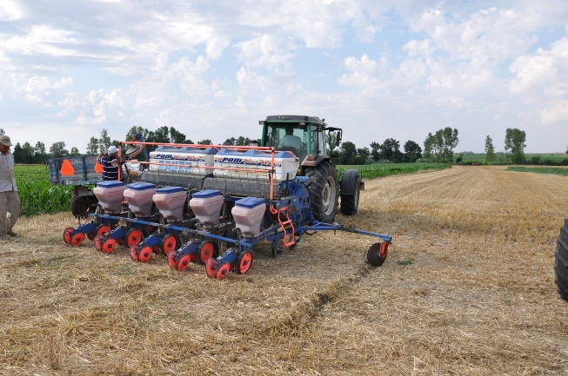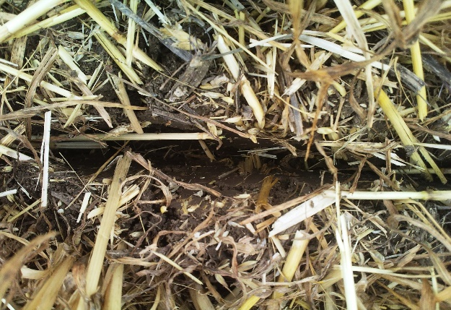
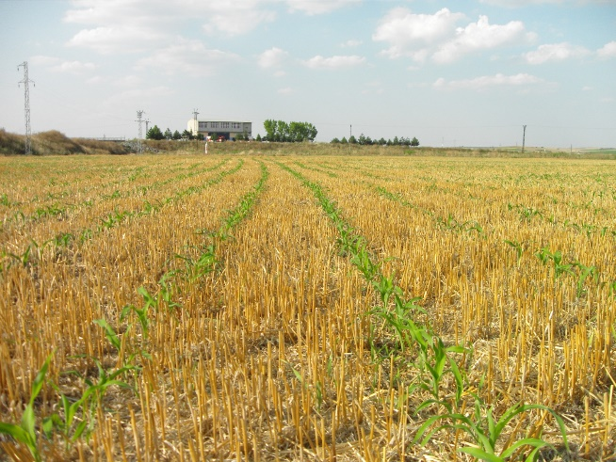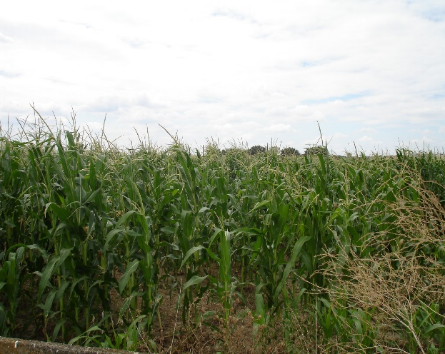
Figure 3: Direct sowing of summer corn as second crop for silage after wheat harvest in Trakya region (Photos were obtained from Ekmen Farming Inc.’s owner, Agricultural Engineer Irfan Ekmen)

1.7 Approaches to increase competitiveness in agricultural sector, ensure sustainability and mitigate climate change under CSA
Previous research on agriculture has focused only on economic impacts, but today agricultural system performance is considered multidimensional, taking into account the economic, environmental and social dimensions and the interaction between these dimensions. Technological developments, environmental sustainability and competition have led to the emergence of CSA, Organic Farming (OF) and Good Agricultural Practices (GAP), precision agriculture, digital agriculture, vertical agricultural practices and smart greenhouses besides traditional agriculture.
OF and GAP practices:
OF is expressed as a production system that protects human health and ensures the continuity of the ecosystem. This system is based on ecological processes, biodiversity and cycles adapted to local conditions, rather than the use of inputs with adverse effects. Although there are chemical input applications in GAP, these applications are applied in a way that does not harm human health and the environment. The development of sustainable agricultural systems is seen as a priority target in the prevention of environmental problems in the world. OF and GAP contribute to preventing climate change as well as environmental sustainability. In BSB country, GAP can be made very common in a short time.
Precision agriculture:
Precision agriculture is a management strategy that gathers, processes and analyzes temporal, spatial and individual data and combines it with other information to support management decisions according to estimated variability for improved resource use efficiency, productivity, quality, profitability and sustainability of agricultural production. By using different technologies such as drone, GPS and IoT, it can continue the planning, planting, irrigation and harvesting processes with minimum manpower and minimum resource usage, thus creating maximum product efficiency. In order for precision agriculture to be widely used in BSB countries, it is necessary to transform agricultural enterprises into medium and large enterprises and to increase the education level of farmers.
Vertical farming:
It is the practice of growing crops in vertical layers. It combines hydroponic farming techniques such as hydroponics, aquaponics and aeroponics, and controlled-environment farming aimed at optimizing plant cultivation. Vertical agriculture can produce more products with less unit land requirement. Also, since products are indoors, they suffer less losses in extreme or unexpected weather events. Vertical farming technologies have large initial costs compared to conventional farms. The energy requirement is high. If solar or wind energy is not used, it harms the environment more than conventional agriculture and can cause climate change.
Smart greenhouses:
Using solar, wind and geothermal energy or hot water released in industrial production can be used to heat fully automated hydroponic smart greenhouses. In this way, there is an opportunity to make long-term agricultural production without being dependent on climatic conditions.
The prevalence of CSA, OF and GAP, precision agriculture, digital agriculture, and vertical agricultural practices in BSB countries will ensure competitiveness in agricultural production, protection of the environment, adaptation to the negative effects of climate change and prevention of climate change. In addition, they can contribute to the development of new industries related to these systems, to increase employment, to ensure sustainable socioeconomic development and food security.

1.8 Institutional aspect of climate smart agriculture implementation
How can institutions support CSA?
Institutions can support farmers, particularly smallholder, in the implementation of CSA in three vital areas (FAO 2013):
- Producing and sharing technical knowledge: For relatively resource-poor smallholder farmers, putting CSA into practice requires knowledge and support. Farmers need easier and more affordable access to the information that underpins innovative CSA practices. Institutions that produce and share information and help people translate this information into knowledge and action are essential.
- Providing financial services, credit and access to markets: The benefits gained by adopting CSA usually take time to realize. In the meantime, the farmers must bear the costs in terms of labour, land and cash. As a result, poor farmers lacking access to credit and markets are unable to adopt these techniques. This is why strengthening institutions to support agricultural markets, financing mechanisms and insurance schemes are critical for the CSA’s success.
- Supporting the coordination of collaborative action: Collective action is critical for managing communal forests and pastures and lowering transactions costs. Many CSA activities are only feasible and affordable if people work together (e.g. improved water or rangeland management). Institutional arrangements that make groups function efficiently and effectively are essential. On a larger scale, institutional arrangements are also needed to facilitate coordination across organizations and sectors (e.g. through networks and knowledge-sharing platforms).
Key institutions for CSA initiatives:
Successful changes in agricultural practices, technologies or policies are possible when dialogue and cooperation is encouraged among all the stakeholders who possess, produce, or use different kinds of knowledge. The most effective initiatives allow researchers, community members, private sector actors and policy-makers to jointly define the problems they aim to solve (FAO 2013).
Under changing climate, two types of advice are needed: firstly, information about available options (e.g. technology and market) to help adapt farming and livelihood systems; and secondly, information about the climate itself, in the form of weather forecasts, seasonal forecasts and longer-term climate trends. Preference should be given to early warning and early action initiatives rather than find out solution during the disaster such as drought, flood and etc. (FAO 2013).
Roles and responsibilities, as services provider or as stakeholders, of public sector institutions, civil society, non-governmental organizations, universities and research institutions, the media, private sector institutions, individual farmers, producer cooperatives, national and international agribusinesses, commercial consultancies, banks, credit and savings institutions, purchasers of carbon credits should be defined.
For the synergy to facilitate interaction and communication between many individual institutional actors, a conducive environment needs to be created. This ‘institutional interplay’ should not only be ‘horizontal’, taking place on the same organizational level, but also integrate institutions ‘vertically’, incorporating perspectives across traditional levels and hierarchies (FAO 2013).
Because of the many institutional interactions involved, CSA initiatives requires reliable networks to support information exchange and partnership-building. Equity issues and cultural considerations should also be tackled with.

Bibliography:
Akinnagbe .M and Irohibe I. J (2014). Agricultural adaptation strategies to climate change impacts in Africa: a review. Bangladesh J. Agril. Res. 39(3): 407-418.
Amare, T. (2016). Review on Impact of Climate Change on Weed and Their Management. American Journal of Biological and Environmental Statistics. Vol. 2, No. 3, pp. 21-27. doi: 10.11648/j.ajbes.20160203.12.
Anderson, W.K and Sıddıque K.H.M (2015). The role and value of crop residues in dryland agriculture. Indian Journal of Agronomy 60 (3): 332-340.
Bruinsma, J. 2009. The resource outlook to 2050. Expert Meeting on How to Feed the World in 2050. FAO, Rome.
Dellal, I., McCarl, B.A., Butt, T. (2011). The Economic Assessment of Climate Change on Turkish Agriculture, Journafl of Environmental Protection and Ecology, Vol: 12, No: 1, 376-385.
Farooq, M. and Siddique, K.H.M. (2015). Conservation Agriculture: Concepts, brief history, and impacts on agricultural systems. (In) Conservation Agriculture, Farooq, M., Siddique, K.H.M. (Eds.), p. 3–17, Springer International Publishing Switzerland.
FAO. 2010. “Climate-smart” agriculture: policies, practices and financing for food security, adaptation and mitigation. Rome.
FAO. (2013). Climate Smart Agriculture Sourcebook. Rome. https://www.fao.org/climatechange/37491-0c425f2caa2f5e6f3b9162d39c8507fa3.pdf. f
Intergovernmental Panel on Climate Change. (2014). Climate change 2014: impacts, adaptation and vulnerability. Contribution of working group II to the fifth assessment report of the Intergovernmental Panel on Climate Change. Cambridge, United Kingdom and New York, NY, USA: Cambridge University Press.
Kadioglu, M., Unal, Y, Ilhan, A. and Yuruk, C. (2017). Türkiye’de İklim Değişikliği ve Tarımda Sürdürülebilirlik. Türkiye Gıda ve İçecek Sanayii Dernekler Federasyonu Yayını. https://www.tgdf.org.tr/wp-content/uploads/2017/10/iklim-degisikligi-rapor-elma.compressed.pdf.
Konukcu, F., Albut, S. Ve Altürk A. (2019). TR21 Trakya Bölgesinde İklim Değişikliğinin Etkileri ve Uyum Stratejileri. Namık Kemal Üniversitesi Yayınları No: 2.08-027-0030/A-I, 46-60.
Lakhran, H., Kumar, S., and Bajiya, R., (2017). Crop Diversification: An Option for Climate Change Resilience. Trends in Biosciences 10(2), 516-518, 2017.
Lal, R. (2010). A dual response of conservation agriculture to climate change: reducing CO2 emissions and improving the soil carbon sink. (In) Proceedings of the European Congress on Conservation Agriculture-Towards Agro-environmental Climate and Energetic Sustainability, Madrid, Spain, 4–7 October 2010. pp. 3–18.
Loss, S., Haddad, A., Khalil, Y., Alrijabo, A., Feindel, D. and Piggin, C. (2015). Evolution and adaptation of conservation agriculture in the Middle East. (In) Farooq, M., Siddique, K. H.M. (Eds.) Conservation Agriculture. Springer International Publishing Switzerland. pp. 197–224.
Schwilch, G., Laouina,A., Chaker, M., Machouri, N., Sfa, M. And Stroosnijder, L. (2013). Challenging conservation agriculture on marginal slopes in Sehoul, Morocco. Renewable Agriculture and Food Systems: available at http://journals. cambridge.org/action/displayAbstract?fromPage=online&aid=9095422.
Sommer, R., Piggin, C., Haddad, A., Hajdibo, P., Hayek, P. And Khalil, Y. (2012). Simulating the effects of zero tillage and crop residue retention on water relations and yield of wheat under rainfed semiarid Mediterranean conditions. Field Crops Research 132: 40–52.
Trout T.J, and Martin D.L. (2020). Deficit Irrigation Strategies for the Western U.S. American Society of Agricultural and Biological Engineers. 63(6): 1813-1825.

Module 2: Climate-resilient agro-food value chains

2.1 The essence of the concept of Value chain and its key parameters.
The formation and actualization of the concept of value chains was a result of the market globalization on the one hand, and the need to increase business efficiency to deliver the most value for the least possible cost.
The value chain approach was first used by Michael Porter in 1985 and serves to increase competitiveness and, in particular, to achieve high performance results and ensure their sustainability. The basic premise of this approach is to integrate the full chain of business activities in creation of a product or service – from the initial reception of materials and all the way through its delivery to market, including everything in between.
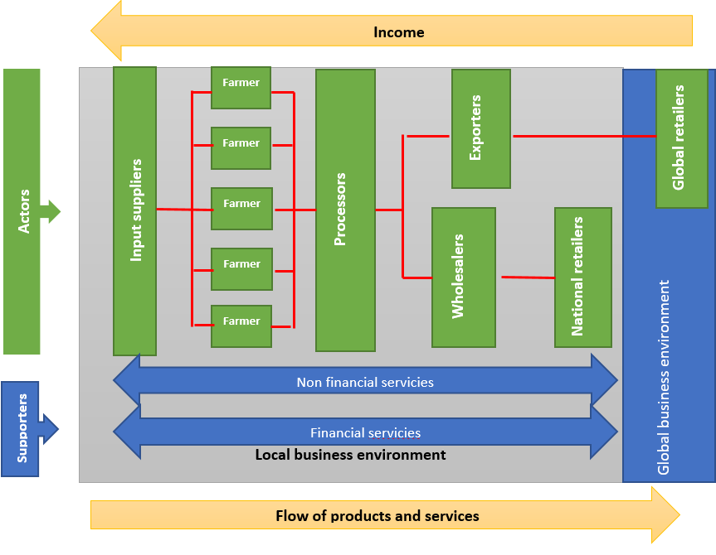
Local Business Environment
Income
Flow of products and services
Financial services
Non financial services
Global Business Environment
Supporters
Farmer
Farmer
Farmer
Farmer
Farmer
Exporters
Wholeselers
National Retailers
Global Retailers
Processors
Input suppliers
Actors

2.2 Principles of building a Value Chain structures (stages/partners)
The structure of any value chain consists of interconnected players, some of whom perform a direct function of delivering a product or service and are called "players", while others have a supporting function that affects the overall efficiency and are called "support service providers".
Value chain study involves the study of the sequence of operations that results in the creation of value for a product or service and the increase in that value at different stages. Value growth refers to the contribution of a particular stage in the preparation of this product / service and represents the difference between revenue and expenditure. It should be noted that this value is not created instantly and represents the accumulated value that it will acquire after going through all stages of production.
In order to understand a value chain approach, it is necessary to study the market system as a whole, in particular to find out what kind of players are represented in this system (starting with suppliers of products and ending with end users), what kind of supporting organizations operate (technical, financial and other services) and general business environment (political, social, economic, legal, etc.) around specific segments.
What determines the competitiveness of value chains:
- Focus on the end market. It is the end market that determines how profitable a particular industry will be and how far it can develop, what requirements it has for product quality. Typically, a value chain may have several end markets, and to better meet demand, it is important to segment the market. Because end markets are constantly changing, information about them must be constantly updated;
- Major players. The key players in the value chain are its foundation and determine its competitiveness. What matters is their quantity, financial strength, production potential and qualifications, as well as geographical distance and possibly other additional characteristics that may affect the functioning of the overall value chain;
- Value chain management principles. Value chain management principles determine the standards by which a particular value chain operates and what the relationships are between the players in the chain. Distribution of power and profits between players is also an integral part of this principle. A value chain management model can determine whether it is possible to integrate a value chain operating by the regional standards into the global market;
- Inter-connection between players. The principle of management in value chains leads to the need for coordinated actions between their players. Therefore, the quality of the relationship in the value chain is of great importance and depends on trust and willingness to cooperate, which implies the existence of mutually beneficial relationships. Therefore, the value chain approach is aimed not only at solving specific production or marketing problems, but also at transforming the relationships of the players involved in the value chain in order to work together, to adapt to new conditions and maintain competitiveness;
- Business environment. Value chains are created and operate in a certain environment, which affects both their participants and structures. The business environment includes the legal, economic, political, social and cultural norms and rules, as well as other aspects, such as road infrastructure and others. It should be noted that in the event of an unfavorable business environment and the inability to rectify it, there may be a need to eliminate the entire value chain;
- Support services. Support services, as already mentioned, consist of financial and non-financial services and play a major role in strengthening both the value chain and its participants. These can be formal or informal companies, government representatives, financial institutions, research institutes, media representatives, individuals and others.

2.3 Types of value chains and their composition
The value chain structure for a particular product depends on the logistical capabilities that are available to deliver the product to the specific target markets and should also take into account the essential requirements that need to be considered and met. Logistics sets out the task of delivering the product efficiently from manufacturer to customer and considers the following seven tasks described in the below chart:
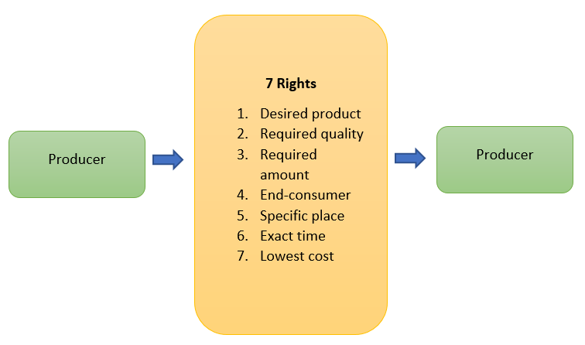
The value chain approach expands the list of these tasks and already includes the stages of product planning and efficient and cost-effective production.
Producer
Producer
7 Rights:
- Desired product
- Required quality
- Required amount
- End-consumer
- Specific place
- Exact time
- Lowest cost
Therefore, value chains for the same product can vary, depending on the markets they are intended to be sold.
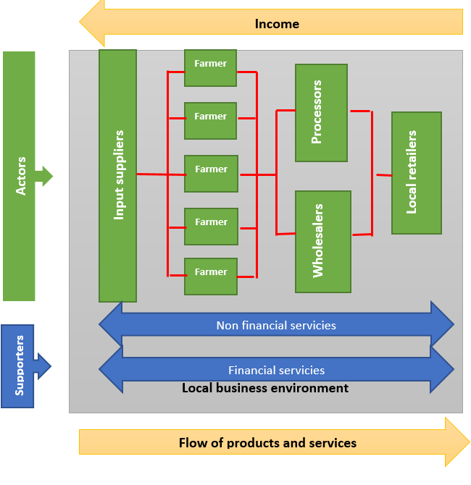
In order to supply products to local markets, the value chain may have the following structure, taking into account the requirements of that market.
Farmer
Income
Local Retailers
Processors
Actors
Input suppliers
Farmer
For example, in the domestic markets of developing countries, product certification may not be required and documentation provided by relevant Food Safety or Phytosanitary Inspection may be sufficient. Therefore, the value chain built for internal markets should include the provision of non-financial services, such as the conformity documentation of relevant agencies.
Local Business Environment
Supporters
Non financial services
Financial services
Wholeselers
Farmer
Farmer
Farmer
Flow of products and services

Local Retailers
Local Business Environment
Supporters
Non financial services
Financial services
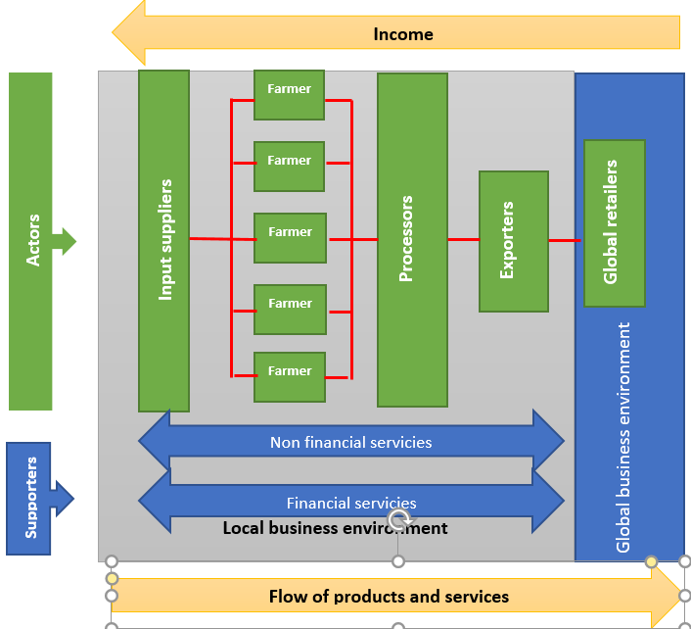
Value chains for international markets, unlike locals, should take into account both the local business environment and its requirements, as well as the requirements of the country where the product is planned to be delivered. Therefore, if there are different regulations in the target market (for example, the requirement of a certain certificate, packaging, labelling, transportation, etc.), the value chain should include provision of non-financial services that ensure that these requirement is met.
Processors
Input suppliers
Actors
Supporters
Global retailers
Financial services
Non financial services
Exporters
Farmer
Farmer
Farmer
Farmer
Farmer
Global Business Environment
Income
The standard of living of the rural population and farmers is directly related to the effective functioning of agricultural value chains, including climate-smart agriculture, which offer new opportunities to farmers today. If traditional value chains already have a more or less well-established structure, the latter requires its potential participants to develop strategic planning skills for analyzing perspectives and using these perspectives to develop new structure.
Local Business Environment
Flow of production and services

What aspects should be considered during creating value chains in climate-smart agriculture?
Issues to consider:
- At the level of end market: Based on the analysis of market research, the end markets will be prioritized, what the requirements are for particular markets in terms of product quality, as well as volume and supply;
- At the level of players: The first step is to determine what type and how many players are needed to meet the market demand, to what extent is it possible to meet quantitative and qualitative demand, what potential do players have to meet demand and what are the gaps that need to be addressed / eliminated at all stages of the value chain. It is also important at this stage to identify the key players who will potentially benefit most from the launch of the planned value chain and who are likely to have the highest motivation;
- At the level of Value Chain Management Principle: In the process of establishing value chain management principles, it is essential to consider the end market requirements for the product / service. These requirements can apply to both qualitative and quantitative aspects. Requirements should be formulated for all stages of the value chain, should be specific and verifiable. The management principle should also include in-demand control mechanisms for all stages of the value chain;
- At the level of interconnection between players: Establishment of interconnection between players is preferably contractual in nature. However, given that at the level of small farmers (who usually make up the majority of the agricultural sector in developing countries) this may become impractical. Alternatively, rules for participating in the value chain may be developed, which will be easily accessible to all players and will reflect a list of requirements that must be met at all stages of the value chain.
- At the level of the business environment: Analyzing the business environment is one of the most important issues in deciding whether to start any business. In case of agricultural business, in addition to legislative, political and social issues, natural environment – soil and climatic conditions must be taken into account, without which it is impossible to produce agriculture products. It should be noted that even if there is only one unfavorable environment in the business environment, the value chain as a whole can be at insurmountable risk;
- At the support service level: Support service analysis allows to determine what external assistance will be available for the individual stages of the value chain, as well as for the whole cycle. It should also be noted that if the support is feasible and used effectively, it will be possible to reduce the costs along the value chain, but the absence of such support cannot be a precondition for stop the creation of a value chain.
- Profitability forecast: The profitability forecast should be based on a detailed financial forecast, which should be made both for the value chain as a whole and for its individual stages, and it is an indicator of the motivation of the players involved in it. We should also keep in mind that the results of the financial analysis should be harmoniously integrated into the principles of value chain management in terms of profit distribution among players, to ensure that all actors are interested in participating in the value chain.

2.4 Principles of evaluating effectiveness of the Value Chains (stages, volumes and profitability, SWOT analysis)
The main objectives of the value chain analysis are to clarify the following issues:
- Relationships between key players of the value chain and their relationship to the economic and social profit provided by this value chain;
- Motivation;
- Decision-making.
To do this, we need to carefully study the existing or plan a new value chain and take into account the following steps in the process:
- Study the sequence of actions and mark decision points;
- Study the participants conducting these activities;
- For each action, study the input and output data (costs, resources, incomes, etc.);
- Define criteria for entering and exiting the value chain (minimum production volume, ability to meet standard requirements, compliance rules, etc.);
- Study how different actors relate to each other;
- Study information flows throughout the process;
- Learn the rules and regulations related to the value chain;
- Study the quantitative indicators of the processes in the value chain (number of steps, time required for each step and financial indicators).
There are different methodologies for value chain analysis, and most of them need the involvement of highly qualified experts or even a special company, but it is also possible to carry out a rapid analysis with own efforts and small costs. This methodology includes the following actions:
- Inquiry of several stakeholders at all steps of the value chain;
- Conduct group meetings for the participants of different steps of the value chain.
During individual surveys and group meetings, information should be collected on the economic and time costs of individual links in the value chain, on the relationship between participants, on the norms and rules for participating in the value chain, etc. It is desirable that after the survey, the value chain is presented schematically or in as a diagram, and on top of it were indicated both input and output quantitative data, as well as time costs and relationships. This makes it easy for all stakeholders to understand the current situation.
Also, SWOT analysis of the entire value chain should be prepared, where the results obtained from the study will be reflected. It is desirable to conduct the stakeholder survey as after the analysis of individual survey results and provide them the opportunity to discuss the critical points/steps of the process identified during individual surveys.
It should be noted that during the survey of the participants of the value chain, we should bear in mind that it is possible that among the respondents you will have competitors (for example, different farmers producing the same product) or opposing participants at different steps (raw material suppliers and processors), so the information provided may not be related or even contradict each other. The existence of such cases directly points to the inferior relations in the value chain and requires a separate study and analysis.

2.5 Measuring results and fine-tuning.
Based on the information obtained as a result of the analysis, it is necessary to highlight the steps with the greatest financial and time costs, those relations where there are no clearly established relationships, and these stages should be discussed and analyzed separately in order to determine how financial costs can be reduced and to what extent (technological retooling, changes in process management, etc.); How it is possible to reduce consumed time, how much it is possible and what it will cost (change in the sequence of processes, re-sharing of responsibilities, technological retooling, etc.) and what kind of relationships can be established where these relationships are either not clearly defined, or do not correspond to the needs, based on survey results.
The information obtained from the analysis of the value chain allows us to assess at which step of the value chain there is a gap that hinders the development of the business as a whole, and which steps need to be reviewed and improved. When it is necessary to reorganize the value chain, the consultant should always keep in mind that:
- Changes or offers must be understandable and acceptable to all;
- All participants must have a financial interest in participating in the value chain;
- Obligations imposed on participants should be executable.
Conducting a value chain analysis using these principles and approaches enables the stakeholders to periodically and at low cost conduct an analysis and take timely corrective actions to maintain or improve efficiency.

2.6 Case study
Please explore the given examples as case studies and execute the tasks according to the instructions.

Case study 1 – Planning a specific type of Value Chain
Description of the initial situation:
Organic wine production has been launched by 10 small organic wine producers, who produce one type of wine each. Wine cellars are located in different regions of the country, and the market for this type of product is located in a big city. Experts rate highly the quality of their wines. The volume of production of all wine cellars is small. The price added by the shops is too high, so the final price rises significantly, and sales fall.
The task for the consultant is to ensure sales growth.
The process of value chain analysis and planning
SWOT analysis identified the following key challenges and opportunities:
Contributing factors | Interfering factors
The consumer is interested in buying quality wine, different from the industrial one. | There is no organic wine distribution company.
The organic wine market exists and its main part is located in a big city (the capital of the country). | The shops are not interested in cooperation with small entrepreneurs with a limited assortment and require regular and small volumes of products.
The conclusion of experts about the quality of the wine is positive. | Wine cellars are located in the regions, which complicates and increases the cost of delivering products to the market.
The results of the SWOT analysis clearly show that the cause of the problems of all producers is inefficient distribution and logistics.
Value chain development potential and the expected result:
The task of the consultant is to offer to producers the optimal strategy for value chain development on the basis of the identified problem. The proposed solution may be one of the following:
- Establish a cooperative relationship with an existing wine distribution company to develop another products’ segment;
- Create a joint distribution company, which will deal only with the placement of products of different quality on the market;
- Establish a jointly owned sales point on the main market.
All of the strategies mentioned have both, advantages and disadvantages. Therefore, these strategies need to be discussed with sector representatives, including detailed development plans and financial analysis.
Issues to which the consultant should pay attention to in the justification process:
- Growing market interest in a wide range of products;
- Increasing sales when the logistics center is located close to the main market (prompt delivery of orders);
- Costs reduction for each entrepreneur (logistics/warehouse, transport, advertising, etc.).
Planning of joint activities, where the responsibilities and rights of the participants are clearly distributed, requires special attention and consideration.
Success stories:
- A good example of establishing an organic wine segment in an existing wine distribution company is a cooperation with Georgian wine shops/showrooms of organic wine producers, such as https://8000vintages.ge/ and https://ka-ge.facebook.com/VinothecaGe/;
- The online shop of organic farmers association www.ecomart.ge, which offers products produced in accordance with organic and agro-ecological standards, can serve as an example of creating a joint distribution company;
- Joint wine tasting cellar created by several small organic wine cellars. Later it expanded the range with wines made according to “natural” wine standard: https://ka-ge.facebook.com/VinoUnderground/; http://vinoge.com/degustacia/Rvino-underground-saqarTvelos-Rvinis-barebis-da-maRaziebis-megzuri-3

Case study 2 – Build a Value Chain according the specific additional conditions
Description of the initial situation:
The export of products made in accordance with a special standard imposes different requirements on the exporter and the producer. An example is export of organic honey from Georgia to the EU countries. The problem is a lack of appropriate accredited laboratory in the country, the conclusion of which is necessary to obtain an organic certificate for honey. Because of this gap, the certification body is forced to send product samples (for a specific batch) to an accredited European laboratory, which is associated with significant financial costs.
The main problem is that the Georgian beekeeping sector is represented by small farmers (10-100 hives). Therefore, the export consignment consists of honey collected from many beekeeping farms. For this reason, the risk of contamination is high, and even if one small amount of poor quality honey is mixed into the total, the whole batch will be rejected. This risk is especially high as beekeeping in Georgia is based on a nomadic style and contamination can occur by accident for reasons beyond the control of the beekeeper.
The honey producing cooperative “Natural Products from Racha”, which actively works for honey collection and sale on the local and export markets, has faced this problem.
The task for the consultant is to ensure the operation of the export value chain.
The process of value chain analysis and planning
SWOT analysis identified the following key challenges and opportunities:
Contributing factors | Interfering factors
Demand on the international market | Lack of an accredited laboratory in the country
The possibility of obtaining additional income in case of export | Inability to check products for relevant parameters in the country
Physical presence of products | The high price of analysis in a foreign laboratory
Presence of an exporter | Small farmers and small batches
Presence of a packaging company | Nomadism in beekeeping
Fundraising opportunities
Value chain development potential and the expected result:
Based on the analysis of the situation, there are two solutions to avoid the mentioned problem and meet the requirements of the export value chain:
- Analyze all small batches;
- After validating the quality of small batches of honey, to analyze the consolidated honey.
In the first case, the analysis of all batches in the total amount of honey in an accredited laboratory is so expensive that the cost price of the product is higher than the market price, which makes export impossible. In the case of analysis of a consolidated batch of honey, the risks are so high that the consolidation of the product becomes almost impossible.
Thus, in order to launch the export value chain, the cooperative decided to apply a risk reduction strategy. The essence of this strategy was as follows:
- Purchase portable laboratory equipment in accordance with standard requirements and operate the own laboratory without accreditation;
- In the process of honey consolidation, check all small batches in own laboratory for compliance with the standard parameters. This will prevent the contaminated batch from being included in the consolidated amount of honey;
- Checking the consolidated batch by an accredited laboratory and paying for only one sample.
Issues to which the consultant should pay attention in the justification process:
First of all, the consultant should evaluate the following:
- The possibility of acquiring laboratory equipment and how realistic the fundraising is;
- The type of qualifications required for personnel working with laboratory equipment and the availability of such personnel;
- The amount of work to be done in the laboratory;
- The possibility and necessity of using the laboratory to test other products and what is the potential of this market;
- The cost of one laboratory analysis and whether small farmers are willing to pay this fee (or how much the export value added justifies this cost).
In accordance with the existing strategy, the Natural Products from Racha cooperative purchased the appropriate laboratory equipment, trained a laboratory assistant and today successfully exports honey from members of the cooperative, as well as from other beekeepers, both to the European Union and to other countries.
In addition, it should be noted that the purchased laboratory has the necessary functions for testing other products, and in the region there are many wine cellars. They constantly need quality control in the process of winemaking. For this reason, they send samples to the laboratories of the capital of the country, which, on the one hand, takes a lot of time, and on the other hand, is associated with financial costs.
Case study 3 - Evaluate the participation of a particular actor to participate in the Value Chain
Description of the initial situation:
Georgian hazelnut is one of the most important export products, and the country ranks second in the European market for the export of hazelnuts. From importers to Georgian exporters there is a demand for the supply of organic and UTZ-certified hazelnuts. To do this, the production of hazelnuts must comply with the requirements of organic or UTZ certification systems. Importers offered an added value of around US$ 0.2 for organic and US$ 0.08 for UTZ certified hazelnuts, which was attractive to exporters.
In Georgia, mainly small farmers are engaged in hazelnut production. Their land area is about 1 ha, and very few growers cultivate hazelnut plantations of 2 ha or more. At the time of demand, there were already hazelnut plantations operating on the principles of organic production, but their number was limited, so the question arose of adding more large players.
For adding new hazelnut producers in the value chain, farm certification is required, the cost of which is absolutely unacceptable for a smallholder, and in the case of a hazelnut plantation of 1 ha, the cost of the product increases by about 0.60 US$/kg for organic certification and 0.3 US$/kg for UTZ certification, and even more for smaller plots.
The task for the consultant - is to ensure the operation of the export value chain.
The process of value chain analysis and planning
SWOT analysis identified the following key challenges and opportunities:
Contributing factors | Interfering factors
Demand in the international market | High price of certification for small farmers
Opportunity to receive additional income in case of export of certified products | Duration of the conversion period - 3 years
Production potential in the region | Insufficient value added to interest small farmers
Sensitivity of wholesale price even to small added value. | Small farmers and small batches
Presence of an interested donor
Value chain development potential and the expected result:
Based on the requirements of specific value chain standards and SWOT analysis, it became necessary to draw up special criteria for the inclusion of new players and develop a system for their compliance with these criteria. As we can see, the price of certification was absolutely unacceptable for most farmers, and the number of large farmers was so small that it was not possible to collect a critical mass of products needed for export.
In order to create value chain for certified products and attract farmers, emphasis was placed on reducing the costs of certification, and the following activities were implemented:
- The possibility of reducing certification costs was discussed and a group certification model was chosen. Based on the export demand, the benefit that the farmer could receive from the certification fee was calculated. Calculations showed that with a certification system in place, it would be possible to reduce the certification fee by 90%, which, together with the already guaranteed sales and other incentive mechanisms, was an interesting package for the farmer.
- The main criteria for selecting farmers for inclusion in the certification system have been established.
- The mentioned Case Study served precisely to the second activity and selection process of farmers, since group certification has additional frame conditions:
- An organization that will be awarded a certificate must be created;
- With group certification, the principle of mutual responsibility applies and serves to reduce risks when collecting products (in case of contamination);
- An internal control system should be developed and implemented;
- In order to reduce costs, a certain number of farmers should be trained as inspectors, etc.
Thus, the criteria for selecting and accepting farmers into the certified hazelnut value chain are as follows:
- The hazelnut planting area must be at least 0.15 ha;
- Hazelnut plantations should not be located near the sources of pollution;
- In the hazelnut plantation it should be possible to allocate a buffer zone;
- The farmer must take into account the principles of organic farming;
- The farmer should deliver the harvest to the organization;
- The farmer should not object to the inspection of his plot;
- The farmer must take into account the recommendations of experts and inspectors;
- The farmer has to keep records, etc.
As we can see, if there are certain requirements, it becomes necessary to formulate criteria for selecting key players, and at the same time, in the process of assessing the fulfillment of these criteria, it becomes necessary to introduce democratic principles.
Issues to which the consultant should pay attention in the justification process:
The process of joining new members to farmers’ unions is a very responsible one, especially for group certification and group responsibility. Therefore, first of all, the consultant should provide potential players with the following information:
- What possible additional profit can be obtained in the case of the production of certified products (per unit of area or per unit of product) and for what period;
- What are the expenses the farmer has to charge (per unit area or per unit of product);
- A transparent and acceptable system for allocating certification costs and supplements should be developed;
- The duties and rights of all participants must be clearly defined;
- Particular attention should be paid to the training of process managers and personnel and to the development of a transparent system for recruitment of these personnel and management on the basis of democratic principles and professional skills.
Applying these principles, today the Association of Organic Hazelnut Growers unites more than 700 members, of which 300 members are already certified, and the rest are in the conversion period. The association has already received a certificate for the 2021 harvest and has sold more than 100 tons of crushed hazelnut kernels on the EU market. In 2022, its sales potential is already more than 400 tons, and if all existing producers are certified, the production potential is 1,500 tons.

Bibliography:
Training Manual “Trade Facilitation to Improve Access to Regional and Global Markets”, UNICEF http://www.unece.org/trade/publications.html
“Reducing Rural Poverty through a Value Chain Management Approach. “Local Market Development Project” ICCO Worldwide, Helvetas
“The structure of the value chain as a factor in assessing the competitiveness and investment attractiveness of an object” network scientific journal “Scientific and Practical Result”;
Value Chain Analysis – USAID https://www.marketlinks.org/good-practice-center/value-chain-wiki/32-value-chain-analysis
Manuals of Biological Farming Association “Elkana”: “Fundamentals of Marketing for Farmers”, “Value Chain in Agriculture”, “Strategic Business Planning”, “Agricultural Cooperatives and Planning of Their Activities”

Module 3: Managing sustainable farms

Sustainable farm management ensures access to a sufficient supply of healthy, diverse, and safe food for the global population – while limiting the impact on the environment and coping with climate change and without compromising the ability of future generations to meet their own needs.
In a manner of Whole Farm Approach, the farm is treated as a holistic system where all the elements are supporting each other and material and energy circles shall be complete. These farms should be productive, profitable, should enhance the quality and abundance of the natural resources and improve the quality of life for human communities.
Numerous sustainability standards, like organic farming (OF), geographical indications (GI) or fair-trade have been developed in recent years to address issues of food safety, environmental quality, social equity, and economic prosperity of global production and trade practices. As an instance, the Voluntary Sustainability Standards (VSS) (FAO/UNEP, 2014) are rules that producers, traders, manufacturers, retailers or service providers may be asked to follow so that the things they make, grow or do, do not hurt people and the environment.
While CSA is concentrated on reducing climate change impact on agriculture and adopting, biodiversity, soil, water, energy conservation strategies and implementation of good agriculture practises to reduce those impacts which is well explained in the 1st training module, Sustainable Farms Management (SFM) is addressing same issues as practical aspects of SFM. The issues, like climate change are global, meanwhile many of the solutions are local and may be applied on the farm level. SFM can be implemented with using several different methods which are described in this training module.

  - Enhancing biodiversity as a practical component of SFM
BIODIVERSITY
One of the most important goals and means of SFM is to enhance biodiversity thus providing nutritious foods which are culturally acceptable and often adapted to local and low-input agricultural systems. It is also a source of important traits for breeding resilient, nutritious crops and animal breeds (Biodiversity International, 2017a).
Biodiversity should exist at the genetic (breeds and varieties), species (crops and animals) and ecosystem (farmlands, field margins, hedgerows, streambanks, etc.) levels too, which are necessary to sustain key functions of the agro-ecosystem, its structure and processes (Biodiversity International, 2017a).
Cooperation with national and community gene banks can contribute to maintain genetic diversity with making old varieties and land races common and give samples to farmers to try them out and use them in production if they like (Vernooy et al. 2015). Farmers’ seed saving and seed sharing practices can help to save rare but valuable varieties (Seed Savers Exchange, 2017). Seed swap events can serve agrobiodiversity increasing and community building purposes (Anderson, 2021) where gardeners or farmers can meet, discuss properties of different varieties and exchange their saved seeds.
On species level diversity can be enhanced for example with having animals and crops on the farm. Mixed farms with not only crop production but with animal husbandry too are very important to have, as the health of these food production systems is supported by the natural and healthy interactions between plants and animals. That can take the form of pest control (chickens eat pests and weed seeds), fertility cycles (animal manure is used to fertilize crops), etc. (Growth Farms Australia, 2018).
Crop rotation is another method to maintain agrobiodiversity on species level. It is based on growing a series of different types of crops in the same area in sequential seasons. It is one of the most effective agricultural control strategies that is used in preventing the loss of soil fertility and lessening plant protection problems, weeds included. Second cropping is when crop rotation is further diversified with inserting a second crop after the main crop is harvested and therefore the soil remains uncovered for an extremely short period only.
Variety mixtures (DIVERSIFOOD, 2018) are two or more different varieties grown on the same field at the same time.
Using polycultures involves growing multiple crop species in one area with intersowing. You have seen a few examples like cereals mixed with legumes in chapter 12.1.6. These species are often complementary to each other. Agroforestry is a special form of polyculture because it means the growth of woody species, like trees and hedges amongst annuals or grassland and could include animal keeping as well. (Fig.1).
Farmers can combine vegetable production with orchard trees as described in chapter 12.1.6. Another form of agroforestry is called alley cropping where the alley is the space between the rows of trees in an orchard or timber providing trees. It can also help to have income in an early part of the orchard’s lifespan when the fruit trees do not provide yield yet.

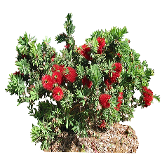
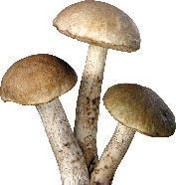
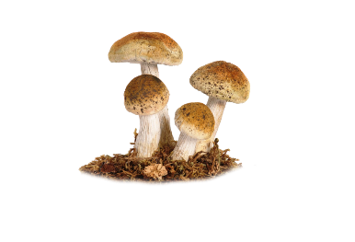
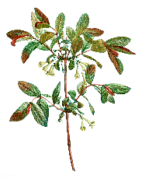
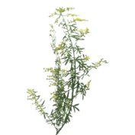
North
15
30
50
125
250
Height
1. Nitrogen fixers
Can grow in any layer – important to overall system
Locust trees, Alders, Russian Silverberry, Clovers, Peas, Beans, Groundnut, etc.
2. Canopy/tall trees
125-250+ cm height
Oaks, Pecan, Black Walnut, Walnut, Hackberry, etc.
Small places may not have the room for some of these species, or you could prune for height control. Taller species should be placed toward the North, shorter to South for optimal partitioning of sunlight.
3. Groundcover
2,5 cm or less height
Strawberries, Violets, Clover, Mints, Thymes, etc.
4. Understory trees
5. Fungi
Underground, or on mushroom logs in shade
6. Vines
Climbing plants: Hops, Grapes, Hardy Kiwi, Squash, Melons, Pole Beans, etc.
7. Medium-tall trees
75-125 cm height
Chestnut, Wild Pear, Heartnut, etc.
8.Shade-tolerant species below
10. Forbs/Herbs
2,5-15 cm height: Asparagus, Perennial Greens, Nettles, Mints, Grasses, Rhubarb, Brambles, Daylilies, etc.
11.Tubers
Below soil surface (11 and 13 can be merged like on the original version): Sunchokes, Groundnuts, Potatoes, etc.
12.Small trees
25-75 cm height
Plum, Apple, Apricot, Pear, Quince, Pawpaw, Hawthorn, etc.
13.Roots
Below soil surface
Horseradish, Salsify, etc.
14. Sun-loving/shorter species to South
9.Shrub
10-40 cm height
Currants, Hazelnuts, Viburnums, Aronia, Gooseberry, Rose, Elderberry, Quince, etc.
Figure 1: Agroforestry

On the ecosystem level, the pollinator habitat protection is an important tool to enhance agrobiodiversity. These habitats could be newly planted (Fig. 2) or conserved native wildflower field edges, flowering hedgerows (Biodiversity International, 2017b). They are keys not only for enhanced biodiversity on species and ecosystem level but with having more pollinator, yield of crops will be higher as well (Robinson et al. 2022).

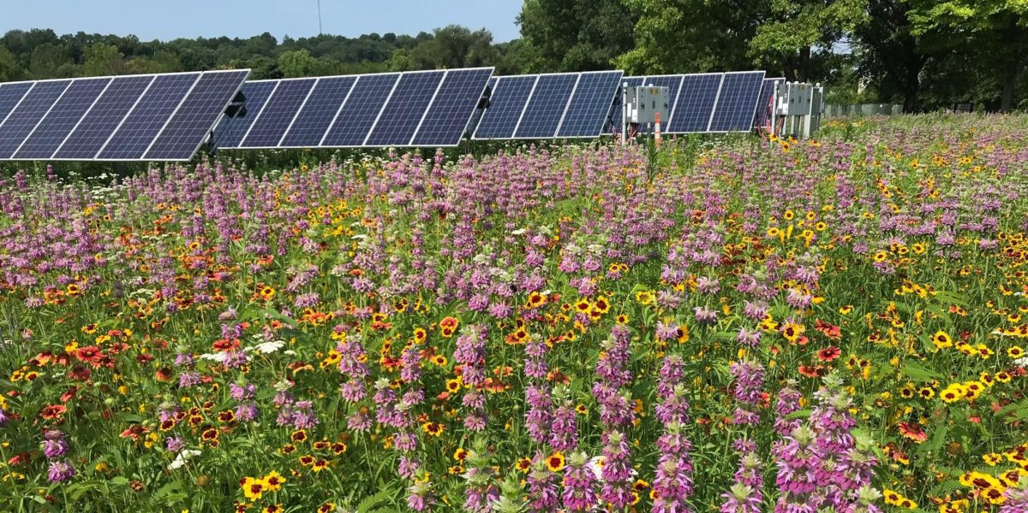 | Forest belts and hedgerows around agricultural fields have several positive effects on microclimate, soil properties, erosion control and protection of our fields for example against drift of chemicals used on neighboring areas. We can collect wild berries, or use black locust flowers to produce honey or coppicing material as firewood.
Figure 2: Pollinator habitat can usefully occupy the unused spaces in your farm. Source: https://pv-magazine-usa.com/2019/08/03/solar-and-pollinators-photo-essay/

Young shoots especially willows and hazel are good for interweaving in wattle fencing. Pollarding is a similar process carried out at a higher level on the tree. These forest belts and hedgerows are shelters, nesting places and green corridors for wild species. Green corridors are linking and spreading biodiversity over great distances (Mackey et al. 2010).

  - Benefits of nature resource protection in SFM

3.2.1. Enhancing soil health
A healthy soil is the basis of everything we eat. Two things are very important to have a healthy soil, which are organic matter content and an abundant and diverse microflora and fauna in the soil.
Organic matter will give structure to the soil. Organic residues, even the roots of the harvested crops will provide organic material.
Not only crop residues can serve as organic matter sources but e.g. green manure crops sown directly to increase organic matter content of the soil are contributing to this purpose. Cover crops, sown between two main crops in time when the soil would remain uncovered otherwise, are also increasing the amount of organic material in the system. Any kind of plants with living roots in our soil will provide assistance for useful microbes of the soil (FAO, 2021).
While photosynthesizing, plants are capturing and building in carbon from CO2 content of the air. Therefore, plants are extremely important in any ecosystems. They cover the soil and do not allow the already fixed carbon to escape again. This is where minimum tillage comes to our help as a more SFM practical tool.
3.2.2 Implementing water conservation
Beside the techniques listed in chapter 3.1, there are some other methods a farmer can try as well.
The so-called swales are ditches dug on contour on slight or steeper slopes (3-15%). It will prevent the water to rush into the valleys but while spreading in these long ditches, the rainwater will infiltrate into the soil and will be stored there (Tallarico, 2018). Swales could be combined with organic material into the ditch and also in the berms (Fig. 3). These buried organic materials will spread nutrients what plants can uptake.

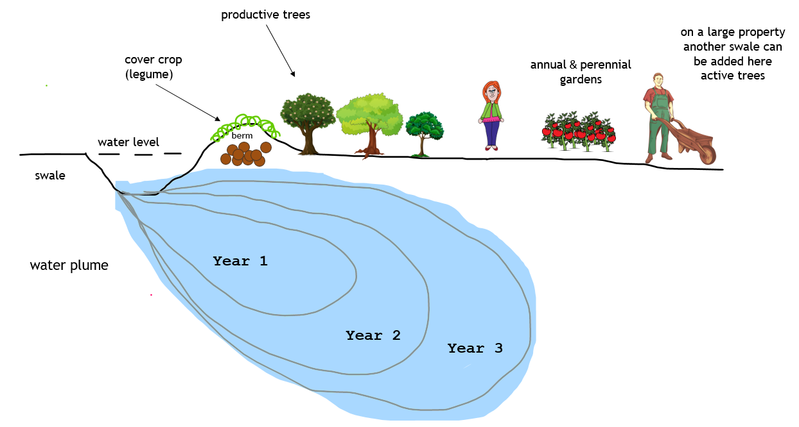
Figure 3: Swales and open areas for annual gardens and/or small livestock grazing
(Source: https://livingpermaculturepnw.com/what-is-a-swale-an-introduction-to-permaculture-water-harvesting/)

Keyline design is also a technique that’s used for maximizing the beneficial use of water resources. Our whole farm can be designed to harvest and store rainwater with this keyline design.
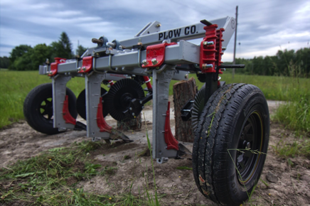  Figure 4: Yeomans Keyline Plow  (Source: https://hatchetnseed.ca/keyline-project-update/) | 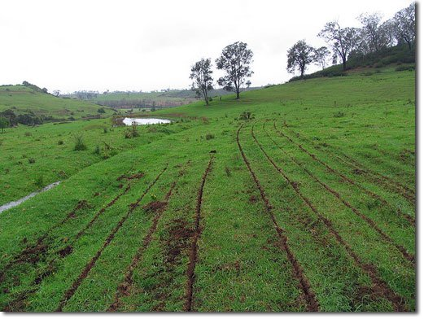  Figure 5: Fresh keyline plowed field  (Source: https://www.permaculturenews.org/2013/02/22/before-permaculture-keyline-planning-and-cultivation/)
A strong subsoiler with few knives, a so-called Yeomans Plow (Fig. 4 and 5) could be dragged and the slots in the soil will swallow as much rainwater as possible and store it.
3.2.3 Adopting sustainable pest management methods
Minimizing pesticide use first of all starts with prevention instead of direct control of the already appeared problem. Methods of prevention could be e.g. using certified healthy sowing seeds, cleaning of machinery before using them on another field, choosing locally adapted and resistant varieties, etc.
All the above described biodiversity enhancing actions can help in prevention as well as it is also described in 12.1.6. Keeping a constantly changing environment with different crop species in our crop rotation will keep the pests and weeds away from becoming dominant. When animals are inserted into our rotation, eg. chicken tractor (Fig. 6) (Holmes, 2020; ABC acres, 2016) and pig tractor, they can help in breaking lifecycle of pests and weeds too.

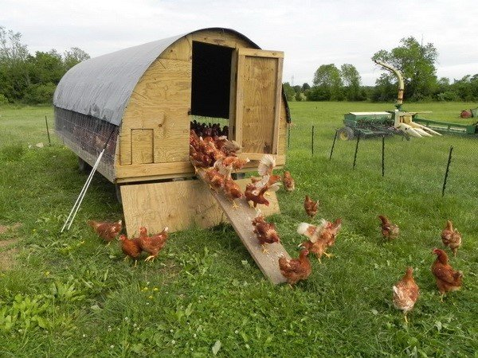
Figure 6: Mobile chicken coop to be placed wherever it is needed to have the chickens in our rotation (Source: https://removeandreplace.com/2013/05/26/chicken-coop-ideas-designs-and-layouts-for-your-backyard-chickens/)

Integrated Pest Management (IPM) combines the use of biological, cultural and chemical practices to control insect pests in agricultural production. Its goal is to use natural predators or parasites to control pests, using selective pesticides only when pests are unable to be controlled by natural enemies.
  - Sustainability of family-controlled farms, economic viability and human wellbeing

FAO views family farming as “a means of organizing agricultural, forestry, fisheries, pastoral and aquaculture production which is managed and operated by a family and predominantly reliant on family labour, both women’s and men’s.
There are over 500 million family farms in the world, which produce at least 56% of agricultural products on 56% of the land. Family farms maintain the traditional food, at the same time contributing to the conservation of local agro-biodiversity and the sustainable use of natural resources (FAO, 2014).
In the same geographic area and climatic conditions higher food security and biodiversity are more achievable with small scale family-controlled farms than with enormous monoculture fields (Wittman et al. 2016). Typically farms of between a half and six hectares in extent, are around four times as productive as farms of over 15 hectares (Hambler and Speight, 1995).
In SFM it is an important goal to maintain inner cycle of nutrients, materials and energy without purchasing inputs from outside the farm unless it is indispensably necessary. The product or side product of one element is gratifying a need of another element and in a well-designed and well-working system these useful connections among the elements are numerous (e.g. forage-livestock-manure-crop production).

One of the products can be the energy providing firewood from e.g. forest belts for heating or cooking and preserving or processing harvested goods with it. When processing yield before selling it, means an added value to our product and therefore the price, we can get for it, is higher (example in case study).
To decrease our expenses, we should minimize waste. Waste or side products of farming should be reconsidered in terms being reused, recycled or returned to the soil (composting) as part of the 5R (strategy (Fig. 7).

Figure 7: The 5R strategy of zero waste living
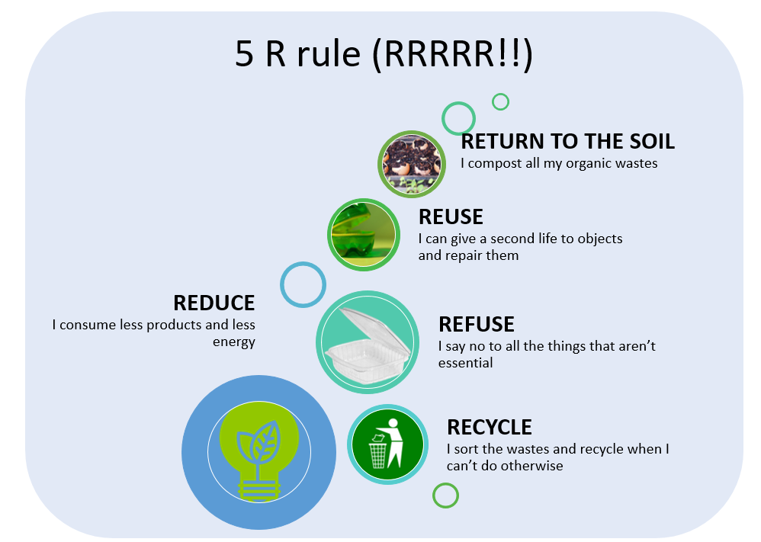
(Source: https://pimpyourbestlife.earth/en/the-5-r-rule-to-reduce-our-wastes/)

Marketing our products in local communities will mean not only shorter food supply chain with lower environmental effect from transportation, but this will strengthen the community around the farmers who are sustainably managing their farms. A local farmers market or a cooperation with other likeminded farmers will connect us better to others, civic organisations, and consumers that will help to avoid social isolation and manage stress.
An important part of sustainability in all territories of life is knowledge transfer. To preserve valuable sustainable farming knowledge a good solution could be the internship, volunteering, thematic workshops.

  - Integration of Sustainable Farm Management /SFM/ practices into agribusiness
Agribusiness refers to any business related to farming and farming-related commercial activities. To make agribusiness more sustainable, the three main dimensions of sustainable agriculture - economic, environmental and social, - need to be integrated and adopted. Integration of these dimensions will provide an opportunity for agribusiness to be economically profitable, environmentally sustainable and socially inclusive.
Implementing SFM practices in agribusiness can take many forms, such as waste-free production, resource-saving approaches, the use of safe packaging materials, and caring attitude towards employees.
At all stages of agribusiness planning and management, it is imperative that sustainable practices be implemented for the entire business system as well as for its components separately.
It is also very important to take an ecosystem approach to agricultural activities by ensuring sustainability of agroecosystems, where each component is interconnected and interdependent.
The first step towards stability is strategy development. The strategy must include a clear guideline for stability of a farm. Specifically setting credible sustainability targets aligned with your sphere of activities, such as reduction of CO2 emissions, ensuring circularity and non-waste or reduced waste production. Creation of your farm sustainability roadmap and following the steps forward will provide you with extra strength in competition and positioning of your agribusiness.
The chart on sustainability components allows one to assess the state of sustainability of the business and identify possibilities for improvement of your sustainability performance.

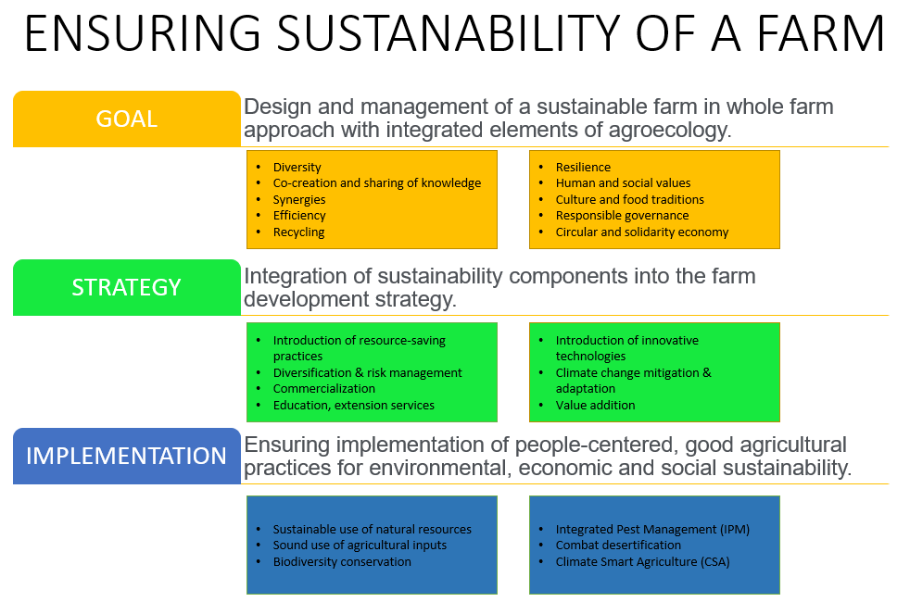

The difference between SFM and 'traditional management' is mainly that, in addition to generating traditional income while taking care of natural resources, it also pays special attention to the social aspects of agriculture.
During the whole production lifecycle, data should be collected through ongoing monitoring, the quality should be under control, and the product should continuously be adjusted to the customer needs.

  - Checklist of sustainability
This section presents collected practices of sustainable farm management formed as a checklist where students can check their practices/actions/farming elements from the point of view of sustainability and can internalize new possibilities and ideas towards a more sustainable farm management. It will serve as a summary and revision of the formerly earned information as well.
Do/will you have the following elements on your current/future farm?
Click the checkbox if yes:

Enhancing biodiversity
□ Mixed farming
□ Seed saving
□ Diverse crop rotation
□ Second cropping
□ Variety mixture
□ Intersowing
□ Agroforestry
□ Pollinator habitat
□ Forest belt
□ Hedgerow
□ Nesting boxes for birds
□ Nesting boxes for bats
□ Nesting boxes for pollinators
□ Hiding places for lizzards
□ Hiding places for hedgehogs
□ Pond

Ensuring soil health
□ Organic residues
□ Green manuring
□ Cover cropping
□ Reduced soil tillage

Mitigating GHG emissions
□ Mixed farm
□ Rotational grazing
□ No artificial fertilizer
□ Zero tillage where possible
Implementing water conservation
□ Mulching
□ Minimum tillage
□ Organic matter into the soil
□ Drip irrigation
□ Swales/Keyline design
□ Rainwater harvesting
□ Runoff water storage

Adopting sustainable pest management methods
□ Healthy sowing seeds
□ Matured FYM
□ Cleaning machinery
□ Locally adapted varieties
□ Locally adapted breeds
□ Resistant varieties
□ Resistant breeds
□ Crop rotation
□ Mixed farming
□ Integrated pest management
□ Organic pest management

Ensuring economic viability and human wellbeing
□ Minimising purchased inputs
□ Capturing energy
□ Added value to products
□ No food waste

□ Applying the 5R strategy
□ Alternative marketing strategies
□ Providing internship possibilities
□ Organizing workshops
□ Providing volunteer possibilities

  - Case study of a sustainable farm
Valaha Tanya
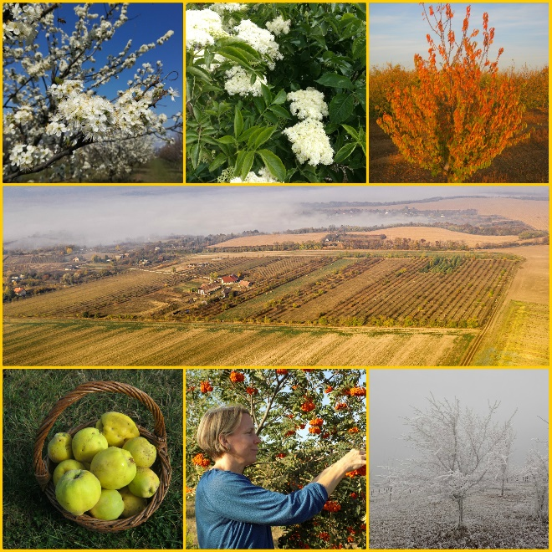
This case study refers to management of a family-run organic farm on 12 hectares revealing specifications of sustainability applied. A 5 hectares-plot is mixed orchard, with old resistant varieties of different species planted with 1 ha of wild fruits. 2 hectares are in arable status, planted with alfalfa. There are 2 hectares of meadow and 0,5 hectares of berries. There is a little vegetable garden with some herbs and spices and a paddock for the livestock. The whole area is eco-certified.

About 90% of the fruits and herbs are processed, they make more than 30 kinds of artisan fruit cordials out of them. As small farmers they process about 5 tons of fruits and herbs each year.
They sell the products mostly to restaurants within 40 km distance and they are also present on local fairs. They have joined a shopping cooperative where in addition to fruit cordials they sell the nicest fruits and the surplus from the vegetable garden. It is important for them that their customers know them well.
In addition to fruit processing the wife manages the farm’s administrative duties. The husband is a mechanical engineer, so their farm machines and engines are also in good hands. They have one permanent part time employee, and during the summer 1-2 seasonal workers are working with them.
Assorted trees and bushes are planted around the farm, which supports a useful microclimate, helps with filtration of external pollutants, furthermore, it provides the farm with firewood with pollarding. The flowers blossoming in the borders are not only used by bees, but they are used in fruit cordials too.

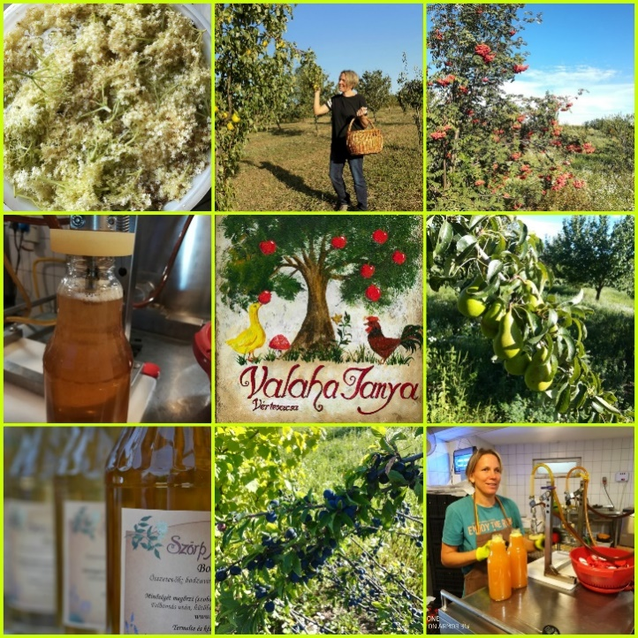
From the perennial herbaceous plants in the orchard, they have created a continuously covered soil surface. Due to the substantial legume species content, it also nourishes the trees with nitrogen and provides a habitat for beneficial insects. The interrow vegetation has yielded profit even in the first year, because it provided the annual forage and hay need of the livestock. The forage of the ruminant animals is entirely made up of grass from the plantation and ‘waste’ from fruit processing since they don't use any concentrated fodder, like cereals or pulses. They exclusively use the composted manure produced on the farm to replace the nutrients in the soil. They compost the leftover green mass too.

They placed nesting boxes in the orchard and they always leave some areas unmowed, where they provide birds with a place to hatch their eggs.
The area is always covered by living plants and the orchards were planted along contour lines, across to the slope of the field. Little swales developed while cultivating the orchards which help to stop and hold water. While choosing plant varieties, they took into consideration their water needs, and during replacement, they were already able to select which species and varieties are worth keeping on their farm, based on their observations.

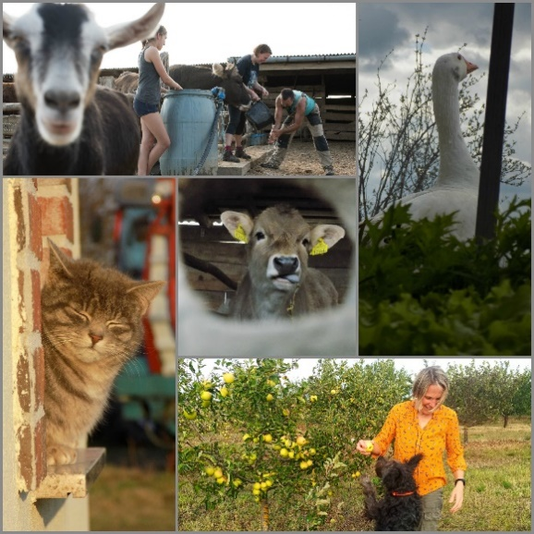
They use drip irrigation only in their vegetable garden. For now, they can only use water from a well, but they are planning on implementing a rainwater harvesting system, so they can store rainwater runoff in a pond. They also established a deep mulch area and intersown white clover among the vegetables. Below is a schematic plan of the farm with explanations.
N | Description
1 | Stables and paddocks
2 | House + processing in the basement
3 | Firewood storage
4 | Polytunnel
5 | Workshop
6 | Vegetable garden
7 | Suntrap
8 | Pine trees
9 | Pond
10 | Road
Symbol | Description
 | Black locust
 | Fruit tree
 | Berries
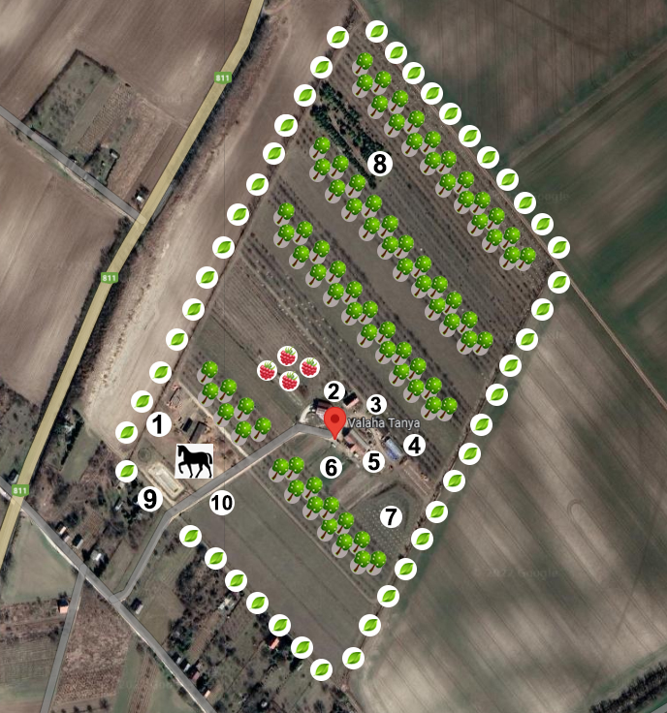

The hot water needed for the house and fruit processing is provided by solar collectors, from April to November and during the winter they heat the house with a mass stove, with firewood from chopped up branches of cut orchard trees and pollarded black locust trees from the forest belt around the farm.
They also care about knowledge transfer through hosting training courses, students for field practice or internships.

Bibliography:
ABC acres (2016) Mobile Coop Version 2.0 - episode #019 [Online video] Available at: https://www.youtube.com/watch?v=X8cwRXPdxbs&t=209s
Anderson, T. (2021) 12 useful tips for organizing a seed swap [Online] December 28. 2021. Available at: https://lovelygreens.com/how-to-organize-a-seed-swap-event/
Bioversity International (2017a) Mainstreaming Agrobiodiversity in Sustainable Food Systems: Scientic Foundations for an Agrobiodiversity Index. Bioversity International, Rome, Italy. https://www.bioversityinternational.org/mainstreaming-agrobiodiversity/
Bioversity International (2017b) Reducing risks and seizing opportunities: integrating biodiversity into food and agriculture investments. Rome, Italy. https://www.bioversityinternational.org/fileadmin/user_upload/ABD_Index_Investor.pdf
CICES (Common International Classification of Ecosystem Services) (2016) CICES Website. http://cices.eu/
DIVERSIFOOD (2018) Cultivating Diversity [Online video]. Available at: https://www.youtube.com/watch?v=zXYUwRa_eUI&t=222s
DIVERSIFOOD (2019) Participatory Plant Breeding [Online video]. Available at: https://diversifood.eu/participatory-plant-breeding/
European Commission (2021) Sustainable agriculture in the CAP. https://ec.europa.eu/info/food-farming-fisheries/sustainability/sustainable-cap_en#documents
Ellen MacArthur Foundation (EMF) (2015) Growth within: a circular economy vision for a competitive Europe. Cowes, UK. https://www.ellenmacarthurfoundation.org/assets/downloads/publications/EllenMacArthurFoundation_Growth-Within_July15.pdf. Accessed 21 Feb 2022
FAO (1988) Building a common vision for sustainable food and agriculture. [Online] https://www.fao.org/3/i3940e/i3940e.pdf
FAO (2017) Voluntary sustainability standards in agriculture, fisheries and forestry trade. FAO Trade Policy Briefs. No 30. October 2017. https://www.fao.org/publications/card/en/c/I8843EN/
FAO (2021) Keep soil alive, protect soil biodiversity. FAO Symposium 19-21 April 2021 https://www.fao.org/3/cb6005en/cb6005en.pdf?fbclid=IwAR23iP_6f8ZQZDQbEixR-1yv2jq3rMGcnTew5QNTfzxtDk0t1HrqHCo1Das
FAO/UNEP (2014) Workshop on Voluntary Standards for Sustainable Food Systems: Challenges and Opportunities. Rome, Italy http://www.fao.org/3/a-i3421e.pdf
FAO (2014) Family Farmers, Feeding the world, caring for the earth https://www.globalagriculture.org/fileadmin/files/weltagrarbericht/GlobalAgriculture/SmallholdersFeedingtheworld.pdf
Growth Farms Australia (2018) The advantages of mixed farming [Online video]. Available at: https://www.youtube.com/watch?v=pXKRhz0d1jc&t=162s
Hambler, C., Speight, M. R. (1995) ‘Biodiversity conservation in Britain: Science Replacing Tradition’, in British Wildlife No 6, pp137-147;
Holmes, M. (2020) Get the facts on chicken tractors [Online] Available at: https://www.treehugger.com/facts-on-chicken-tractors-5086805
Mackey, B., Watson, J., Worboys GL of ANU Enterprises Pty Ltd (2010) Connectivity conservation and the Great Eastern Ranges corridor, an independent report to the Interstate Agency Working Group (Alps to Atherton Connectivity Conservation Working Group) convened under the Environment Heritage and Protection Council/Natural Resource Management Ministerial Council. Available at: https://www.activeremedy.org/wp-content/uploads/2014/10/dept-environment-climate-change-and-water-nsw-australia-2010.pdf
Niggli, U., Schmid, H., Fliessbach, A. (2008) Organic Farming and Climate Change. Technical paper. https://www.researchgate.net/publication/28684793_Organic_Farming_and_Climate_Change
Robinson, S.V.J., Nguyen, L.H., Galpern, P. (2022) Livin' on the edge: Precision yield data shows evidence of ecosystem services from field boundaries. Agriculture, Ecosystem & Environment. Vol. 333. https://doi.org/10.1016/j.agee.2022.107956
Seed Savers Exchange (2017) Seed Saving Guide. Available online at: https://www.seedsavers.org/
site/pdf/Seed%20Saving%20Guide_2017.pdf
Sphera
http://3gry456jeet9ifa41gtbwy7a-wpengine.netdna-ssl.com/wp-content/uploads/2020/04/CEOs-Guide-to-Sustainability-Strategy.pdf
S.M. Fakhrul Islam and Zahurul Karim (2019) Sustainable Agricultural Management Practices and Enterprise Development for Coping with Global Climate Change https://www.intechopen.com/chapters/68204
Tallarico, G. (2018) Swales? or not to swale? [Online blogpost] Available at: https://worldpermacultureassociation.com/swales-or-not-to-swale/
Vernooy, R., Shrestha, P., Sthapit, B. (ed) (2015) Community Seed Banks. Biodiversity International https://www.bioversityinternational.org/fileadmin/user_upload/Community_Seed_Banks.pdf
Whitefield, P. (2004) The Earth Care Mannual. Permanent Publications. ISBN 978 1 85623 021 6
Wittman, H., Chappell, M.J., Abson, D.J., Kerr, L.B., Blesh, J., Hanspach, J., Perfecto, I., Fischer, J. (2017) A social–ecological perspective on harmonizing food security and biodiversity conservation. Reg Environ Change 17, 1291–1301. https://doi.org/10.1007/s10113-016-1045-9

Module 4: Financing CSA activities

4.1 The financing of SCA as a contribution to their development and implementation in practice.
This section examines the importance of funding for the development and dissemination of SCA in a practical business environment. At the same time, it gives an idea of the possibility for a certain activity to be easily introduced as a business solution within a given organization/entity through justified financing.
In accordance with the international tendencies regarding the development of agriculture and the entry of the “green deal” idea, different organizations from the agronomy sector are more and more often coming across the idea of Climate-smart Agriculture (CSA). This term defines agricultural systems simultaneously related to the improvement and provision of food security and the adaptation to the active processes of climate change. In this respect, there is a large number of activities, which the farmers or organizations involved in food and agriculture need to carry out in order to align their business with or introduce into it the concepts of CSA. This requires the investment of additional funding since the business structures are often unable to meet the criteria of CSA.
The specificity of the definition of CSA implies that its financing can be implemented in three different ways. On the one hand, these are the food security - related activities, which concern directly the agronomy technologies, equipment and applied practices. On the other hand, these are the activities related to adjusting an agricultural farm to climate-sustainable practices and its adaptation to the concept of saving of the natural resources. The synergic financing of activities, which determine both features of CSA should not be underestimated, too. Thus, the diversification of the financing sources becomes possible, as well as the ways to actually invest this financing in certain types of activities.
According to the definition of FAO with regard to CSA, its introduction requires “the adoption of an eco-system approach working on a landscape scale and providing inter-sector coordination and cooperation …” Such characteristics demonstrate the necessity of serious financing both with regard to the volume in currency units and the introduction of certain requirements. This is to a certain extent related to the idea of ensuring food security, which, against the background of the drastic climate changes requires a total shift in the understanding and technologies, which provide agricultural raw materials. Such change, on its part, requires changes in activities, infrastructure and assets, and thence – high requirements to them and large-volume investments. At the same time, an important aspect of financing is achieving inter-sector coordination and cooperation. The excessive fragmentation of the two sectors related to agriculture and foods will require additional finances for development of cooperation organizations, associations of producers and processors, as well as introducing the idea of consultancy and expertise services to provide direct aid for the farms.
For the distribution of the total concept of CSA, certain investments are necessary, since at the current moment the idea of such practices is little known in the agricultural farms both on the territories of the individual countries and in the European community as a whole. From this point of view, the introduction of certain activities related to CSA would require financing for transmission of information to certain entities. This includes information both about the potential integration of CSA practices in the entire agriculture and also about what is CSA and its main activities and practices, what are the CSA-related policies and what would be the aim and effects of its introduction.
The idea of financing CSA as a whole need to be widely accessible, easy to implement and practically independent of other forms of funding or financing related to other type of activities. This would ensure the effective introduction of the activities and their fast improvement and updating, if necessary. Therefore, the financing itself should not be restricted to specific measures but to a whole concept; it should not be available only to a certain type of business but should allow for integration and cooperation, and for maximum distribution among organizations and structures with activities and production different in scale. Such characteristics of the CSA as a specific activity imply certain flexibility, as well as provision at different levels: international, cross-border, national. This implies and justifies the existence of different sources of financing to provide for the specific activity or a set of activities related to the introduction of CSA. Nevertheless, each specific activity has to be implemented according to specific requirements, i.e. the freedom and diversity of financing should not lead to unjustified practices and spending of funding that would not bring about the desired efficiency and the fundamental concept of CSA from the point of view of providing food security against the background of a changing climate.
The significance of financing for the purposes of CSA can be generalized as follows:
- Distribution of knowledge on the overall concept of CSA;
- Developing of activities related to the introduction of CSA;
- Developing CSA-related infrastructure;
- Acquisition of assets significant for CSA;
- Developing and coordination of cooperation related to CSA activities.

4.2 Legislation in the area of SCA financing
This section summarizes the main regulatory sources at international, European and national level, with national regulations presented for each partner country.
The financing of all CSA-related activities, as well as the acquisition of assets and the development of infrastructures and infrastructural sites should be legislatively regulated due to the rather high peculiarities and goals pursued from a conceptual point of view. At this point in time, there is no legislation specifically targeting the financing and activities related to CSA, with the exception of the international legal acts. However, there are sources of legislation, which to some extent provide for the financing of activities and assets acquisition, which correspond conceptually to the idea of CSA. In this respect, the legislation may be presented as follows, depending on its territorial scope:

International
This includes all international contracts, agreements, protocols, conventions and regulations, which, in one sense or another, give directions or refer to specific legal acts related to the financing of CSA. Since the idea of CSA is of dual nature, sources more specifically related to the climate or to the agriculture may be included also among the international ones. Below are given the more important regulations of international legislation:
- Convention on Biological Diversity (CBD)
- United Nations Framework Convention on Climate Change (UNFCCC)
- Stockholm Convention on Persistent Organic Pollutants (POPs)
- UN Convention to Combat Desertification (UNCCD)
- Minamata Convention on Mercury
- Paris Agreement
- Kyoto Protocol
- Cancún Agreements

European
Within the European legislation, there is no specific regulation, directive or decision directly targeting CSA financing. Nevertheless, concerning the financing of activities and assets related to agriculture, ecology and climate-sustainable practice, the following legal acts can be considered applicable sources:
- Regulation (EU) No 1303/2013 of the European Parliament and of the Council of 17 December 2013 laying down common provisions on the European Regional Development Fund, the European Social Fund, the Cohesion Fund, the European Agricultural Fund for Rural Development and the European Maritime and Fisheries Fund and laying down general provisions on the European Regional Development Fund, the European Social Fund, the Cohesion Fund and the European Maritime and Fisheries Fund and repealing Council Regulation (EC) No 1083/2006
- Regulation (EU) No 1304/2013 of the European Parliament and of the Council of 17 December 2013 on the European Social Fund and repealing Council Regulation (EC) No 1081/2006
- Regulation (EU) No 1305/2013 of the European Parliament and of the Council of 17 December 2013 on support for rural development by the European Agricultural Fund for Rural Development (EAFRD) and repealing Council Regulation (EC) No 1698/2005
- Regulation (EU) No 1306/2013 of the European Parliament and of the Council of 17 December 2013 on the financing, management and monitoring of the common agricultural policy and repealing Council Regulations (EEC) No 352/78, (EC) No 165/94, (EC) No 2799/98, (EC) No 814/2000, (EC) No 1290/2005 and (EC) No 485/2008
- Regulation (EU) No 1307/2013 of the European Parliament and of the Council of 17 December 2013 establishing rules for direct payments to farmers under support schemes within the framework of the common agricultural policy and repealing Council Regulation (EC) No 637/2008 and Council Regulation (EC) No 73/2009
- Regulation (EU) No 1308/2013 of the European Parliament and of the Council of 17 December 2013 establishing a common organisation of the markets in agricultural products and repealing Council Regulations (EEC) No 922/72, (EEC) No 234/79, (EC) No 1037/2001 and (EC) No 1234/2007
- Regulation (EU) No 508/2014 of the European Parliament and of the Council of 15 May 2014 on the European Maritime and Fisheries Fund and repealing Council Regulations (EC) No 2328/2003, (EC) No 861/2006, (EC) No 1198/2006 and (EC) No 791/2007 and Regulation (EU) No 1255/2011 of the European Parliament and of the Council

  - Sources of funding

4.3.1 Subsidies and grants
The subsidies and grants are a form of funding, which is most often administered directly, jointly or indirectly by the government of a given state and is related to the implementation of a certain policy. Although both grants and subsidies are unremunerated funding, there is a significant difference in the two forms of financing. The grants are means paid to implement a certain activity, which should be subject to design and planning, i.e. the grant scheme is realized by preparing a project proposal. The grant programs and schemes are usually developed on a competitive basis and there are a number of requirements the applicants should meet to be approved for funding. The grants are often paid only when the approved grantees carry out most of the activities envisaged in the project proposal and acquire the assets pre-targeted therein. Nevertheless, some of the schemes, measures and programs envisage advance payment of a part of the funding, but only in certain and pre-planned instances. A peculiarity of the grants is that they are unremunerated funding above national level. The grantor can provide for or fund only a certain part of the project proposal, or fund it entirely depending on the policy carried out or on certain specific aspects.
Subsidies, on their part, are also paid by the government or other institutions, which, however, do not require a preliminary project proposal. The beneficiaries receive unremunerated financial means to overcome the unfavorable consequences of climatic, anthropogenic or biological activities in the form of money transfer, tax allowances and tax reliefs, vouchers, etc. The subsidies are often used with the aim to carry out policy at a national or regional level. Subsidy as a form of financing is related rather to specific activities and in large part is not an investment.
Depending on the financing sources, various mechanisms, schemes, programs, projects, policies, etc. can be differentiated, which are managed at national, cross-border, community or international levels.

4.3.1.1 Global sources - multilateral mechanisms - FAO funds
One of the strongest policies for financing of CSA is being carried out at international level. The multilateral financing is often associated with the possibility of accelerated adoption of certain practices. In this respect, such type of financing is a prerequisite for wider acceptance of climate-sustainable practices and enables accelerated integration of smart agriculture at national and regional levels. A significant peculiarity of this type of financing is that it is managed by large international organizations or funds based on conventions, agreements or protocols; it is provided directly to the national governments to carry out project policy in a certain field.
The means for such funds are raised as a result from multilateral participation of a large number of states. Concerning CSA, the main financing is carried out within the funds established under UNFCCC – Global Environmental Facility Trust Fund, Special Climate Change Fund, Least Developed Countries Fund, Green Climate Fund, Adaptation Fund.
The basic idea of these funds is maintaining biodiversity, mitigating the effect of the climatic changes, food security, protection of the water resources, sustainable management of forests. A specific feature of multilateral financing is that it is provided exclusively or as a priority to developing countries, which are not able independently or as a part of a certain community to develop climate-resistant agriculture. Therefore, countries such as Bulgaria, Romania and Greece, and the rest of the member-states of the European Union are not among the countries, which can be financed from the above funds. The financing is done via national institutions serving as multilateral agencies to a certain fund.

4.3.1.2 International systems - bilateral mechanisms
The bilateral mechanisms differ from the multilateral ones by the way of raising finances. With the bilateral sources, the donor directly provides financial aid to the recipient. This can be done both at a governmental and non-governmental level via different institutions of the governmental sector or foundations. In Bulgaria and Romania, the foundations America for Bulgaria and Romanian-American Foundation are operative, performing activities aimed at assistance of certain projects and initiatives depending on the set priorities. Both foundations are public, founded by the USA Congress and funded by the US Agency for International Development. A part of the priorities of the two agencies is the financing of sustainable practices related to the development of the rural regions, increasing the qualification of the farmers, cooperation and development of rural networks, etc.
As a part of the bilateral financial support, the US Agency for International Development (USAID) considerably aids the agricultural and food security in extremely unfavorable regions. In the area of food and agriculture, USAID operates within the framework of two initiatives - Feed the Future and Food Assistance. Both are targeting the developing countries, where there is a potential or high risk of food insecurity. With regard to decreasing the effects of climate, initiatives aimed at adapting food and agriculture to a changing climate have also been developed.

4.3.1.3 National programs
The national programs in relation to the financing of CSA are rather specific and are usually dependent on the policy in the field of agriculture and climate carried out by the government of a specific country. This for example, Republic of Bulgaria has used and is using 60 different types of state aid to agriculture (plant production, husbandry, apiculture). Most often, the national aid is in the form of direct subsidy payment; the greater part of the measures function in this way and are of compensatory nature. Another form of national support for agriculture is financing of expenses and subsidy for services, especially in the wine sector. A specific form of national support is providing of vouchers for fuel as a form of reimbursement of excise duty for used diesel fuel. A main form is also the corporation tax relief for farmers in the form of 60% discount that should be invested in new agricultural equipment or new buildings. The national aid is also in the form of capital subsidies given for investments in tangible and intangible assets, which are usually financed up to 50% of the capital costs made. One of the most interesting forms of national aid is providing of guarantees and credit preferences on the part of the state.
Regardless of the varied measures the state government envisages, it is important to investigate such programs in time since they are usually short-term ones. At the same time, they are not permanent but are limited to a certain period of time and are strictly dependent on the specific policy and the necessary decisions and trends in the respective sub-sector of the national agriculture. Specifically, with regard to CSA, the national aids are in practice non-existent. This is due to the fact that the activities and practices envisaged in CSA are similar to the support for the farmers with regard to measures and programs for overcoming and mitigating the unfavorable climatic effects and providing food security. Simultaneously, the government has funds provided for compensation of unfavorable climatic processes and phenomena thus ensuring indirectly food security.
On the other hand, when urgent necessity arises for specific agricultural raw materials, the governments are prone to undertaking emergency measures to ensure the local farms with sufficient resources, so that they are able to provide for the food needed in the country. Such emergency measures are the aid for the agricultural producers in Bulgaria to overcome the pandemic effects of the Corona virus infection and the state compensations for overcoming the negative effects of drought in the region of Dobrudzha during 2021.

4.3.1.4 EU funds, programs and grants as a specific source of CSA activities funding.
Based on the approved community policy, the European Union undertakes financing to achieve the targeted values and principles in various economic sectors. With regard to agriculture, EU has one of the best financing policies. The European Agriculture Fund for Development of Rural Regions (EAFRD) is among the largest ones. In practice, the financing for development of the rural regions is the second pillar of the common agricultural policy of the community and one of the most important activities with regard to agricultural production.
Beside the overall development of rural regions, one of the aims of the financing is environmentally friendly agriculture and food security, while the priority is sustainable development. In this respect, the aims and framework concept of the common agricultural policy and financing of agricultural activities largely cover the basic concept of CSA. Therefore, the overall financing within the Programs for development of the rural regions can be considered financing of CSA-related activities. This conclusion arises also from the fact that certain grants, credits and measures are funding projects, which meet the requirements of sustainable development and promote low-carbon practices, regenerative agriculture and organic production. The main way to secure funding from EAFRD is through the Rural Development Programs (RDPs), which are managed at a national or regional level by the respective member countries. These programs can be further financed on a national principle by a decision of the local governing authority after approval and notification by the European commission. Each RDP has a number of measures targeting the funding, investment and development of sustainable agriculture in the agricultural regions. At least 30 % of the funds provided by a RDP should be for measures related to the environment and climate changes; they should be provided to the farmers in the form of grants or direct payments. At least 5% of the funding should be directed to the so-called Local Action Groups (LAGs), which come up with own strategies and financing priorities according to the specificity of the region where they operate. As a part of EAFRD, financial instruments may be used in the form of credits, guarantees, micro credits, capital investments, which should be available to the agricultural producers and should fund modern projects corresponding to the goals of EAFRD. The Cohesion Fund of the European Union could also provide funds for certain CSA-related activities concerning bio diversity, environment, sustainable development (especially in urban areas) and construction of specific infrastructure. It should be emphasized that such funds are not given to agricultural producers. Such programs are Operational Programme Environment in Bulgaria, Programme Transport infrastructure, Environment and Sustainable Development in Greece and Regional Operational Programme in Romania.
The programs of the European structural funds described above can finance projects and activities and are available only to EU member-countries. If a state is in a pre-accession procedure, the Pre-accession instruments can be used for financing of certain activities. Concerning CSA, there is the Instrument for pre-accession assistance for rural development (IPARD), which is aimed at development of rural regions and agricultural production in the states, which are in the process of joining the EU.
The main purpose of such an instrument is to achieve sustainable development and to ensure the food security of the candidate state, and also to harmonize the agricultural practices with the Common agricultural policy. Currently, six such financing programs are active in Turkey, which are related to investment in assets, agro ecology, climate and bio agriculture, diversification and business development, technical assistance, etc.

4.3.2 Investment financing
Financing through investments is also a way of funding, especially when talking about financing of unpopular measures, the knowledge of which is concentrated in a small group of entrepreneurs. Since at the current moment the idea of CSA is not popular on a large scale and a comparatively small circle of people have the necessary information concerning its overall concept, the financing of investments related to such ideas is of key importance.
There are different ways of providing funding through investments. One such way is establishing a company and fundraising in the form of equity contribution specifically directed toward CSA-related activities. Another way is the use of own financial resources and establishing of start-ups. An important instrument is investment fundraising in already existing businesses in the form of equity contribution based on a business plan.
Last but not least, a financing instrument are also the inter-company loans, as well as dividend financing, bond financing, targeted investment in securities, etc. The last three methods are rather complicated to implement and are practically possible in large companies, the petty farmers not having access to them.

4.3.2.1. Establishment of specialized companies in the field of CSA activities
This form of financing is a comparatively little used method of fundraising for realization of certain ideas when considering agriculture and petty agricultural producers. It is usually used by large companies to carry out certain activities: an entirely new company is established, attracting investors who possess a part of the equity of the new company, and who maintain controlling or majority shares with the aim of efficient management.
Concerning the small and medium agricultural producers, such type of investment is also available, although on a smaller scale, since, regardless of the country where the activity is carried out, almost all legislations have capital companies suitable for the purpose or non-capital forms of cooperation. This allows establishing associations of farmers, which possess certain funds, assets and knowledge with a common goal – undertaking of activities related to CSA. In practice, such associations or cooperation are a kind of CSA-activity since such practices are the basic concept of CSA.
Association or cooperation can be carried out to achieve a certain goal and after its accomplishment the company may be wound up. On the other hand, when forming capital companies, their existence is related to permanent association and a long-term strategy for development of certain business ideas. A typical example of a temporary association is the formation of the so-called operative groups according to one of the measures of the Programs for rural development. The main idea is establishing a company that would introduce innovations from science to practice by associations with research organizations, consultancy companies and agricultural producers.

4.3.2.2. Investing in start-ups
By nature, the start-ups are new business organizations established with the aim of realizing an innovative business idea. Such companies are comparatively small-sized and require fast additional financing to introduce their ideas. At the same time, they are highly risky enterprises because they are based on a large amount of uncertainty due to the rather innovative nature of the product they develop. Concerning CSA, there is a large number of start-ups offering such products as solar pumps for irrigation or services for assisting own food growing.
Establishing a start-up by itself is not necessarily related to financing. The products or services being developed should be highly applicable. Thus, the probability such an activity to receive financing through equity investment becomes considerably higher. The mechanism of receiving financing for CSA activities does not differ from the financing of any other specific start-up business.
First is the establishment of a low-budget capital company, which develops a specific product or a service with low funding. It is highly important that they are appropriately presented either in a project proposal for investment financing or promoted in social networks or other suitable media. The offer for investment financing is then followed by a choice of potential partners. In the process of financing, it is possible a large part of the product or the rights over the service to become property of the financing organization through the established company. Based on the received financing, the respective product or activity are then introduced for practical usage. At this stage, there is a considerable risk for the financing organization since the new products and services have not been tested under real production conditions. If they are well marketed, the investors may add more funding to the initial investment in the form of additional equity, credits, guarantees, dividend financing or grants.

4.3.2.3. Attracting investment financing
By itself, the attracting of investment financing is an exceptional challenge for the implementation of a business idea. This relates to considerable requirements of the investors and entities providing the financing because they take on themselves a considerable risk for the realization of the business idea. Such forms of financing are typical for the USA, Canada, Australia and Great Britain, or in the so-called Anglo-Saxon legislative system. On the territory of the European Union, the financing of business project is done primarily by external financing from commercial banks. However, in certain cases the business project may be financed through one of the strategies for investment financing.
With regard to CSA as an innovative process, its financing can be done in three different ways, depending on the size of the project and the organization or company, in which investments are made.
First, in very small and micro family projects, the investment is usually done at the level of the family, the potential investors (family members) investing savings and assets in the start-up. In spite of the close relationships, such investment also requires developing and presenting a business plan, since the savings of the natural persons are of special nature and are related (particularly with older family members) to the ensuring of a certain life standard. Such an investment is highly risky because the company is at a very early stage and the realization of the business intent is uncertain.
With regard to investments in a start-up type of business, quite interesting are the so-called business angels. Most often, these are natural persons, investors, who contribute comparatively low sums: 5 to 250 thousand Euro. The investment is done at the start-up level, in companies at the early stages of their development, and to some extent – in young but stable companies. The risk in this case is also comparatively high, especially with regard to the start-ups and the companies at young stage. The investments are made for a 3-8 year period and the desired return on the investment is within 20-35%. A peculiarity in this instance is that besides capital, the business angels also provide management knowledge and experience, which are highly important for the start-up company.
The official risk capital investment, the so-called venture capital, is a formal type of investment, in which the investors (persons or entities) are financing high-risk projects with expected high return. Nevertheless, the level of risk in this type of investment is lower in comparison to the business-angel investment, the need of capital is comparatively higher, and the companies are at a young stage but with a clear concept. In this investment, similar to the business-angels, the investors are active participants, i.e. they set guidelines for the development of the company, design financial plans, take part in the management decisions. This investment is with a longer period of return, usually within 5-10 years. The investment is between 1 and 10 million Euro.
The highest needs of capital are being financed through the so-called IPO scheme – initial public offering of stocks. Such type of fundraising is done by large companies, which are at an advanced stage of their development and are looking for financing to ensure large structural projects. The return on the investment is very high – at least 5 and over 10 years, the risks are comparatively lower, and the stability of the financed activity is also very high. The investors may be different categories of persons or entities, they are not necessarily active investors, i.e. they can buy stocks and bonds with the aim to later sell them, or to receive dividends and interest. When buying large blocks of stock, however, the investors may aim at introducing certain politics in the company, which receives finances in exchange of the offered funding. Such investments are usually larger than 100 million Euro.
Concerning CSA, the last two types of financing are unlikely due to the extreme amount of formalities needed. Since a major goal of CSA is ensuring food security, the investment should be rapid, free of long-term procedures of investigation, registration and various permission regimes. On the other hand, the agricultural producers are small-sized companies or natural persons. Therefore, one of the most adequate forms of investment capital financing is attracting business-angels. In Bulgaria, there is an Association of Business Angels established with the aim of assisting the investment process when developing own businesses.

4.3.2.4. Business loans
One of the last possibilities for financing of an organization is getting loans from other companies, organizations and firms different from the ones envisaged in the financial sector. This is a high-risk form of financing since the financing organization does not always do detailed investigations on the possibility the loan recipient to repay the borrowed means. On the other hand, it is comparatively easy to receive such a loan, it is not burdened with heavy formal procedures, but the size of the finances is comparatively limited. The interests are considerably higher, and the loan repayment period is much shorter. From the point of view of CSA, such type of financing is justifiable only if all other options have been exhausted, and the need of financing is urgent.

4.3.3. Bank financing
The bank financing is one of the best organized and used ways of financing different types of activities. In contrast to the investment financing, the bank financing is widespread on the territory of the European Union and some countries in Asia, especially with regard to enterprises that can be classified as micro, small and medium-sized. Furthermore, the bank financing usually provides much more limited funds, according to a pre-established procedure and after a thorough analysis of the financial position of the borrower. The reimbursement of means thus borrowed is related to payment of a certain price in the form of interest; another great advantage is that the reimbursement is made in several repayments but not of the entire amount all in one (with some exceptions).

4.3.3.1. Financing of activities
The financing of certain activities with bank funds is most often in the form of the so-called operating loans, or working capital loan assistance or portfolio. A large part of the bank sector on the territory of the European Union offers operating loans specially designed for agricultural producers. In order to assist this sector, some banks develop special products in the form of revolving or operation loans against a security of the governmental subsidy according to the single area payment schemes. Such credit instruments have been developed and are now also functioning on the territories of Turkey, Armenia and Georgia. A particular feature of the countries outside of EU is that the bank credits for agricultural activities and growing of crops are special-purpose and are bonded with purchase of seeds, fertilizers, plant protection products, fodder, consumables for beekeeping and other typical agricultural activities. Usually, the funding cost of the activities for growing is not very high and is within the values equal to 100 000 Euro.
An example of efficient financing of CSA comes from Turkey. The Turkish bank sector offers special credits related to the implementation of good agricultural practices and credits for young farmers. Such instruments are targeting the financing of environmentally friendly, safe and healthy plant and animal production with a focus on preservation of the bio diversity, sustainability and sustainable practices. At the same time, there are special credits for organic farmers, as well as credit schemes for the EU pre-accession funds.
The working capital financing is usually one of the fastest and easy forms of funding. A serious advantage is the fast approval and the low number of required documents. A major requirement is the agricultural producers to be operative, to regularly perform their professional activities, to have at least two years of credit history and to present financial documents (at least a statement of profit and loss) demonstrating the incomes or earnings of the producer and the financial results of the activity. A particular feature of the working capital financing of activities is that it is of comparatively short-term nature – it is usually provided for one year or a season, and the longest terms for repaying the borrowed funds is within 5 years (as an exception up to 10 years, if the loans are larger ones).

4.3.3.2. Financing of assets and investments
The funding of assets purchase through a credit and investment facility for business plans and development of businesses is one of the most common forms to receive funds for start-ups or when expanding the activity. In this respect, there are a large number of options to get funds in the form of various credit schemes, credit lines, credit frames and credit portfolios. There is no significant difference between the countries within and outside of EU with regard to the possibilities for crediting for purchase of assets and investment in business ideas concerning agricultural production.
The investment loans, however, are considerably more complicated by their way of providing the funds by the bank and with regard to the requirements to the potential loan recipient. The bank institution undertakes a thorough investigation of the financial and economic condition of the company or the agricultural producer. The available assets are considered in detail, as well as the condition of the main activity, the crops grown and their potential for income, the history of formation and development of the enterprise or the organization, the sales, the claims and liabilities to commercial counterparties, credits or other loans received by the enterprise or organization, and the return on business. Therefore, the main part of the required documentation are the most recently prepared (usually by the end of the month or the last quarter) or annual financial reports. Since for the development of a working mechanism corresponding to the CSA concept, justified purchase of assets different from the existing ones is often required to provide for the implementation of a certain activity, a business plan is necessary, which describes in detail the entire activity, the needed assets and the essence of the CSA-investment to be financed.
One of the most commonly used forms of crediting is funds-secured loan, receiving of the funding after a contract for project implementation from Program for rural development in EU member-countries has been signed. In this type of crediting, on the basis of the signed contract, there is a preliminary financing of the investment for implementation of the activities envisaged in the project and for purchase of assets, and after the implementation of the contract and the reimbursement of the funds, the credits will be repaid. Considering that the implementation of the project is not covered entirely by the funds provided by the Program, or a part of the expenditures made are non-eligible, then the remaining part of the received credit is at the expense of the main activity funds according to the preliminary prepared payment plan. The interest on the loan in this case is not covered by the funds of the Program.

4.3.3.3. Infrastructure financing
The financing through a credit on infrastructure and infrastructural projects is comparatively rare because they are rather finance-consuming, and large-sized funding is necessary for their implementation. In the case of infrastructure development, with regard to CSA-related activities, large loan recipients with large-sized investment intentions are involved. Special credit products are usually prepared for this type of crediting aimed at funding particularly the infrastructure site. The crediting of infrastructure projects is done primarily by large investment banks or by large development banks, which may be private as well as governmental.
In CSA, the infrastructure is related to the construction of riparian belts, shelter forest belts, fodder and manure storage facilities, installations for generating energy from renewable sources, installations for biogas production from wastes, construction of logistic sites by the principle of the shortest distance to the filed. Such sites require considerable resources starting from their project planning to their placing into operational service. In the member-countries of EU and in other countries as well, the bank sector offers considerable financing. An interesting form of such a credit instrument is the providing of funds from the Multilateral Development Banks to a local bank system with the aim of providing funding resources for development under UNFCCC. Such funding resources, however, can be used only in the developing countries.

4.4 Business Plans and Business Budgeting
This section details the development of a business plan and its importance for the financing of an organization in the field of SCA. At the same time gives an idea of the basic principles of budgeting of the organization in the field of SCA financing. Some management models and decisions related to business planning and strategic planning of the organization related to SCA.
The financing, regardless of the chosen form and source, is not provided without a preliminary developed activity and without formal declaration of the intent of the potential beneficiary. Therefore, the planning of certain activities and determining the financial potential and financial status for the implementation of these activities are crucial. Many organizations, which provide unremunerated funding in the form of grants and subsidies, as well as the investment funds, the business-angels and primarily the bank sector require a detailed business plan as a part of the evaluation process.
The elaborating of a business plan for the purposes of CSA financing is a complex task. The content of a business plan is dependent on two basic aspects:
  - What CSA activity will be financed;
  - What are the mechanism and the source of financing?
Depending on the type of activity to be financed, the form and content of the business plan may vary. The form of a given business plan for financing of low-carbon practices such as no-till, for example, will differ from the plan for financing of shelter forest belts. In this case, the differences will concern also the planning activities, which are important for the business plan. While the introduction of a new or parallel practice in the farm would require operational (short-term) planning or targeted (medium-term) planning, in case of infrastructural changes, which are required in the planting of shelter forest belts, the strategic (long-term) planning is a must.
With the first two types, the business plans include relatively little information and may be designed independently. With the third type, the business plans are an obligatory part of the management strategic plans and should be in accordance with the set strategies for development. Nevertheless, each developed business plan should include a detailed review and description of the respective CSA activity subject to funding. The description should include the following:
  - What is the respective CSA activity to be financed;
  - What imposes the need to transition to a specific CSA activity or introduce a parallel CSA activity;
  - What period of time will the activity encompass;
  - What is the purpose of developing and introducing this activity;
  - What will be the potential effects of the activity;
  - What products will be qualitatively and quantitatively realized as a result of the activity;
  - What will be the cost of the activity;
  - What assets should be purchased, introduced, made, improved or adapted for the activity;
  - What infrastructural changes may be needed for the transition to another parallel activity;
  - What revenues will the activity generate;
  - What will be the financial result from the introduction of the activity.
Depending on the eventual source of financing, the business plan should be in accordance with certain requirements. Usually the greater the financing, the more detailed and financially sound the business plan should be. At the same time, each financing organization has its requirements toward the structure, content and form of the business plans, and some governmental institutions even have templates of developed business and financial plans and the only requirement is the management body of the respective applicant organization to fill them in.
Also, each financing organization requires information, which is different in essence. Thus, for example, when applying for international funding under UNFCCC, of higher importance are not the financial parameters of the activity but the effects the introduction of the funded CSA will have for the food security in the respective region or if there will be a potential impact on the unfavorable effects from the climate changes. Therefore, such organizations ask for information about what jobs will be created, what will be the amount of production for the set period of time, what low-carbon practices will be introduced and what will be the carbon footprint of the farm after they are introduced, i.e. what will be the overall economic and social effect.
With the investment funds, the economic effect from the investment is largely important – what will be the long-term profit from the introduced activity and practices, will the company be self-sustaining or the initial investment will require further financing, where and how will be the products realized, i.e. is there a market for them and are the consumers open to them, what will be the revenues from such a project, what will be the return from the investment. Similar is the policy of the bank sector. Depending on the size and type of credit, the banks may have different requirements to the business plans – from formal questionnaires to a fully elaborated business plan. However, for any bank it is highly important what is the current (and also minimum 2 years prior to the present moment) financial position and financial dynamics, what is the indebtedness level of the enterprise, what are the main suppliers, how the entry of CSA will affect these parameters, will the introduced activity allow the payment of debt according to a payment plan, as well as the envisaged interest payments. These are some examples of the basic questions a business plan should answer depending on the specific funding organization. Its design, however, should be in compliance with a certain structure, which, with regard to the CSA activity, may be presented as follows:

1. Title page
2. Table of contents
3. Details to be contained
4. Brief description of the main goals and effects of the CSA practice to be funded (Annotation of the project)
5. Brief presentation of the organization applying for funding – the company’s mission, its legal form, a brief history, management authorities and management team, specificity of the market or niche where the company is positioned, main strands, products and services, need for funding. It is very important to state here that the company or organization needs financing, what are the reasons for the needed financing, why and how the financing organizations were chosen.
6. Full description of the CSA practice to be introduced (see above for the contents of this section).
7. Short-term, medium-term and long-term analysis of the company/organization’s mission.
- Current tasks of the company/organization, especially those arising from the entry of CSA.
- Medium-term goals of the company/organization.
- Strategic analysis of the company/organization (if applicable to the business plan)
8. Analysis of the internal business environment – internal factors, strengths and weaknesses
- Marketing
- Main products and services offered
- Main markets, market share
- Reputation, sales organization
- Price strategy
- Information campaigns, promotion policy, marketing activities
- Main sources of financing of the activity up to now
- Structure and potential for changes in equity
- Structure of attracted funds
- Received financing
- Financial strategy
- Possible financing of the organization - in this sub-section it is particularly important to point out to what extent the entry of the CSA activity or practice will impact the financial position, the equity structure and the attracted funds.
- Production
- Expenditures for raw materials, materials, storage facilities
- Economy of scale
- Efficient usage of the enterprise’s assets
- Necessity to introduce different raw materials and materials
- Necessity to introduce different assets
- Relationship with suppliers
- Staff
- Management
9. Analysis of external environment
- Analysis of the political, economic, social, technological and natural environment (PEST analysis).
- Analysis of the political environment – legislation, governmental regulation, communities and NGOs.
- Analysis of the economic environment – distribution of incomes, savings, debt and credits, GDP, unemployment, minimal and average salary.
- Analysis of the social environment – demographic parameters, education, ethnic markets, household models, geographic distribution.
- Analysis of the technological environment – technological discoveries and technological development innovations and scientific discoveries, tendencies in technology.
- Analysis of the natural environment – scarcity of raw materials, expenditures for energy, level of pollution, conservation of the environment, sustainable development, food security.
In this section, it is of key importance to describe the factors of the external environment, which actually concern the introduction of a certain CSA activity or practice. At the same time, too much detail should not be given to aspects, which are not significant, and analyses, which are not necessary for assessment of the activity that will be financed through the business plan should not be made. On the other hand, advantage should be given to this type of environment, which is important both for the funding organization and for the effects from the introduction of the CSA activity or practice. Thus for example, if the financing organization is a bank, important will be the political, social and natural environment, but the economic environment, i.e. the major macroeconomic parameters (GDP, interest rate, unemployment, minimal and average salary, etc.), which are significant for such parameters as volume and structure of sales, financial position, will be of key importance when developing the project.
- Analysis on the opportunities and threats from the entry of a CSA activity or practice
- Opportunities - Matrix analysis of the opportunities is done by comparing Attractiveness and Probability of success. The greater these two characteristics of a given opportunity, the higher the probability to materialize this opportunity is. Concerning CSA, only the most favorable opportunities should be selected because all compromise variants, or those with a doubtful possibility of realization, could lead to failure to achieve the main objectives of CSA. The business plan should elaborate on the most favorable opportunities for the CSA activities and practices.
- Threats - Again, a matrix analysis is carried out, comparing in this case the severity level and the likelihood of occurrence. The higher the two parameters, the greater the probability of occurrence of a threat is. In contrast to the opportunities, in this case all potential threats should be considered, even the most insignificant ones, and actions are to be foreseen for minimizing of their potential effect. Since a major objective of CSA is the food security, even a minimal threat to it should be analyzed. In this respect, the threats to the respective CSA activity or practice should be described in greater detail in the business plan than the opportunities.
10. Financial plan
- Estimated financial position after the entry of CSA activity or practice
- Estimated profit and loss
- Estimated changes in equity
- Cash flow projections
- Estimated return
11. Applications

A significant part of the business plan is the financial plan. In this respect, the financial planning and estimation is an important stage of the project proposal for financing. In practice, the financial plans should be further developed into budgets. There are different approaches to budgeting:
- Bottom-up budgeting – Each department sets its own financial plan as a part of the total financial planning. When elaborating a financial plan for CSA activities, this type of budgeting requires planning each activity separately but in accordance with the general or strategic objectives of the company/organization.
- Top-down budgeting – This method is rather of a strategic nature, setting the budgets on the basis of the general objectives, planning the separate activities according to the total budget. Concerning CSA, each activity is subjected to a previously formulated strategic objective.
- Complementary budgeting – This mechanism is based on a previous budget, making amendments according to the current objectives. With the CSA activities, especially when making a financial plan for their initial introduction, such an approach will not be appropriate because these activities often differ considerably from other approaches in agriculture.
- Zero-based budgeting – An entirely new budget is prepared, without relation to previous or existing ones. This would be an applicable solution to CSA due to the unique character of the activities that will be introduced in the company/organization.
- Fixed budget – a preliminary set budget not subject to updates. Since the CSA activities are dynamic and their realization would lead to varied effects and the need of varied resources, the use of a fixed budget is appropriate only if the resources are limited.
- Flexible budget – Constantly updated budget. It is a suitable solution for CSA, provided that the company/organization has the possibility to update preliminary set expenditures and redirect financing between the different types of expenditures.
- Activity-based budgeting – It is used for precise estimation of costs and requires thorough analysis, precise estimation of all production activities and all necessary resources. It is applicable to CSA activities, provided that the introduced activity or practice can be analyzed in detail with regard to the inputs.
- Rolling budgeting – Type of budgeting with a continuous process of observation and update. Difficult to apply in practice because additional resources are needed for the ongoing monitoring of all processes of introducing a given CSA activity or practice. If the size of financing is fixed, this type of budgeting is inapplicable.

4.5 Costs and effects of financing
This section presents the necessary costs that the organization should incur in undertaking various types of funding. This involves various assessments, research fees, information costs, and more. At the same time, the effect of the financing related to certain requirements of the financing organization, terms, revenues, etc. from the introduction of certain SCA are considered.
The financing of a certain activity is not a single process and is not related only to obtaining revenues for the company/organization in the form of cash flow or assets. Each activity related to planning, estimation, modelling, budgeting, business-planning, documenting, etc., incurs certain expenditures, which are to be borne by the company/organization applying for funds. In this respect, these are the more important cost items, which in some cases may be considerable in value:
- Expenses for salary of the staff working on the business-plan.
- Expenses for evaluation of land, assets, equity, needed for the introduction of a CSA activity, or in the process of planning.
- Expenditures for taxes for bank lending inquiry.
- Expenditures for design, modeling, and other expert activities necessary for the preparation of the project proposal.
- Expenditures for buying of raw materials, materials and assets needed for the introduction of the funded CSA activity.
- Expenditures for legal authorization schemes, license activities, connecting to mains and plumbing.
Expenditures incurred in relation to providing the funds and all interest rates on credits are not covered by the received financing and are at the expense of the respective company/organization.
After receiving the funding, no matter if it is based on preliminary received sums or reimbursement of expenditures, the effects of the financial activity should be taken into account. The bank institutions often include in the credit contracts the condition to follow the financial position of the company/organization. This is necessary to asses to what degree the crediting has led to certain effects on the activity and how the external financing of a certain activity influenced the financial position. Simultaneously, the ability of the company/organization to fulfill its contract obligations on the payment of debt and interest is being evaluated.
Institutions different from banks, particularly the investment funds, the private investors and the business angels have much higher requirements to the compliance with the objectives set in the business plan and to the proper spending of the funds. This relates to the preliminary estimated rate of return and the potential profit from the investment made. If the investor is of active type, besides the financial parameters of the introduced CSA activity, the fulfillment of the non-financial and basic ideas of the initial investment should also be estimated. At the same time, it is necessary to determine if the introduced CSA activity and its implementation actually correspond to the concept and objectives of CSA. This is important for the investors because the compliance with such concepts and objectives is related to the building of reputation and company stability and thence to possibility of higher return on the investment.
Significantly higher are the requirements for the implementation of the set objectives when receiving funds under grant schemes, international financing and funding under UNFCCC. The main requirement is to incur and document all costs, deliver all assets (and put them into operation) and construct all infrastructure sites envisaged in the initial project or business plan. Assessment is made on possible non-eligible expenditures and on the actual implementation of all activities. Subsequently, evaluation is done on the continued functioning of the activity in compliance with the set medium- and long-term objectives. When evaluating the implementation of the activity, attention is paid to the observance of the preliminary set parameters related to the basic ideas and concepts of CSA, i.e. whether the introduced CSA activity ensures food security and mitigates the unfavorable climate effects on the production carried out.
As a final result, the company/organization should evaluate the achieved effect of the funded CSA activity or practice. In this respect, it is important to determine the economic efficiency and the profit made. The revenues of this activity should be compared to the ones prior to the entry of CSA in the company. At the same time, it is necessary to analyze if the objectives set in the business plan, which were funded, were realized, and what was the efficiency of the implemented activities. Such an activity is related to the evaluation of the possibility the company/organization to realistically estimate its potential against the external environment and to find out if the introduction of the practices is justifiable from economic and from social point of view.

Bibliography and additional reading sources
https://ec.europa.eu/info/food-farming-fisheries/key-policies/common-agricultural-policy/rural-development
https://ec.europa.eu/info/food-farming-fisheries/key-policies/common-agricultural-policy/financing-cap/cap-funds_en
https://european-union.europa.eu/live-work-study/funding-grants-subsidies_en
https://ec.europa.eu/regional_policy/en/atlas/programmes/
https://ec.europa.eu/info/food-farming-fisheries/farming/international-cooperation/enlargement/pre-accession-assistance/overview_en
https://www.fao.org/climate-smart-agriculture-sourcebook/enabling-frameworks/module-c4-finance/chapter-c4-2/fr/
https://www.fao.org/3/cb1593en/CB1593EN.pdf
https://www.ifad.org/documents/38714170/42157470/climate-finance-gap_smallscale_agr.pdf/34b2e25b-7572-b31d-6d0c-d5ea5ea8f96f
https://www.fao.org/3/i2640e/i2640e.pdf
https://www.fao.org/3/i3325e/i3325e.pdf
https://unfccc.int/kyoto_protocol
https://www.greenclimate.fund/
https://www.thegef.org/
https://eur-lex.europa.eu/legal-content/EN/TXT/?uri=CELEX:32013R1304
https://eur-lex.europa.eu/legal-content/EN/TXT/?uri=CELEX%3A32013R1305&qid=1649073685949
https://eur-lex.europa.eu/legal-content/EN/TXT/?uri=CELEX%3A02013R1306-20201229
https://eur-lex.europa.eu/legal-content/EN/TXT/?uri=CELEX%3A02013R1307-20220101
https://eur-lex.europa.eu/legal-content/EN/TXT/?uri=CELEX%3A02013R1308-20211207&qid=1649074000131
https://eur-lex.europa.eu/legal-content/EN/TXT/?uri=CELEX%3A02013R1303-20201229&qid=1649074057330
https://eur-lex.europa.eu/legal-content/EN/TXT/?uri=CELEX%3A02014R0508-20201201

Module 5: Marketing for sustainable agricultural produce
The production process of sustainable agricultural products does not end at harvesting but rather at selling the products. Therefore, the Marketing of sustainable agricultural products plays a vital and important role to defining the farmers’ income and therefore the level of prosperity for both producers and consumers. This module aims at transmitting valuable knowledge on the of Marketing sustainable agricultural products. Among others, students/trainees will become familiar with the concept of Marketing, its purpose, and its main principles. Moreover, we will establish and analyse the necessary connection between agriculture, sustainable agriculture and marketing, and the way it can be applied and used. We will analyse the concept and importance of Green Marketing, that is tightly related to raising awareness about the sustainable characteristics of the product and its production methods. We will study some of the most relevant and effective marketing strategies that are best suited for the agricultural sector and students/trainees will become familiar with the development of the Marketing Plan. By the end of the module, participants will be able to develop their own Marketing Plan and evaluate the results of implementing their marketing strategies.

5.1 The definition of Marketing and its purpose
5.1.1 The evolvement and definition of Marketing
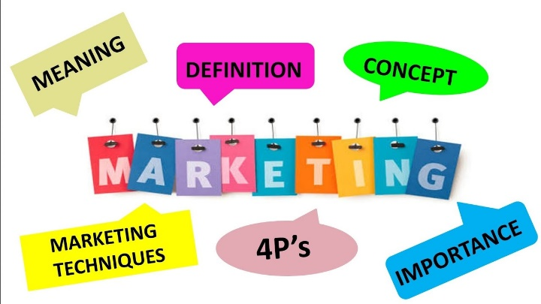
The evolving discipline of marketing

The marketing discipline had its origins in the early 20th century as an offspring of economics. Economic science had neglected the role of middlemen and the role of functions other than price in the determination of demand levels and characteristics. Early marketing economists examined agricultural and industrial markets and described them in greater detail than the classical economists. This examination resulted in the development of three approaches to the analysis of marketing activity: the commodity, the institution, and the function.

Commodity analysis studies the ways in which a product or product group is brought to market. A commodity analysis of milk, for example, traces the ways in which milk is collected at individual dairy farms, transported to and processed at local dairy cooperatives, and shipped to grocers and supermarkets for consumer purchase. Institutional analysis describes the types of businesses that play a prevalent role in marketing, such as wholesale or retail institutions. Finally, a functional analysis examines the general tasks that marketing performs. For example, any marketing effort must ensure that the product is transported from the supplier to the customer. In some industries this transportation function may be handled by a truck, while in others it may be done by mail or e-mail, facsimile, television signal, the Internet, or airline. All these institutions perform the same function.
As the study of marketing became more prevalent throughout the 20th century, large companies — particularly mass consumer manufacturers — began to recognize the importance of market research, better product design, effective distribution, and sustained communication with consumers in the success of their brands. Marketing concepts and techniques later moved into the industrial-goods sector and subsequently into the services sector. It soon became apparent that organizations and individuals market not only goods and services but also ideas (social marketing), places (location marketing), personalities (celebrity marketing), events (event marketing), and even the organizations themselves (public relations).
Definitions of Marketing
- Marketing is the activity, set of institutions, and processes for creating, communicating, delivering, and exchanging offerings that have value for customers, clients, partners, and society at large. (American Marketing Association, Approved 2017)
- Marketing is the science and art of exploring, creating, and delivering value to satisfy the needs of a target market at a profit. Marketing identifies unfulfilled needs and desires. It defines, measures, and quantifies the size of the identified market and the profit potential. It pinpoints which segments the company is capable of serving best and it designs and promotes the appropriate products and services. (Dr. Philip Kotler – the father of modern marketing)
- Marketing is the management process involved in identifying, anticipating and satisfying customer wants profitable (Institute of Marketing)
Summing up, we can infer that marketing is the process of getting potential clients or customers interested in your products and services. The keyword in this definition is "process." Marketing involves researching, promoting, selling, and distributing your products or services. This discipline centers on the study of market and consumer behaviors and it analyzes the commercial management of companies in order to attract, acquire, and retain customers by satisfying their wants and needs and instilling brand loyalty.
Today, marketing is something that every company and organization must implement in its growth strategy. Many companies use marketing techniques to achieve their goals without even realizing it, as they work to promote themselves and increase sales of their product or service. These days, marketing is one of the key aspects of business.
People often do not know exactly what marketing is and, when asked, they define it as selling or advertising. While these answers are not wrong, they are only a part of marketing. There are many other aspects to marketing like product distribution, promotion, designing and creating materials like landing pages and social media content, improving customer experience, doing market research, establishing market segments, and much more.
Marketing is very broad and encompasses all the strategies that help a company, brand, or individual achieve their objectives.
5.1.2 The purpose and benefits of Marketing
Marketing is a fundamental activity when doing business and growing a brand. If no one knows about your products or services, no one can buy what you offer. Marketing communicates the reasons why consumers should choose your brand, including the benefits, the price, and the unique features of your goods. It also helps maintaining relationships with customers and create engagement, which in turn drives word of mouth and referral marketing.
The positive benefits of marketing will be evident as the brand is built, the visibility of the company and products/services rises among diverse audiences, and the company gains a competitive edge over competition. Some of the expected benefits include:
- Growing sales. Developing and employing good marketing tactics, will undoubtedly result in making more sales. However, marketing is not just targeting new customers but also encouraging additional sales to existing and past customers, which is quite crucial when planning the company’s future. A marketing strategy makes the company more memorable and visible / easier to find when customers need what it sells and want to know more about the company’s activities, products, services, etc.
- Using and managing reputation. Having a positive reputation is proving to be a critical differentiator. Marketing a business online and through advertising, being transparent, engaging with customers and using smart tactics will enhance the company’s reputation positively while building a brand’s reputation is one of the marketing benefits that a company should not overlook. Consumers today tend to research every product and service they want to buy, so reputation matters more than ever.
- Getting to know your audience. Good marketing enables the collection of data and metrics about targeted audience and therefore companies can adjust their strategies and advertising. A targeted marketing strategy based on data about customers is one of the best ways to develop multiple revenue streams from segmented audiences. Once a company has a solid understanding of its audience, it can target them to match their specific needs and pain points.
- Earning trust. Great marketing strategies help building trust that will keep customers investing in the company’s products, services, and brand.
- Knowing what works. Effective marketing strategies help determine what works and what doesn’t. When a company implements a series of campaigns, measuring and evaluating results pinpoints the features of the marketing strategy that brings the best outcomes.
- Learning the marketplace. Implementing the marketing process will result in a better understanding of the marketplace in which the company is operating. The more a company knows about its marketplace the easier it gets to identify opportunities. Especially for small businesses, being familiar with the marketplace is quite essential. This entails acquiring knowledge not only about the target market, but also getting to know the local, national and international competitors, the industry events, and the consumer trends.
The above-mentioned benefits of using well designed marketing tactics only constitute the six main reasons good marketing can help a business succeed. However, there is a supporting cast of additional benefits, direct of indirect, in the short or long run, depending on the specific marketing strategy and tools in action.

5.1.3 Marketing Principles
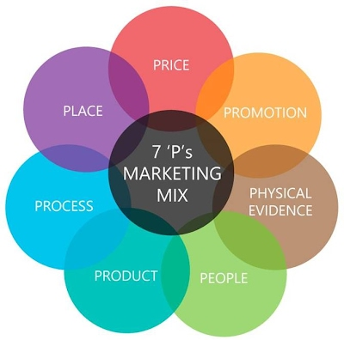
Marketing principles are the most commonly used principles that are around since the 1960s, these principles stood the test of time and have remained the
same - with a little variation here and there - for decades. Businesses follow these principles for a successful marketing strategy.

There are four original principles of marketing referred to as 4Ps or 4P marketing Matrix that companies use for their marketing strategy. These four basic marketing principles Product, Price, Place, and Promotion are interconnected and work together; hence, they are also known as “Marketing Mix”.
There have been some variations throughout the years while during the 1980s three more principles were added to these original four principles that are used by some companies and referred to as 7Ps.

The 4 Principles of Marketing (4Ps):
Product
Product is one of the most crucial principles of marketing. The product can be either a good or a service the company provides to customers. One important thing that often owners ignore is to study the appeal of their product and market for it before deciding what it is they want to offer.
If a company wants to sell a profitable product, then it needs to do thorough planning and look at the product(s) from the customers’ eyes and consider all the essential factors when developing a plan. These factors may include questions such as costumers’ needs, the quality of the product, how is it different from others and what is its selling point, as well as how safe it is for the customers.
You not only need a quality product but also be able to successfully define the quality of your product to your prospective consumers and turn them into consumers and customers.
Price
The price refers to the money the customer has to pay for the product or services they receive. There are two types of pricing, such as cost-oriented prices and market-oriented prices.
In market-oriented prices, there is more to price than the contribution price, and it needs thorough market research. Some things to look into are:
- What the customers are willing to pay.
- The price of the same type of products offered by competitors.
- And the goals the company has set to reach.
Moreover, the price is selected after determining the market value. Or on the value the company offers through its products or services. If the price is set at higher level than market value, customers will have more expectations from the product, and the company should live up to these expectations for a successful business. The price can also be adjusted with time to make sure it is right for the current market.
Place
Place refers to the process of bringing the products and services to the customers. The place is wherever the products or services are available for purchase and customers can buy them. It could be an actual store, an online website, or multiple channels can be used to reach a broader audience.
It is essential for a business to choose the right place that is convenient for customers, and reach out to the potential customers to increase the sale of the product. Therefore, careful planning of the placement or distribution of your product is important for a successful business. For instance, knowing where your prospective customers are, where your location should be, and how to connect your potential customers to your location is an essential part of your business growth.
Additionally, in today's digital age, no matter where the store or services are located, a digital presence can make a huge difference in reaching out to potential customers, as more and more people tend to search online for their needs.
Promotion
Promotion is creating awareness for your products, services, company, and brand. All the ways a company use to build awareness for their product and services are known as promotion. Promotion should give customers a reason to choose your product or service, as well as show the prospective customers the benefits of using these specific products.
Promotion is the backbone of marketing and as crucial for businesses as the quality of the products they produce. It refers to communicating with the target audience through different channels and creating awareness for your product and services.

5.2 Marketing and the Agricultural Sector

5.2.1 How is marketing related to agriculture?
The production of quality and /or sustainable agricultural products on its own cannot guarantee the successful operation of an agricultural company or the prosperity of the farmer. The international environment of agricultural products markets is highly competitive and in order for farmers/producers to be able to find the appropriate ways out for selling their products they have to follow the principles and philosophy of marketing in every aspect of their activity.
Agriculture fulfils the basic need of humankind by producing food. About a century ago, farmers used to produce food commodities mostly for self-consumption or for exchange with others (cash or kind) mostly in the same village or nearby places. They were primarily self-reliant. But now production environment has changed considerably from self-reliance to commercialization. Technological advancement in the form of high yielding varieties, use of fertilizers, insecticides, pesticides, farm mechanization has led to a substantial increase in farm production and consequently the larger marketable and marketed surplus. The improved production is accompanied by the increasing urbanization, income, changing lifestyle & food habits of the consumers and increasing linkages with the overseas market. Today consumers are not limited to rural areas where food is produced. Further, increasing demand for processed or semi-processed food products requires value addition in the raw agricultural produce. These developments require movement of food commodities from producer to consumers in the form of value-added products. Agricultural marketing brings producers and consumers together through a series of activities and thus becomes an essential element of the economy. The scope of agricultural marketing is not only limited with the final agricultural produce. It also focuses supply of agricultural inputs (factors) to the farmers.

5.2.2 The meaning of agricultural marketing
The term agricultural marketing is composed of two words- agriculture and marketing. Agriculture generally means growing and/or raising of crops and livestock while, marketing encompasses a series of activities involved in moving the goods from the point of production to point of consumption. Many scholars have defined agricultural marketing and incorporated essential elements of time, place, form, and passion utility.
Agricultural Marketing or Marketing of Agricultural Products is a set of rational business activities put into action by farmers or agricultural companies, so that they can foresee the needs and demands of the market, plan and develop the products that will satisfy these needs. Agricultural marketing is what comes in between the producer and consumer during the flow of the products from the one part to the other. It is a high value system that includes marketing channels, intermediaries and other procedures that enable the production and promotion of agricultural products.
Some of the definitions of agricultural marketing are given below:
- The study of agricultural marketing comprises all the operations, and the agencies conducting them, involved in the movement of farm produced foods; raw materials and their derivatives, such as textiles, from the farms to the final consumers, and the effect of such operations on the farmers, middlemen and consumers (Thomsen).
- Agricultural marketing is a process which starts with a decision to produce a saleable farm commodity, involves all the aspects of market structure or system, both financial and institutional, based on technical and economic considerations, and includes pre- and post-harvest operations, assembling, grading, storage, transportation, and distribution (National Commission on Agriculture, 1976).
Agricultural Marketing is the most important multiplier playing a crucial role in accelerating the pace of economic development, providing ways of directing excessive production to domestic and international markets. Some of the advantages in implementing agricultural marketing include:
- Optimization of resource use and output management: an efficient agricultural marketing system leads to the optimization of resource use and output management. An efficient marketing system can also contribute to an increase in the marketable surplus by scaling down the losses arising out of inefficient processing, storage and transportation.
- Increase in farm income: an efficient marketing system can reduce the number of middlemen and therefore products can be available in better prices, leaving room for additional investments.
- Widening of markets: marketing can help farmers access new and remote markets
- Growth of agro-based industries: an improved and efficient system of agricultural marketing helps in the growth of agro-based industries and stimulates the overall development process of the economy. Many industries like cotton, sugar, edible oils, and food processing depend on agriculture for the supply of raw materials
- Price signals: efficient marketing helps farmers in planning their production in accordance with the needs of the economy. This work is carried out through transmitting price signals.
- Adoption and spread of new technology: marketing systems help farmers in the adoption of new scientific and technical knowledge since farmers can keep up with market trends and have assured their sales at given prices due to the marketing strategy they implement.
- Additional income and better living: marketing activities add value to the product and thereby promote better sales and prices, which in turn adds up to the income and well-being of the farmer.

5.2.3 The role of Food Marketing in sustainable agriculture
The role of food marketing, which is an integral part of sustainable agriculture is constantly growing globally to further promote its use, we are need the contribution of all essential elements, namely social, economic and environmental, starting from the level of small farms and reaching big production conglomerates. We also need to focus on principles and steps required to make the food marketing successful with the optimal use of natural resources, avoiding their exhaustion. We need to study and understand know-how, best practices, consumer behavior and expectations, consumer, nutritional needs taking into consideration the rapid evolution of the world we live in. We should also pay due attention to the environmental protection. And, of course, we should not forget making profit –“how a farmer can make profit using successful food marketing (in addition to all other sustainable agriculture techniques)”. We need to understand how a farmer can be proactive in marketing, what he or she should produce depending on the consumer demand and how a farmer can produce and market optimally without exhaustion of natural resources. In the search of optimal steps of growing, producing and marketing, it is essential for the farmers at every level to reach the right combination of all essential elements paying due attention to the principles of sustainable agriculture. This will eventually provide agricultural production a sustainable character and will ensure better return on investments.
5.2.4 Green Marketing
Green marketing refers to the practice of developing and advertising products based on their real or perceived environmental sustainability. These products or services may be environmentally friendly in themselves or produced in an environmentally friendly way.
Examples of green marketing include advertising the reduced emissions associated with a product’s manufacturing process, or the use of post-consumer recycled materials for a product's packaging. Some companies also may market themselves as being environmentally-conscious companies by donating a portion of their sales proceeds to environmental initiatives, such as tree planting.
Green marketing is one component of a broader movement toward socially and environmentally conscious business practices. Increasingly, consumers have come to expect companies to demonstrate their commitment to improving their operations alongside various environmental, social, and governance (ESG) criteria. To that end, many companies will distribute social impact statements on an ongoing basis, in which they periodically self-report on their progress toward these goals.
Typical examples of ESG-related improvements include the reduction of carbon emissions involved in a company’s operations, the maintenance of high labor standards both domestically and throughout international supply chains, and philanthropic programs designed to support the communities in which the company operates. Although green marketing refers specifically to environmental initiatives, these efforts are increasingly presented alongside social and corporate governance policies as well.
There are many incentives for companies that choose to engage in green marketing. To begin with, a companies’ perceived commitment to environmental causes is an increasingly important factor influencing many consumers' spending habits. The 2014 Nielsen Global Survey on Corporate Responsibility, for example, found that roughly 55% of consumers were willing to accept higher prices from companies deemed to have a positive social and environmental impact—a 10% increase from the previous survey in 2011. In some regions, such as Asia, Latin America, and the Middle East, this attitude was even more common, shared by roughly 65% of respondents in 2014.
When it comes to sustainable agricultural products, green marketing can play an increasingly important role in promoting the benefits of consuming these products, thus contributing to business development of sustainable agricultural products as well as the development of national and international sustainable agriculture. Promoting sustainable agricultural products through the use of green marketing techniques is useful for improving human, environmental and economic health, in the context of sustainable development.

5.3 Marketing Strategies for Sustainable Agricultural Products
Direct Marketing
Direct marketing is a common strategy especially for beginning and small farmers, and very appealing to producers that want to promote the special characteristics of production methods or the premium quality of their products. Direct marketing not only gives the opportunity to the farmer to have more control of the price and receive full profit by avoiding intermediaries but also to get in direct contact with customers. Some of the direct marketing strategies include:
- Farmers Market: During the last decades the number of Farmers’ Markets has more than doubled reflecting the enormous demand for farm-fresh produce. Most farmers markets offer a reliable, flexible outlet where vendors can sell a wide range of fresh produce and value-added products. Moreover, nowadays, farmers can also sell their products in specialized farmers markets, especially those that offer organic products or products with some type of certification. The farmers’ market is often the very first place that new farmers begin selling their produce due to the fact that it is easily accessible and attract many customers. Among other benefits, the farmers’ market gives the opportunity to the farmer to sell directly to the public and reap all profits as well as to develop personal relationships with customers.
- Community Supported Agriculture: Community supported agriculture is a marketing method in which members of the community invest in a local farm operation by paying-up front for a share of the harvest. The community idea carries over into the farm itself, with members dividing the weakly harvest as well as the risk of crop failure. Farmers may also ask members to come to the farm to pick up their shares or they might deliver them to centrally located distribution sites. Many farms ask members to commit time and labor to the operation, which not only lowers costs but also allows members to learn more about what it really means to grow food. When evaluating this marketing method as an option, the farmer must take into consideration the location of the farm, the availability and willingness of members to get involved and his/her capability to sponsor events on the farm, publish newsletters or provide other services that help customers fell connected to the farm.
- On-Farm Sales and Tourism: This type of marketing strategy refers to farms that are open to visitors for product sales and experiences. More and more consumers seek opportunities to shop at farm stands and interact with farmers. In response, farmers are becoming more attuned to ways they might maximize their offerings. They usually offer experiences like pick-your own operations, overnight farm stays, tastings, events (weddings, cooking classes), tours, horseback riding, farm walks and hunting.
- Internet, e-mail and social media: Using Internet as a way of selling agricultural products is changing marketing channels in the agribusiness industry. Internet can serve farmers as an alternative marketing channel. Farmers who establish a website by which they sell agricultural products, thus use quite a different marketing channel. It helps many farmers to find new customers, to cross geographic market limitations and to find new markets. Farmers can use internet on many possible ways to sell their products. Through internet, farmers can sell the products directly to the consumers through B2C (business to customers) transactions but also to retailers, wholesalers and other organizations through B2B (business to business) electronic commerce.
- Cooperative marketing: Farmers can form or participate in cooperatives in order to market and sell their products all together. This way they can better control the prices they get for their products and reduce costs of transportation and marketing.
- Season Extension: involves using greenhouses, unheated hoop houses, row covers or alternative varieties to push fruit and vegetable crops earlier into the spring or later into the fall. Lengthening the marketing season can be critical to spreading workload and evening out cash flows.
- Sales to Restaurants and Institutions: restaurants, especially high-end restaurants, provide lucrative markets. Chefs and restaurant patrons pay premium prices for top quality, distinctive, locally grown products to include in their menus. Moreover, if the restaurant itself applies green marketing, it will surely search for sustainable locally produced agricultural products. In many cases, restaurants tend to identify farms in their menu item description and in other promotional activities.
- Buy-local Campaigns: these campaign, that are usually developed by a group of farmers operating in the same area, can engage consumers and promote purchases from local farmers and ranchers. Moreover, these campaigns are in many cases developed and supported by chambers, municipalities and other local public authorities.
- Value Added Products, Food industry, Specialized Retail Shops, etc.

5.4 The Agricultural Marketing Plan
This section details the development of a marketing plan and its importance for the promotion of sustainable agricultural products. We will study the contents of a marketing plan, briefly analyzing each critical section giving special attention to the allocation of resources for implementing the marketing strategies.
Marketing success grows out of a good marketing plan. This is a formal, written document that describes the company’s brand marketing and the promotional strategies. It should outline who the company represents, what it does, who the customers are and how the farmer plans to market the products. Usually, the marketing plan covers a period of 12 months. For an agricultural producer developing a good marketing plan will help identify and quantify costs, set price goals, determine potential price outlook, examine production and price risk and develop a strategy for marketing crops.
The marketing plan includes several components: situation, objectives, value proposition, marketing strategy and tactics to achieve the company’s marketing goals
There are many different models for marketing plans but they all include the following five essential sections:
5.4.1 Analysis of current situation
In this section the farmer has to develop an analysis of the current situation of his/her farming operation. This includes the development of a SWOT analysis, looking at the company’s strengths, weaknesses, opportunities, and threats. This involves identifying competitors, understanding how they operate and becoming familiar with their strengths and weaknesses.

Strengths are any competitive advantage, skill, expertise, proficiency, talent or other factor that improves the company's position in the marketplace and can't be easily copied. Examples are a well-trained sales team, low staff turnover, high consumer retention or low production costs due to superior technology.
Weaknesses are the factors that reduce the company's ability to achieve its objectives independently. Examples include unreliable delivery, outdated production tools, insufficient marketing efforts and a lack of planning.
Opportunities are ways for the business to grow and be more profitable. These can include seeking new markets, managing technological change or addressing new consumer trends. Farmers should examine the way the company's main skills can be used to take advantage of these opportunities.
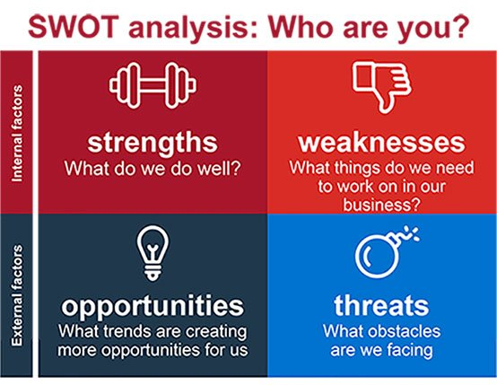
Threats are barriers to entry in the primary markets, such as a labour shortage, legislative hurdles or detrimental economic or political developments.

5.4.2 Determining the target market
Having a well-defined target market gives farmers a significant advantage when it comes to effectively competing against large companies by targeting a niche market. Targeting a specific market does not mean excluding customers that fit the criteria but rather allows the producer to focus the marketing budget on a specific market that is more likely to buy the products. Moreover, a clearly defined market offers the foundation on which one can determine where and how to market his/her company.
A good place to start in determining the target market is the already existing customer base, their common characteristics and interests that can also be found in other groups of people and become potential customers. In case of a new company, the farmer should first analyze the characteristics of the product(s) and then segment the market and define the targeted one(s).
It is a fact that many agricultural products do not find the place in the market that they deserve and despite the fact that farmers put additional effort, knowledge and expertise in producing them, they are not compensated accordingly. When these products enter the channels of massive distribution, they get mixed up with others and their special attributes and quality get lost in the food production process. Moreover, final products are even more expensive with apparent deficits. The case is even worse when it comes to sustainable agricultural products where the benefits of the production process and the quality of the final product never reaches the consumer.
So even though farmers seem to have multiple target markets, it is to their best interest to choose the ones that bring out the unique attributes of their products, the environmental- friendly production process and the health benefits to the consumers.
Once the characteristics of the products as set out and are matched with the benefits they provide to customers, the producer can easily determine to whom the products are addressed to and therefore define a general target market. To make it even more specific, the market can be segmented based on demographic and psychographic criteria. What is the age range and/or gender of the potential customer? Where does he live? What are some determining personality characteristics, attitudes or values?
Last but not least, a producer must always check out the already existing competition in the same market. Special attention should be placed not only on the competitors’ products but also on their current customers. A farmer must be able to determine whether he/she targets the same market as competitors or if there is a niche market that they are overlooking and whether his/her products are superior to the competitors’.
5.4.3 Knowing your customers
Understanding customers is the key to providing good products and services. And to succeed that a producer must know the customers so well that can anticipate their needs, deliver what promised, and exceed their expectations. Being really attentive to customers when in contact with them can generate significant rewards for the business, like customer loyalty and positive word-of-mouth recommendation to new potential customers.
Understanding customers is the key to giving them good products and services which in turn will result into strong customer relationships and new sales. Issues to be addressed by producers are: customer real time behavior, different categories of customers, customer engagement, customer service interactions and customers’ personal tastes and preferences.
This section must include a customer profile with basic demographic portraits such as age, sex, profession or career, income level, educational level and geographic location. Moreover, an estimation should be done concerning the expected demand for the products as well as the rate at which this demand is expected to grow.
5.4.4 Setting marketing objectives
Marketing objectives are specific goals put in place by the farming operation in order to promote their products and services to customers. Marketing objectives are an overall marketing strategy that helps to achieve organizational goals in a set period. These goals may include increasing sales by 13% in the next six months, improving consumer awareness of a new product or service, or increasing customer satisfaction. Marketing objectives must have the following characteristics so that they can be easily achieved: Specific – Measurable – Achievable – Realistic – Time-specific (SMART)
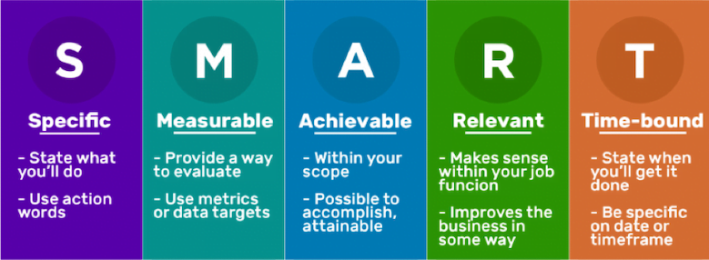
Examples of marketing objectives include:
- Increase sales revenue
- Grow brand awareness – develop a customer reward system in
- Promote new products and services – promote new products so that a specific quantity is sold in a specific period of time
- Grow digital presence – create a new blog, a website, sell products through the website, join an electronic farmers’ market
5.4.5 Determining the Marketing Strategy(ies)
As defined by Investopedia, a marketing strategy is “a business’s overall game plan for reaching prospective consumers and turning them into customers of the products or services the business provides”. So actually it is about strategic planning on how the producer can get his company in front of people who are going to buy from it. The Marketing Strategy helps the farmer reach the target market and the target audience as defined in the previous sections of the marketing plan. In addition, the selection of the appropriate strategy(ies) helps the farmer invest in the right places, with better return on the money invested and have measurable results.
When selecting a strategy, the farmer must always keep in mind to cover the 4Ps, meaning which product or which product characteristics, at which price, where to be sold and how to be promoted. There are many different forms of marketing strategies that a producer of sustainable agricultural products can choose from, some of which are already mentioned in chapter 3. The list in not exhaustive while producers can make as many combinations as needed. Moreover, today more than ever, new generation farmers are highly creative and bold trying out innovative marketing strategies never tested before, like e-commerce or selling a basket of products rather than a unique product.
The marketing strategy must contain information on: i) how to reach specific categories of customers (will you use digital, traditional marketing or both?); ii) who will be responsible for creating the marketing / promotional materials (brand, videos, photos, advertisements, online store, etc.); iii) how will these materials be shared (e-mail campaign, social media, farmer’s market, salesperson, PR, etc.); and iv) how the success of the strategy is going to be analyzed (was the strategy successful? Did it bring the desired results? Were the objectives met?).
5.4.6 Financial Planning
Financial planning is an essential part of developing the company’s marketing plan. The producer should make sure that he has allocated enough money to achieve marketing goals without being wasteful. Similarly, he must ensure that he is getting a sufficient return on the investment for the marketing activity to be worthwhile. The farmer must take into consideration the costs and expenses required to implement the selected marketing strategies and set specific quantitative or even qualitative goals to be achieved by the completion of the process.

5.5 Measuring Results and Fine-tuning
This section presents the necessary assessment and evaluation of the results after the implementation of the Marketing Plan. We will study the way to assess the achievement of quantitative and qualitative goals set in the Marketing Plan and quantify results. Moreover, students/trainees will learn how and where they need to take corrective measures and actions in their marketing plan and how often they should repeat this procedure.
As stated above, marketing plans help businesses and companies attract new customers, get sales, and generate profits. To determine whether a marketing campaign is successful, you need to measure more than just the number of sales and amount of profit brought in. Establishing and measuring the success of a marketing campaign involves using key performance metrics (KPIs), some of which are:
- Return on Investment (ROI) which measures how much a company has invested in marketing versus how much it earned back
- Cost per win, which measures the expense of each sale against overall cost of marketing. Really useful to compare campaigns against each other to see which performs better.
- Cost per lead, which measures the effectiveness of marketing campaigns from a financial perspective focusing on the number of leads rather than sales
- Cost per conversion, really useful for online sales, which measures how much it costs to convert a website visitor into a buying visitor
- Customer lifetime value, which measure the lifetime value by calculating the customer’s average sale amount by how many times they buy each year by the average amount of years they remain a customer
- Cost per acquisition, website traffic, conversion rate, new vs returning visitors, and many more.

5.6 Case Studies
The learners will be asked to identify and examine a local sustainable agriculture product that has successfully implemented a marketing strategy either in their country or elsewhere (unsuccessful marketing strategy is also an option for studying an example of what went wrong).
For Greece we are studying the successful marketing of Saffron (Krokos Kozanis) that used a cooperative marketing strategy, creating a Compulsory Saffron Producers Cooperative and has been certified as a PDO (Protected Designation of Origin) product.

Bibliography
https://www.ama.org/marketing-news-home/
https://www.researchgate.net/profile/Thabit-Thabit/publication/324923406_The_Evaluation_of_Marketing_Mix_Elements_A_Case_Study/links/5aeb827a458515f59981df6e/The-Evaluation-of-Marketing-Mix-Elements-A-Case-Study.pdf
https://www.thebalancesmb.com/green-marketing-2948347
https://smallfarms.cornell.edu/resources/guides/guide-to-farming-in-ny/
https://farmandanimals.com/how-do-farmers-sell-their-produce/
https://venngage.com/blog/marketing-plan/

Module 6: International trade and cooperation

6.1 The importance of agricultural trade
Agriculture as a branch of the world economy plays a significant role in human life. Its main goal is to meet the needs of the population in food, and industry in raw materials. Even the ancient Greek scientist Xenophon said that: “... agriculture is the mother and breadwinner of all other crafts. When agriculture is well managed, all other trades flourish, but when agriculture is neglected, all other trades decline.” It is difficult to overestimate the role of agriculture, it provides people with food, the lack of which leads to hunger. Problems in the field of agriculture lead to social tension and instability in society, so its development is controlled in all countries [Dolgov, 2014]. As indicators of the role of agriculture in the world economy, one can use such indicators as: the share of agriculture in the structure of GDP, investment in agriculture, the share of people employed in agriculture among the economically active population. Although the role of agriculture in people's lives is unambiguous, its role in the economic sphere is not precisely defined. The main indicator of the role of any industry is its share in the production of world GDP. According to the World Bank, from 2002 to 2009 the share of agriculture in world GDP. The share of agriculture in gross domestic product (GDP) increased, making it the sole bright spot in GDP performance during 2020-21. The resilience of the farming community in the face of adversities made agriculture the only sector to have clocked a growth at constant prices in 2020-21, when other sectors slid. Agriculture value added per worker versus gross domestic product (GDP) per capita, constantly increased in the BSB Countries and EU (https://tradingeconomics.com/country-list/gdp-from-agriculture).
The role of agriculture will also help reflect investments in this area. It is difficult to talk about investments since there is no detailed information about their scale. Investors are mainly the private sector, but governments and public investment funds are also involved. Investment companies in the private sector are often founded by the government or state investment funds, which makes it difficult to separate them and assess the degree of public involvement. Over the past fifty years, the number of multi-national companies has grown. They have expanded their global reach to supply food, feed and biofuels, timber, and minerals. Recently, new international players, including governments and some companies have also begun to acquire land [Revenco, 2010].
Agricultural exports are also on the rise, and are becoming more and more important, with increased transport capacity and capacity retention and growing challenges some countries face in domestic production, including due to restrictions related to lack of arable land. International trade in agricultural products has expanded faster than the GDP of world agriculture [Glauber, 2020].
With the increase in the volume of global trade in agricultural products, the structure of this trade has also changed over the past decades. There has been an increase in the share of high-quality products - mainly fish and fish products, fruits and vegetables - in world agricultural trade. Developing countries have experienced a sharp increase in these exports, while the importance of their traditional exports such as coffee, cocoa and tea has declined. Traditional crops still play an important role in many countries. In many countries, a combination of population growth, lack of technological development and inefficient distribution mechanisms have led to a rapid decline in the availability of natural resources for many poor farmers. Soil fertility is still declining in many areas due to lack of nutrients (mineral or organic) due to imperfect markets or lack of purchasing power. Water is becoming an increasingly scarce commodity around the world as water resources such as rivers are increasingly being used for a variety of purposes such as agriculture, hydropower, or drinking water. Despite the decrease in the share of agriculture in world GDP, it continues to play a significant role in the development of the world economy and society. Agriculture provides a large number of jobs, it produces food and raw materials. With the transition of energy to biofuels, agriculture will occupy a special place in the world. In addition, agriculture contributes to food security and poverty reduction. The development of agriculture is proceeding at a rapid pace, and in this it is helped by progress in science and technology. Agriculture not only develops, but also contributes to the development of world trade and the world economy as a whole.
Food security problems are closely related to the development of agricultural production. States have an obligation to ensure the right of everyone to have access to safe and nutritious food consistent with the right to adequate food and the right to be free from hunger.
The high dynamics of demand, production and sales in all sectors of agricultural production, a sharp increase in world prices for raw materials, including those of agricultural origin, and food - all this created new conditions and prerequisites for the further development of the agricultural sector.
All countries of the world are involved in trade in agricultural goods and foodstuffs. In the structure of world trade, this sector accounts for 12% by value and 19% by tonnage. The high dynamics and volumes of trade in these goods in recent years are associated with a general increase in world consumption - an increasing population, an increase in its well-being, and a change in the structure of demand. There are signs that during the period of the global crisis, trade in basic types of food in physical terms not only did not decrease but continued to grow. The growing demand for agricultural products comes from industry, energy and transport [World Trade Statistical Review, 2019].
The engines of world trade in agricultural goods and foodstuffs are currently populous rapidly developing countries. They are not only major food importers, but also world-class exporters [https://www.fao.org/3/i6583e/i6583e.pdf].
State policy has a great influence on the development of agricultural production. The dependence of this sector on the state is largely determined by the fact that significant volumes of agricultural products are produced in countries and areas with high costs (USA, Europe) and potential producers cannot survive in conditions of free competition.
The success of agriculture, therefore, depends not only on the level of technical equipment, as is the case in industry, but also on the ability to provide financial and administrative support to the producer and exporter. A high degree of state participation is also determined by the need to solve strategic problems - ensuring national food security, supporting the development of agricultural territories, providing employment, and solving social problems.

6.2 Modern Trade models
Country Similarity Model
Country Similarity Model
In the BSB region, consumers have similar levels of per capita income and development may well have the same tastes and could proportionally consume the same quality products. Therefore, those countries are likely to trade and consume the same quantity and quality of goods and services. Products are mostly traded based on similar demand structures in countries [Linder, 1961].
International Product Life Cycle Theory
Countries would first and foremost, produce and locally consume a product, before it goes to other countries. In the long run, the production and sales locations of the enterprise’s products may change. A comparative advantage of a given product may shift from one country to another [Vernon, 1966]. Vernon described five stages of a product life: the introduction of new, production to the market stimulates trade, that mostly takes place in similar regions or countries. The growth stage leads to competition, capital intensity and increase for exports and transfer of technology from the innovating country, and foreign investment to other countries. Thirdly, maturity leads to the decline in exports from the innovating country. Fourthly, the saturation takes place at a stage in which the sales or distribution of product(s) reach the peak position, and finally, the phase of declining as overseas production intensified. It is characterized by a concentration of production in the developing countries [Verter, 2015].
Intra-Industry Trade
This model states that international trade takes place as a result of economies of scale, product differentiation and imperfect competition between and within industries and countries.
The New Trade Theory
The gains from trade arise due to a larger number of varieties of goods available to consumers. Greater production of each type results in higher real income as prices are reduced due to increasing market size and competition. Comparative advantage does not solely depend on the differences in factor endowments; rather it depends on the economies of scale and network effects that occur in the critical industries.
Porter’s National Competitive Advantage Theory
Trade patterns are determined by the level of businesses and economic situations in countries that traded. Porter pointed out that, ‘the only meaningful definition of competitiveness at the national level is national productivity’ [Porter, 1990, p. 6]. Porter postulated four keys to a state’s competitive advantage in comparison to the other nations: factor conditions; demand conditions; related and supporting industries; and firm strategy, structure and rivalry of markets, research and development) determinants available in a given economy. Factor conditions are the basic (natural resources, location, vegetation and climatic condition and fertile land for agricultural production) and the advanced (i.e. communication, skilled workers, deregulation. Nations should export products from those companies in where all the four pillars are conducive, whereas, in that area that are not favourable, countries should import. The Government has a vital role to play in ensuring that businesses maintain a high quality of production, service delivery and healthy competition among firms.
The Gravity Model of Trade
This model stresses that the economic sizes and distances between nations are the primary factors that determine the patterns of trade across national boundaries. The model argued that larger economies are more likely to produce goods and services for domestic consumptions and exports than small economies. More so, these economies generate more revenues from their products sold, paving ways for people to buy more import products. The theory further stressed that the distance or geographical location between individual countries or markets has an influence on the cost of imports and exports of products.
New ‘New Trade’ Theory
Trade is mostly carried out with homogeneous products (equal in productivity). Trade in homogeneous products, mostly takes place in industrialized countries, while inter-industry trade with heterogeneous products takes place in both developed and developing countries. Agricultural markets are often either faced with imperfect competition through the downstream or upstream sector. Farm products are modelled as differentiated and monopolistic competition along the supply chain. But usually, firms are rather heterogeneous and vary in their productivities. Free trade does not only lead to resource reallocations within sectors, but also between sectors.

6.3 Food price and price fluctuations
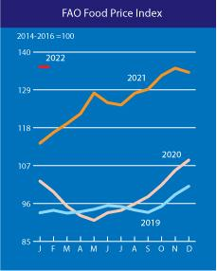
Many factors contribute to the rise in prices and their volatility. Among them worth notice the imbalance of the elements of the market mechanism, the lack of an effective system for regulating world food trade, the rise in energy prices in the medium term, the development of the bioenergy sector, speculative activity in the food markets, the impossibility for developing countries to use their natural and labour potential for the development of activity in the agricultural sector due to economic backwardness and the inability to meet the requirements of world markets [WTO, Agreement on Agriculture]. To this, one can add the growth of well-being and consumption of food products by the population of a number of rapidly developing countries, the measures taken by the governments of many states to subsidize domestic consumption against the backdrop of low investment in the agricultural sector and reduced supply on the world market.
Figure 1: Food price index (https://www.fao.org/worldfoodsituation/foodpricesindex/en/) Note. The food price index consists of the average of price indices for six commodity groups (55 commodities) weighted by the average share of exports in trade of each commodity group in 2002-2004: the overall index includes published prices for 55 commodities considered by FAO experts in as representative international food prices.
An important role in increasing the amplitude of price fluctuations in the world markets for basic agricultural and food products is played by the speculative factor. In the context of the current global crisis, the spread of prices was much higher than the usual 8-10% of the average level typical for calm periods. An indirect factor in the impact of speculation on prices, according to UNCTAD, was the growth of world trade in futures and options for food products.
Eight major segments can be distinguished in the structure of the world food market: grain (including flour and cereals), fruits and vegetables (vegetables, fruits, nuts, products from them), oil seeds (oilseeds, vegetable oils), dairy products (fresh and dried milk, cream , yogurt, animal butter, cheeses, etc.), meat (various meats, edible offal, fat, sausages), fish (including seafood), sugar, beverages, other (coffee, tea, spices, cocoa products , chocolate, sweets, flour products, sauces, eggs, honey, etc.). The markets of grain, oilseeds, meat, sugar, as well as coffee, cocoa, bananas, etc., are of the greatest importance in world trade [International trade in food and agricultural products, 2017].

  - Institutional regulatory and legal framework

6.4.1 Food and agriculture organizations
Agricultural and horticultural organizations promote the interests of persons engaged in raising livestock, harvesting crops or aquatic resources, cultivating useful or ornamental plants or similar pursuits. Generally, agricultural, and horticultural activities are those involved in the art or science of cultivating land, including preparing the soil, planting seeds, raising and harvesting crops or aquatic resources (including fishing and related pursuits), and rearing, feeding and managing livestock.
The World Trade Organization (WTO) was established in 1995, forming the cornerstone of a rules-based, multilateral system for trade. The WTO is the sole global organization mandated to deal with the rules of trade between nations. The WTO is a member-driven organisation with 164 members (at July 2019). Its core activities are:
- multilateral negotiations aimed at progressive liberalisation of markets;
- setting the legal ground-rules for trade in the form of agreements;
- resolving trade disputes between states;
- monitoring members’ trade policies.
The European Union is a member of the WTO and as the world’s largest trading bloc, the EU is a key player in the WTO. The European Commission represents the EU, negotiating as a single entity on behalf of all the EU countries. The WTO Agreement on Agriculture aims to establish ‘a fair and market-oriented agricultural trading system’. It sets out rules applicable to all WTO members to provide for substantial progressive reductions in agricultural support and protection [European Commission, Agricultural trade].
The Food and Agriculture Organization (FAO) is a specialized agency of the United Nations that leads international efforts to defeat hunger. Their goal is to achieve food security for all and make sure that people have regular access to enough high-quality food to lead active, healthy lives.
FAO, in its Trade and Food Standard [https://www.fao.org/3/i7407e/i7407e.pdf, p2] stated that “Food standards give confidence to consumers in the safety, quality and authenticity of what they eat. By setting down a common understanding on different aspects of food for consumers, producers and governments, standards enable trade to take place. If every government applies different food standards, trade is more costly, and it is more difficult to ensure that food is safe and meets consumers' expectations”. To trade internationally and have access to markets for high-value products, producers must be able to meet national food regulations.
The Codex Alimentarius Commission was established by FAO and the WHO in 1963 as part of the Joint FAO/WHO International Food Standards Programme [https://www.fao.org/fao-who-codexalimentarius/en/]. It is the single most important international reference point for food standards. Codex Alimentarius is the world’s preeminent international food-standard-setting body. standards contribute to facilitating trade in food and protecting public health. Codex Alimentarius and the WTO form a system of rules to ensure that food is safe, of expected quality, and that it can be traded fairly. Codex standards, guidelines and codes of practice are advisory in nature: to become legally enforceable, countries must voluntarily translate them into national legislation or regulations. All Codex texts are freely available on the Codex website [https://www.fao.org/fao-who-codexalimentarius/en/] and can be accessed by anyone. The standards published in the Codex Alimentarius codify a common understanding among members on what is considered safe food and of agreed and acceptable quality, which allows them to ensure fair practices in the food trade [https://www.fao.org/fao-who-codexalimentarius/en/].
The SPS Agreement [https://www.wto.org/english/tratop_e/sps_e/spsagr_e.htm] sets out rules for food safety and requirements for animal and plant health. It recognizes the right of governments to adopt and enforce measures necessary to protect human, animal or plant life or health. While the need to constrain trade may arise, any measures taken to do so should not be applied in an arbitrary or discriminatory manner or act as a disguised restriction on international trade.
The TBT Agreement https://www.wto.org/english/tratop_e/dispu_e/repertory_e/t4_e.htm] covers a wider variety of product standards and regulations adopted by governments to achieve a range of public policy objectives, such as protecting human health and safety or protecting the environment, providing consumer information and ensuring product quality.
Regional trade agreements (RTA) proliferated in the last decade [https://www.worldbank.org/en/topic/regional-integration/brief/regional-trade-agreements], but, when it comes to food standards and measures, and the TBT and SPS provisions of RTAs, the WTO rules remain the primary determinant for participating in trade.

6.4.2 International trade regulations and standards
Each country establishes procedures and conditions for the purchase of agricultural products from agricultural producers and (or) organizations and individual entrepreneurs engaged in primary and (or) subsequent (industrial) processing of agricultural products produced by agricultural producers on its territory.
Most countries establish Rules for the Functioning of Markets which provide the list of essential terms of the agreement on the provision of a trading place. As a general rule, such conditions may include the right of the market administration to terminate the agreement on the provision of a trading place in cases of failure to provide it with documents that must be available during the entire period of work on the market.
Agri-food products are mostly traded within the EU but exports to third countries are increasingly important. The EU trade balance in agri-food is now positive, and this has been the case for the EU since 2010.
Trade regulation refers to Testing, Inspection and certification, Conformity Assessment, Product Certification and Accreditation, other Technical Regulations.
The general characteristics of agricultural products trade and specific regulation for each AGREEN country are listed below, as described by the International Trade Administration [https://www.trade.gov/research-country].
Armenia:
Armenia has been a member of Russian-led Eurasian Economic Union since 2015 and has free trade agreements with Commonwealth of Independent States countries. Armenia also has a free trade agreement with neighbouring Georgia.
Armenia is able to export certain products to the United States and European Union under generalized system of preferences programs.
Standards for trade are determined by Armenia’s commitments within the Eurasian Economic Union (EAEU) and national legislation. The EAEU stipulates a preference for international standards, with some exceptions. The Eurasian Economic Commission (EEC), the EAEU’s executive body, approves the general list of products subject to EAEU technical regulations, procedures for the development and adoption of EAEU technical regulations, the regulations themselves, procedures for the inclusion of certification bodies and testing laboratories in the EAEU registry of compliance assessment bodies, and uniform compliance certificates and declarations. With Armenia’s accession to the EAEU, some standardization requirements have become much more stringent to match EAEU requirements, particularly with regard to sanitary and phytosanitary requirements.
At the national level, issues related to standards and technical regulations are the responsibility of bodies under the Ministry of Economy. National authorities are responsible for establishing procedures for compliance with EAEU technical regulations in Armenia, establishing accreditation procedures for conformity assessment bodies, and encouraging the accreditation of conformity assessment bodies.
Armenian companies have been granted a transitional period to comply with EAEU technical regulations. This period began in 2016 and will last through 2022 for some products. The Armenian government has recommended that traders adopt EAEU technical regulations as soon as possible. By 2022, all goods produced in, imported into, and circulating within the EAEU must meet EAEU-wide mandatory requirements.
EAEU draft technical regulations are published in Russian on the EEC website for at least 60 days, after which notification is sent to the World Trade Organization (WTO). Any Armenian or foreign entity may comment (in Russian) to the contact listed on the website. Final EAEU technical regulations are published on the EEC website. Once EAEU technical regulations come into force, they prevail over the relevant Armenian technical regulations for the same products.
The National Body for Standards and Metrology (SARM) operates under the Ministry of Economy and is the main standards organization in Armenia. SARM focuses on the research, development, and publication of national, interstate, and international standards. Other key bodies include the National Accreditation Body and Market Surveillance.
Bulgaria
Bulgaria is one of the leading agricultural exporters of crops in South-eastern Europe. Although smaller compared to its neighbours, Bulgarian farmers have long traditions in cultivating all major crops including wheat, corn, sunflower seeds (in 2020 Bulgaria ranked seventh largest exporter in the world), rapeseed, barley etc. One of the key priorities of the Bulgarian Government in the last years have been upgrading and investing in irrigation systems to help local farmers increase efficiency and compete in the EU and worldwide. Modernization of agricultural enterprises, particularly for small and medium-sized farms, is a key priority for the Bulgaria authorities which is backed by EU financial mechanisms such as the EU structural funds and the National Recovery and Resilience Development plan and available to all eligible farmers in purchasing agribusiness technologies and solutions.
In 2020, the share of the agriculture industry in the Bulgarian gross domestic product (GDP) accounted for some 5.1 per cent with industry at 27.5 and services at 67.4 per cent. The total arable land in Bulgaria is some 3.8 million hectares or about 47 percent of the country’s surface area. Bulgaria is a well-respected market player in South East Europe and a key exporter of raw agricultural commodities.
For the period 2021-2027 Bulgaria will have access to some USD 8 billion for farmers support and development of Bulgaria’s agricultural industry which is a notable increase compared to the previous period. Once available, Bulgarian farmers will be able to tap into EU funding and buy new equipment.
Each law, regulation, ordinance, Council of Ministers decree, decision, technical regulation, or agreement enters in force after it appears in the official publication the State Gazette (only in Bulgarian), and the official journals of all issuing authorities. Translated versions of the legislation can be found at: https://www.apis.bg/en/
Institutions linked with trade standards and regulations are: Bulgarian Institute for Standardization, Bulgarian Institute for Metrology, State Agency for Metrological & Technical Surveillance, Bulgarian Drug Agency, Bulgarian Ministry of Health, Bulgarian Accreditation Service
Georgia
At a minimum, imports in Georgia require a declaration, an invoice, and transport documentation. The Customs Code of Georgia [https://mof.ge/en/4677] does not require financial guarantees from importers to Georgia prior to the customs clearance, except for the temporary entry of goods.
The main standards organization in Georgia is the National Agency for Standardization, Technical Regulations and Metrology. Conformity Assessment is one of the functions of the National Agency. Partners of the Agency are ISO, ASTM, IEC, CEN, CENELEC, BIPM, COOMET, IRSA. According to the Governmental Order of March 7, 2013, the United States is among 37 EU and OECD counties that have technical regulations the Georgian government accepts.
Greece
The agricultural sector in Greece remains an important sector of economic activity and employment for Greece, with exports of agricultural products accounting for one third of total exports in Greece. Agriculture contributes 4.1 percent of GDP and is characterized by small farms and low capital investment. Greece’s utilized agricultural area is close to 5 million hectares, of which 57 percent is in the plains and 43 percent is in mountainous or semi-mountainous areas. There are about 150 million olive trees in the country, either in systematic orchards or scattered across the country. Lower agricultural productivity in Greece, compared to other EU Member States, is correlated to the smaller average-size of holdings. The economies of scale offered by modern farming practices have limited impact on the small plots of land typically used in Greece.
Greece imports significantly more food and beverages than it exports. Products with good sales potential include cheese, meat, alcoholic beverages, organic foods, dairy products, some exotic fruits, off season fruits and non-GMO ingredients for the domestic food processing and confectionary/ice cream sectors. Greece has rebounded with 6% growth for 2021 and consumption is gradually recovering. Retail and Food sectors have begun to pick up.
To the extent that European Union food laws have been harmonized, Greece’s food laws and regulations follow European Union rules.
In Greece, food safety is the primary responsibility of the Greek Ministry of Rural Development and Food in cooperation with the General Chemical State Laboratory of Greece and the Ministry of Citizen Protection. Occasionally, the Greek Ministry for Development and Commerce may play a role. The Greek Food Safety Authority (EFET) is responsible for enforcing the regulations and collecting samples from selling points to check compliance with food legislation, both to ensure food safety and protect consumer health in accordance with EU Directive 89/397.
One should check FAS Greece GAIN Report IT1586 Greece Food and Agricultural Import Regulations and Standards for a complete overview of Greek and EU requirements [Hilde Brown, 2015]. Where products are not regulated by specific EU technical legislation, they are always subject to the EU General Product Safety Directive as well as possible additional national requirements.
European Union legislation and standards are under the responsibility of the European Standardization Organizations (CEN, CENELEC, ETSI) and can be used to support EU legislation and policies. The Commission pays special attention to standardization as standards can influence most areas of public concern such as the competitiveness of industry, the functioning of the Single Market, the protection of the environment, and of human health, not to forget the enhancement of innovation. The establishment of harmonized EU rules and standards in the food sector has been ongoing for several decades, but it took until January 2002 for the publication of a general food law establishing the general principles of EU food law. This Regulation introduced mandatory traceability throughout the feed and food chain as of Jan 1, 2005. For specific information on agricultural standards, please refer to the Foreign Agricultural Service’s website.
There are also export guides to import regulations and standards available on the Foreign Agricultural Service’s website.
Romania
Agriculture plays an integral and unique role in Romania’s economy. Nearly one fifth (19%) of Romanians are employed in agricultural related activities, compared to 4.1% EU member average. Romania’s 3.4 million agricultural landowners account for one-third of total agricultural landowners in the EU. However, the average Romanian landholding is 3.7 hectares (HA), considerable smaller than the European Union (EU) average of 15 hectares (HA).
Romania accounts for 11% of the EU area planted with grains and oilseeds. Romania is Europe’s largest corn and sunflower producer and is in the top five of EU wheat and soybeans producers. In 2019, production reached 25.5 million metric tons (MMT) of grains and 4.2 MMT of oilseed. In 2020, Romanian crops have been impacted by an inconsistent weather regime, with frost, wide daily temperature swings and a well below-average rainfall level when plants needed most. These unfavourable weather conditions are expected to reflect in a 15% drop in grain and oilseed production and implicitly, a 23% reduction in exports.
Despite its prominence in agricultural commodity production, Romania remains a net food importer. In 2019 food and agricultural imports increased by 4.6%, while exports grew by 5.1%. Meat, horticulture, dairy, feed ingredients, and beverages were the major product import categories in 2019, while exports consisted of grains, oilseeds, live animals, and fats.
Phytosanitary certificates are required for most planting seeds, fresh fruits, vegetables, and other plant materials. Sanitary Certificates: For commodities composed of animal products or by-products, EU countries require that shipments be accompanied by a certificate issued by the competent authority of the exporting country. This applies regardless of whether the product is for human consumption, for pharmaceutical use, or strictly for non-human use (e.g., veterinary biologicals, animal feeds, fertilizers, research). The vast majority of these certificates are uniform throughout the EU, but the harmonization process is still ongoing. Most recently, certificates for a series of highly processed products including chondroitin sulphate, hyaluronic acid, hydrolysed cartilage products, chitosan, glucosamine, rennet, isinglass, and amino acids are being harmonized. Until harmonization is finalized, certain member state import requirements continue to apply. In addition to the legally required EU health certificates, a number of other certificates are used in international trade. These certificates, which may also be harmonized in EU legislation, certify origin for customs purposes and certain quality traits.
Turkey
Turkey’s agricultural economy is among the top ten in the world, with half of the country consisting of agricultural land and nearly a quarter of the population employed in agriculture. Turkey is a major producer of wheat, sugar beets, milk, poultry, cotton, tomatoes, and other fruits and vegetables, and is the top producer in the world for apricots and hazelnuts. Turkey’s young and growing population provides opportunities for market growth and new product introductions. Turkey imports oilseeds, including soybean and meal, as well as grain products, as animal feed inputs for its meat and rapidly growing poultry sectors. Turkey also imports inputs for its food processing and bakery sector and additional cotton as an input for its advanced textile industry.
Companies selling to the Turkish market must submit evidence of a CE Mark either by providing a conformity certificate from a notified body or a manufacturer-issued declaration of conformity which declares compliance with all relevant standards and directive annexes. A Certificate of Origin certifying the country of origin of specified goods is required by certain foreign countries for tariff purposes. Special health certificates are required for imports of plants, plant products, live animals, and animal products. USDA’S APHIS inspects and certifies that plants, plant products, live animals, and animal products conform to health and sanitary or phytosanitary requirements as mandated by Turkish law.

6.5 Tariffs and exchange rates
Tariffs are a type of tax that governments impose on imports for a variety of reasons, including a way to raise revenue and to protect domestic industries. This latter reason—protection—can come at a cost to domestic consumers in the form of higher prices. The resulting higher prices may stimulate or impede changes in the supply of goods, resulting in impacts on the global balance of trade called “distortions”. Countries apply tariffs to protect domestic industries against price competition from imports. Tariffs are higher on agricultural products than they are on non-agricultural goods in more than 90 percent of countries. The average applied global tariff for agriculture is about 10 percent [https://ec.europa.eu/agriculture/external-studies/2016-bilateral-trade-agreements_en]. The effects of each tariff will be lower GDP, wages, and employment in the long run. The tariffs will also make the EU tax code less progressive because the increased tax burden would fall hardest on lower- and middle-income households.
Rather than erect barriers to trade that will have negative economic consequences, policymakers should promote free trade and the economic benefits it brings. Tariffs removal would induce large export gains, which would occur in regions that are already large agricultural exporters. All regions other than the EU would realize an increase in agricultural exports as well as imports (see chart below). Also, consumer well-being could improve.
Since the end of World War II, the world has largely moved away from protectionist trade policies toward a rules-based, open trading system. Post-war trade liberalization has led to widespread benefits, including higher income levels, lower prices, and greater consumer choice. Tariffs by agricultural sector cand be found at https://www.ers.usda.gov/amber-waves/2021/june/how-the-removal-of-tariffs-would-impact-agricultural-trade/.
Trade barriers such as tariffs raise prices and reduce available quantities of goods and services for businesses and consumers, which results in lower income, reduced employment, and lower economic output.
Measures of trade flows, such as the trade balance, are accounting identities and should not be misunderstood to be indicators of economic health. Production and exchange – regardless of the balance on the current account – generate wealth. Openness to trade and investment has substantially contributed to a country’s growth. The highest tariffs are concentrated on agriculture, textiles, and footwear.

6.5.1 Exchange rates and national/BSB regional agricultural trade
In 2002, Orden concluded that exchange rate movements determine the wedge between the domestic and foreign prices of a traded good. More generally, they serve an equilibrating role when markets require a systematic movement in the relative prices of traded and nontraded goods. Exchange rate movements depend on international capital flows and the macroeconomic factors determining these flows, including monetary policy. Monetary shocks have nonneutral effects that explain some of the variability in agricultural prices. Moreover, macroeconomic conditions are often decisive in the determination of domestic agricultural policies and, hence, levels of competitiveness in world markets and tension in trade relations. These structural policy implications of exchange rate movements, along with their direct effects on markets at any given moment in time, are why exchange rates are important to agriculture [Orden, 2002].
Thortesten and all observed in 2015 that countries with undervalued exchange rates, depending on the level of such depreciation, can have their bound and applied tariffs being increased in greater proportions than the notified tariffs. For countries with a small difference between applied and bound tariffs, any depreciation may imply that applied tariffs surpass the limits negotiated within the WTO. Countries with overvalued exchange rates, depending on the level of such appreciation, can have their bound and applied tariffs reduced or nullified to negative levels, implying that the country is granting a stimulus to imports and waiving the tariff protection level negotiated within the WTO [Thortesten, 2015].

6.5.2 Payments
In the relationship "importer-exporter" constantly raises the question of the method of payment. In international trade, there are several different forms of payment.
When it comes to international trade, the process of buying and selling can be quite time consuming. And in general, be quite complex and sometimes confusing. But first you need to agree on a price and, most importantly, on how the calculation will take place.
What means the terms of payment? These are the conditions that both parties agree upon, for making an international payment. These include an agreement on 1) if the payment is made before or after the shipment of the good, 2) how the funds are transferred 3) who is considered the owner of the product at different stages of the transaction. Of course, the seller wants to receive the money as soon as possible, and the buyer wants to pay as late as possible, after receiving the goods. The most problematic thing is to come to a consensus and find the best way that suits everyone.
There are five main methods of making international payments:

- Prepayment: Cash-in-advance
- Letter of credit
- Documentary collection
- Open account
- Consignment

1. Prepayment
This is the simplest method, which assumes that the importer pays for the goods immediately after the purchase is made, before the goods are shipped. Payment can be made in various ways: by money transfer, by check or by debit card.
“With cash-in-advance payment terms, an exporter can avoid credit risk because payment is received before the ownership of the goods is transferred. For international sales, wire transfers and credit cards are the most commonly used cash-in-advance options available to exporters. With the advancement of the Internet, escrow services are becoming another cash-in-advance option for small export transactions. However, requiring payment in advance is the least attractive option for the buyer, because it creates unfavourable cash flow. Foreign buyers are also concerned that the goods may not be sent if payment is made in advance. Thus, exporters who insist on this payment method as their sole manner of doing business may lose to competitors who offer more attractive payment terms.” (https://2016.export.gov/tradefinanceguide/eg_main_043221.asp)
Of course, exporters may choose this method - they receive money in advance when the goods still belong to them. Usually this happens as follows: both parties agree how much interest the buyer must pay in advance, and how much - after the shipment of the goods.
Prepayment is fraught with many risks for the buyer. It turns out that at some point the exporter has both money and ownership of the goods, while the importer has nothing. All this creates an unfavourable cash flow situation for the acquirer. That is why buyers generally prefer other payment methods.
In extremely rare cases, it is convenient to work on an advance payment. For example, if the product has a small size or the exporter is in a more advantageous position - let's say he sells a scarce product. Also, this method is great for manufacturers who are not sure about the creditworthiness of the buyer, and buyers who completely and unconditionally trust the manufacturer.
It is logical that exporters rarely offer their customers an advance payment - they are well aware of the risks that buyers are exposed to in this case. If you want to attract as many customers as possible, then you need to learn how to be flexible and provide convenient conditions. Exceptions are the cases that were described just above.
2. Letter of credit (L/C)
A letter of credit is one of the most common and, importantly, reliable and secure payment methods in international trade. It is especially popular in China and the Middle East. A letter of credit is a guarantee from a bank that the seller will receive payment if certain conditions are met. Usually, the conditions are spelled out in the letter of credit itself - however, most often they relate to the accompanying documents, and not the goods themselves.
“Letters of credit (LCs) are one of the most secure instruments available to international traders. An LC is a commitment by a bank on behalf of the buyer that payment will be made to the exporter, provided that the terms and conditions stated in the LC have been met, as verified through the presentation of all required documents. The buyer establishes credit and pays his or her bank to render this service. An LC is useful when reliable credit information about a foreign buyer is difficult to obtain, but the exporter is satisfied with the creditworthiness of the buyer’s foreign bank. An LC also protects the buyer since no payment obligation arises until the goods have been shipped as promised.” (https://2016.export.gov/tradefinanceguide/eg_main_043221.asp)
For the importer to receive a letter of credit, the bank must verify its creditworthiness. First, the bank makes a payment on behalf of the importer, and then requires him to reimburse the costs. As a rule, this whole process is spelled out in the terms of the letter of credit.
A letter of credit form of payment is an ideal solution if the exporter and importer have not yet established relations and they are cooperating for the first time. Also, a letter of credit is a win-win option if the exporter is not completely sure of the financial capabilities of the importer. In any case, the letter of credit carries virtually no risks for the exporter since payments are guaranteed.
This payment method has its drawbacks. The first and main drawback is the high cost, since banks charge themselves a substantial commission. The size of the commission depends on the creditworthiness of the importer and the complexity of the transaction. Another drawback is associated with the lack of inspections - the bank does not inspect the goods shipped by the exporter.
3. Documentary collection – D/C
Documentary collection is a settlement method in which the exporter first ships the goods to the buyer and only then receives payment for the goods from him through his bank. This payment method exposes buyers and sellers to the same risks. All operations are carried out directly by banks on behalf of both parties, that is, banks act as intermediaries. The process starts when the exporter ships the goods and sends the importer all necessary transport and financial documents. Among them - invoices, insurance documents, bill of lading. If the buyer refuses to pay, then the documents are not transferred to him, and he is not entitled to dispose of the goods. The seller is obliged to warn the bank what to do with the goods and documents in case the buyer refuses to pay.
“A documentary collection (D/C) is a transaction whereby the exporter entrusts the collection of the payment for a sale to its bank (remitting bank), which sends the documents that its buyer needs to the importer’s bank (collecting bank), with instructions to release the documents to the buyer for payment. Funds are received from the importer and remitted to the exporter through the banks involved in the collection in exchange for those documents. D/Cs involve using a draft that requires the importer to pay the face amount either at sight (document against payment) or on a specified date (document against acceptance). The collection letter gives instructions that specify the documents required for the transfer of title to the goods. Although banks do act as facilitators for their clients, D/Cs offer no verification process and limited recourse in the event of non-payment. D/Cs are generally less expensive than L/Cs.” (https://2016.export.gov/tradefinanceguide/eg_main_043221.asp)
In other words, the bank receives collection (transfer of funds from the payer to the recipient through the bank with the funds credited to the recipient's account) along with instructions from the seller. It also provides documents that are proof of the actual delivery of the goods to the buyer in exchange for payment or acceptance of the bill in accordance with the seller's instructions.
There are two types of documentary collection:
- Service of documents against payment – ​​Documents Against Payment (DAP)
- Service of documents against acceptance – Documents Against Acceptance DA
Documents against payment
The bank makes payment to the exporter after receiving the documents. With this method of payment, there are no delays - as soon as the correct documents are provided, payment is made.
Documents against acceptance
Documents are delivered to the importer's bank after the conclusion of an agreement, which clearly states the date the payment will be made. That is, the payment is not made immediately, but on a specific day, which was agreed upon by both interested parties. With this method of payment, neither the exporter nor the importer is exposed to unnecessary risks. The buyer pays when he sees the documents for the goods or even after the delivery of the goods. Also, this method is less expensive than a letter of credit and allows you to make a payment in a shorter time.
However, as in the case of a letter of credit, banks pay close attention to the documents, not the products themselves. Therefore, it can sometimes be very difficult to detect a quality problem with the goods before the payment has been made. Moreover, if the importer defaults on payment obligations, the exporter will have minimal discretion. Apart from these points, documentary collection is a "symmetrically balanced" payment method for both the buyer and the seller.
4. Open Account
This format assumes the following commercial transaction: the exporter agrees to deliver the goods to the importer without payment, with the agreement that it will be carried out later by a specific date. Usually the pay-out period is 30, 60 or 90 days after delivery. It turns out that the importer receives the goods on credit, and the calculation is carried out later.
“An open account transaction is a sale where the goods are shipped and delivered before payment is due, which in international sales is typically in 30, 60 or 90 days. Obviously, this is one of the most advantageous options to the importer in terms of cash flow and cost, but it is consequently one of the highest risk options for an exporter. Because of intense competition in export markets, foreign buyers often press exporters for open account terms since the extension of credit by the seller to the buyer is more common abroad. Therefore, exporters who are reluctant to extend credit may lose a sale to their competitors. Exporters can offer competitive open account terms while substantially mitigating the risk of non-payment by using one or more of the appropriate trade finance techniques covered later in this Guide. When offering open account terms, the exporter can seek extra protection using export credit insurance.” (https://2016.export.gov/tradefinanceguide/eg_main_043221.asp).
"Buy now - pay later" - this payment method is beneficial for the importer, as he receives the goods in possession without making a payment. The buyer does not need to think about operating costs and working capital - he can sell the goods and use the proceeds to pay the exporter's commercial invoice.
It is not surprising that importers always urge exporters to work under these conditions. In a market where demand is less than supply (there are more goods than those who want to buy them), this method of payment is fully justified and, perhaps, the most convenient. It is also suitable for exporters who want to demonstrate their trust to a valuable client.
Things to keep in mind: an open account carries many risks for the exporter. Risks include non-payment, payment with delays, bankruptcy, and another force majeure. The exporter produces the goods and ships them before receiving payment - in this situation, the working capital inevitably decreases, which causes a lot of inconvenience to the manufacturer.
It is for these reasons that very often exporters try to strengthen their positions using various financial instruments, including export credit insurance and factoring. The latter allows the importer to buy goods with a deferred payment, and the seller to receive a whole range of services: advance payment of revenue, protection against the risk of non-payment, collection of payments on or after the contractual deadlines, and accounting for receivables.
5. Consignment
And finally, another payment method is consignment: the exporter manufactures, ships and delivers the goods, and is paid only after the importer sells all the products. This payment method is often used by exporters who have distributors or third-party agents abroad. In ordinary buyer-seller relationships, it is very rare.
“Consignment in international trade is a variation of open account in which payment is sent to the exporter only after the goods have been sold by the foreign distributor to the end customer. An international consignment transaction is based on a contractual arrangement in which the foreign distributor receives, manages, and sells the goods for the exporter who retains title to the goods until they are sold. Clearly, exporting on consignment is very risky as the exporter is not guaranteed any payment and its goods are in a foreign country in the hands of an independent distributor or agent. Consignment helps exporters become more competitive on the basis of better availability and faster delivery of goods. Selling on consignment can also help exporters reduce the direct costs of storing and managing inventory. The key to success in exporting on consignment is to partner with a reputable and trustworthy foreign distributor or a third-party logistics provider. Appropriate insurance should be in place to cover consigned goods in transit or in possession of a foreign distributor as well as to mitigate the risk of non-payment.”
(https://2016.export.gov/tradefinanceguide/eg_main_043221.asp)
The rarity of this method of payment is explained very simply - it exposes the exporter to unprecedented risks. The seller bears all costs for the production, shipment of goods and their delivery. And that is not all. When the importer has already received the goods, they most often continue to be considered the property of the exporter, that is, in the event of a fire, theft, hurricane or other unforeseen events, it is the exporter who will bear the losses.
The exporter also bears the risks associated with non-payment of payments or delays in payments. Moreover, the importer may, contrary to the expectations of both parties, simply not sell the goods. That is why exporters are extremely reluctant to agree to consignment.
This payment method is applicable when there is a strong relationship between the exporter and the importer. The importer needs to be reputable and trustworthy, and the exporter needs to ship their goods to countries that are politically and commercially safe. In no case should exporters, who do not take appropriate insurance measures, cooperate on such a basis.
If the exporter knows how to protect himself, the consignment can be beneficial for him. This is a good chance to enter a new market, reduce the cost of inventory (which will affect the price of the product), or simply bring the product to market faster, thereby gaining a competitive advantage.
Table 1: Payment risk
 | Least Secure | Less Secure |  | More Secure | Most Secure
Importer | Consignment | Open Account | Documentary Collections | Letters of Credit | Cash-in-Advance
Exporter | Cash-in-Advance | Letters of Credit | Documentary Collections | Open Account | Consignment

Other payment methods to be aware of
In addition to the main payment methods that we talked about above, there are other ways to make payments. Among them:
Bank payment obligation - a new word in the financial world. The process involves two banks - a borrowing bank on behalf of the importer and a receiving bank acting on behalf of the exporter. The first signs an irrevocable undertaking to pay for the goods to the beneficiary's bank by a certain date.
Confirmed Letter of Credit. Represents a letter of credit issued by the importer's bank and verified by another bank (chosen at the discretion of the exporter). The purpose of the verification is not only to make sure that the importer's bank is solvent and solid. The exporter's bank also agrees to pay the exporter for the goods if the importer's bank refuses to pay.

6.6 International transportation of the goods
International transportation is the movement of goods or people from one country to another. That means, when goods pass through the borders of a specific country into another by air, land or sea, the method of transportation is regarded as international transport. International transport works worldwide and goes beyond national borders. It is carried out by forwarding agents (known also as freight forwarder is responsible for arranging the movement of goods from a point to another) and transport companies who ensure safe and fast shipping. The mode and means of transport in international transport depends highly on the timing of goods to be shipped. For example, transporting foods or fruits requires fast delivery. Therefore, speed and distance must be considered when choosing a transport mode [https://www.saloodo.com/logistics-dictionary/international-transportation/].
The United Nations Convention on the Carriage of Goods by Sea (Hamburg, 1978), also known as the Hamburg Rules, establishes a single legal regime governing the rights and obligations of shippers, carriers, and consignees under a contract for the carriage of goods by sea. Considering the Hamburg Rules, the United Nations Convention on Contracts for the International Carriage of Goods Wholly or Partly by Sea (New York, 2008), also known as the Rotter Ladies Rules, was developed, which establishes a uniform and modern legal regime governing the rights and obligations shippers, carriers and consignees under a door-to-door transportation agreement, including an international maritime leg. The Rotterdam Rules provides a legal framework that considers many of the technological and commercial developments that have taken place in maritime transport since the adoption of earlier conventions on maritime transport of goods, including the growth of container traffic, the desire to organize door-to-door transport by concluding a single contract and expanding the use of electronic transport documents. The Convention provides shippers and carriers with a binding balanced and universal regime to support the execution of contracts for the carriage of goods by sea, which may also provide for a multimodal transport of goods.
To establish a special right of drawing as a unit of account in the provisions on the limits of liability of the special right of drawing, the Regulation on the unit of account and the provisions regarding the adjustment of the limits of liability in the international conventions on transportation and liability (1982) were adopted. The United Nations Convention on the Liability of Transport Terminal Operators in International Trade (Vienna, 1991) establishes a uniform legal regime governing the liability of the transport terminal operator, after transportation, for loss of or damage to the goods, as well as for delay in the transfer of goods. (https://uncitral.un.org/ru/texts/transportgoods)

6.7 Relevant international regulations for transportation
United Nations Convention on Contracts for the International Carriage of Goods Wholly or Partly by Sea (New York, 2008) (Rotterdam Rules)
(https://uncitral.un.org/ru/texts/transportgoods/conventions/rotterdam_rules)
United Nations Convention on the Liability of Operators of Transport Terminals in International Trade (Vienna, 1991)
(https://uncitral.un.org/ru/texts/transportgoods/conventions/liability_of_operators_of_transport_terminals)
United Nations Convention on the Carriage of Goods by Sea (Hamburg, 1978) (Hamburg Rules)
model provisions
(https://uncitral.un.org/ru/texts/transportgoods/conventions/hamburg_rules)
United Nations Commission On International Trade Law, Unit of account provision and provisions for the adjustment of the limit of liability in international transport and liability conventions (1982) (https://uncitral.un.org/en/texts/transportgoods/modelprovisions/liability_in_international_transport)

Bibliography
https://tradingeconomics.com/country-list/gdp-from-agriculture
https://www.fao.org/3/i6583e/i6583e.pdf, accessed 23 April 2022
Joseph W. Glauber, PRESS STATEMENT, The current state of agricultural trade and the World Trade Organization, published July 29, 2020, accessed 24 April 2022.
Dolgov, N. I. How important is agriculture in the modern world economy / N. I. Dolgov. - Text: direct // Innovative economy: materials of the I Intern. scientific conf. (Kazan, October 2014). - Kazan: Buk, 2014. - S. 44-47. — URL: https://moluch.ru/conf/econ/archive/130/6217/ (date of access: 02/15/2022).
World Trade Statistical Review 2019, https://www.wto.org/english/res_e/statis_e/wts2019_e/wts2019_e.pdf, accessed 24 April 2022
Hilde Brans, EU-28, Food and Agricultural Import Regulations and Standards -Narrative, FAIRS Country Report, 2015
International trade in food and agricultural products, (Международная торговля продовольствием и сельскохозяйственными товарами), https://studme.org/32332/ekonomika/mezhdunarodnaya_torgovlya_prodovolstviem_selskohozyaystvennymi_tovarami, accessed 25 April 2022
International Trade Administration, https://www.trade.gov/research-country, accessed 10 April 2022.
Revenko L. S. Modern agro-food crisis: characteristic features and features of development // Russian Economic Bulletin. 2010. No. 1. P. (Ревенко Л. С. Современный агропродовольственный кризис: характерные черты и особенности развития // Российский экономический вестник. 2010. № 1. С. 3.)
WTO, Agreement on Agriculture, https://www.wto.org/english/docs_e/legal_e/14-ag_01_e.htm
Agriculture briefing, https://www.eea.europa.eu/soer/2015/europe/agriculture, accessed 17 April 2022
https://www.ers.usda.gov/amber-waves/2021/june/how-the-removal-of-tariffs-would-impact-agricultural-trade/
https://www.tradedatamonitor.com/
Food and Agricultural Import Regulations and Standards Export Certificate Report, https://apps.fas.usda.gov/newgainapi/api/Report/DownloadReportByFileName?fileName=Food%20and%20Agricultural%20Import%20Regulations%20and%20Standards%20Export%20Certificate%20Report_Ankara_Turkey_06-30-2021.pdf
FAO, Trade and Food Standars, 2018, https://www.fao.org/3/i7407e/i7407e.pdf
Nóra Gombkötő, International Trade in Agricultural and Food Products, RACST – International Journal of Commerce, Business and Management (IJCBM), ISSN: 2319–2828 Vol. 6, No.3 May-June 2017.
Nahanga Verter, The Application of International Trade Theories to Agriculture, Mediterranean Journal of Social Sciences, MCSER Publishing, Rome-Italy, Vol 6 No 6 S4, December 2015, Doi:10.5901/mjss.2015.v6n6s4p209 (https://pdfs.semanticscholar.org/d465/fb8458b83eed46a21915ebf2c260024a5771.pdf)
European Commission, Agricultural trade, https://ec.europa.eu/info/sites/default/files/food-farming-fisheries/farming/documents/agricultural-food-trade_en.pdf
"Study on the impact of EU agriculture and agricultural trade of EU concluded bilateral trade agreements", Copenhagen Economics, 2016. https://ec.europa.eu/agriculture/external-studies/2016-bilateral-trade-agreements_en
THORSTENSEN, Vera; MARÇAL, Emerson; and FERRAZ, Lucas, “Impacts of Exchange Rates on International Trade Policy Instruments: The Case of Tariffs”, Journal of World Trade, v. 46, i. 3, 2012
Orden, D. (2002). Exchange Rate Effects on Agricultural Trade. Journal of Agricultural and Applied Economics, 34(02), 303–312. doi:10.1017/s1074070800009056

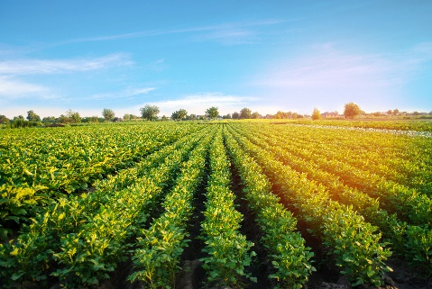
Joint Operational Programme Black Sea Basin 2014-2020
AGREEN project partners’ consortium
October 2022
Joint Operational Programme Black Sea Basin 2014-2020 is co-financed by the European Union through the European Neighbourhood Instrument and by the participating countries: Armenia, Bulgaria, Georgia, Greece, Republic of Moldova, Romania, Turkey and Ukraine.
This publication was produced with the financial support of the European Union. Its contents are the sole responsibility of the AGREEN project partners’ consortium and do not necessarily reflect the views of the European Union.
The editor of the material: AGREEN project partners’ consortium
Lead beneficiary: Dobrudzha Agricultural and Business School (DABS)
Address: Bulgaria, 9300 Dobrich, 3 Bulgaria str.
Phone: +359 58 65 56 26
E-mail: dabs.projects@gmail.com
Website: www.univ-ovidius.ro

